Методическая разработка квест-игры
“Adventures about Russia”
(“Путешествие по России»)

Цель: популяризация путешествий по России и изучение туристических маршрутов на английском языке для развития туристического бизнеса между Россией и другими странами.
Задачи квест-игры:
- повысить уровень мотивации школьников к изучению иностранных языков;
- создать условия для приобщения обучающихся к культуре, истории и достопримечательностям родной страны/ родного края, развитию кругозора посредством использования английского языка в рамках тем, сфер, ситуаций общения, отвечающих опыту, интересам обучающихся;
- воспитывать патриотизм, уважение и любовь к Родине;
- создать условия для выявления и поддержки одарённых обучающихся;
- формирование функциональной грамотности;
- способствовать развитию сотрудничества между образовательными организациями города Вологды в рамках сетевого взаимодействия.

Выполнение заданий квест-игры проходит по следующему маршруту:
- The capital of our Motherland; Москва
- The northern capital of Russia; Петербург
- The resort town of Russia; Курортный город России
- The third capital of Russia; Третья столица России
- Tsaritsyn – Stalingrad; Царицын – Сталинград
- The Pearl of Siberia; Жемчужина Сибири
- The Ussuri taiga; Уссурийская тайга
- Volcano region Край вулканов

Участие в квест-игре командное (коллективное).
Команда-участница должна быть сформирована из 5-7 обучающихся 7 классов.
Каждой команде выдается маршрутный лист. Время выполнения заданий на каждой
Станции – 10 минут.

Вводная часть (вступление)
Hello, pupils!
Nowadays business with other countries is actively developed. If you want to be successful, you should know not only geography of your country, history and attractions of different places, the features of your national culture, but you should be able to communicate in English, so that to receive our foreign guests.
So, today you’ll try yourselves as guides. John, a foreigner from Great Britain, will visit us one of these days. He wants to get acquainted with the culture, sights, and interesting facts of Russian cities. Now we’ll go together along the exciting route of our country. Let's start our journey from the western part of Russia.

Задание № 1
Moscow is a famous capital of our state. Let's try to tell John interesting facts about this city. Answer a number of questions by choosing one correct number from the suggested answers.
Moscow Quiz
1. When did Khan Batyi of the Golden Horde conquer Moscow and the Tatar yoke begin?
a) in 1237 b) in 1380 c) in 1242
2. When did Moscow become the capital of Russia?
a) in the 14th century under Ivan Kalita
b) in the 16th century under Ivan III
c) in the 18th century under Peter the Great
3. Who were the architects of St. Basil’s Cathedral?
a) Minin and Pozharsky b) Barma and Postnik c)Kirill and Mefodiy
4. When did the first street lamp appear in Moscow?
a) 1730 b) 1812 c) 1905
5. Who presented the first spectacled bear as a present to Moscow Zoo?
a) Rudyard Kipling b) Alan Alexander Milne c) Gerald Darrel
6.What is the longest street in Moscow?
a) Tverskaya Street b) Profsoyuznaya Street c) Kutuzovsky Avenue
7. Lobnoye Mesto was not used as a place for
a) holidays b) executions c) reading the tsar’s orders
8. Moscow hosted the XX Olympic Games
a) 1980 b) 1970 c) 1958
9. What river is Moscow washed by?
a) the Neva river
b) the Volga river
c) the Moskva river
d) the Окa river
10. Which of the following monuments is the symbol of Moscow?
a) the Hermitage
b) Red Square
c) the Kremlin
d) St Basil’s Cathedral
11. What kind of the public transport in Moscow is the fastest?
a) a bus
b) a trolleybus
c) Metro
d) a taxi
12. What theatre is famous for its ballet and opera performances in Moscow?
a) the Тaganka Theatre
b) the Bolshoi Theatre
c) the Moscow Art Theatre
d) the Theatre of Satire
13. What famous Russian writer was born in Moscow?
a) Leo Tolstoy
b) Fyodor Dostoevsky
c) Anton Chekhov
d) Alexander Pushkin
14. What building in Moscow is the highest?
a) the Ostankino Tower
b) the Eastern Federation Tower
c) Moskva-city
d) Luzhniki
15. Which of the following parks is the largest in Moscow?
a) Gorky Park
b) the Hermitage Garden
c) Tsaritsino Park
d) Losinoostrovsky Park
_______________________________________
Answers: 1a, 2b, 3b, 4a, 5c, 6b, 7a, 8a.
Ответы:
c) Москва-река
b) Красная площадь
c) Метро
b) Большой театр
d) Александр Пушкин
a) Останкинская телебашня
d) Лосиноостровский парк

Задание № 2. St. Petersburg Sights
Now we are in the northern capital of Russia. Let's get acquainted with several famous sights of St. Petersburg. Match the name of the outstanding places of the city and a suitable picture.

Name | Sight
- Peterhof | A)  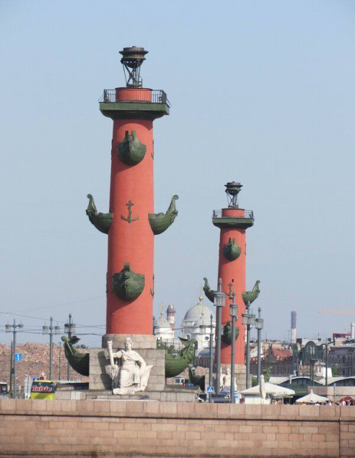
- St. Isaac's Cathedra | B)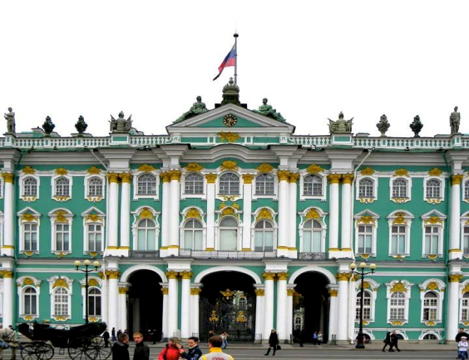
- The Mariinsky Theatre | C)  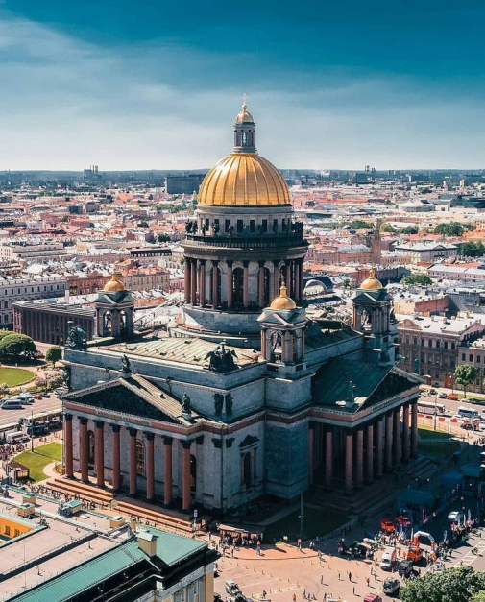

- Rostral Columns | D)  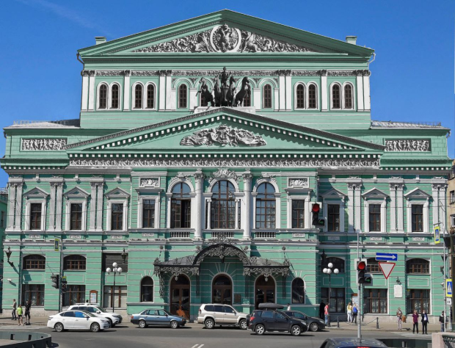
- The Hermitage | E)  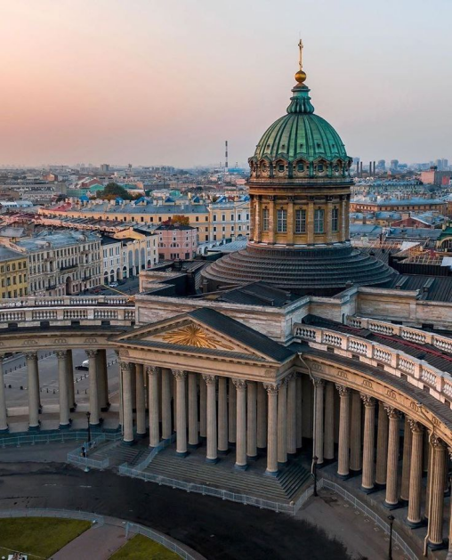
- The Cabinet of Curiosities | F)  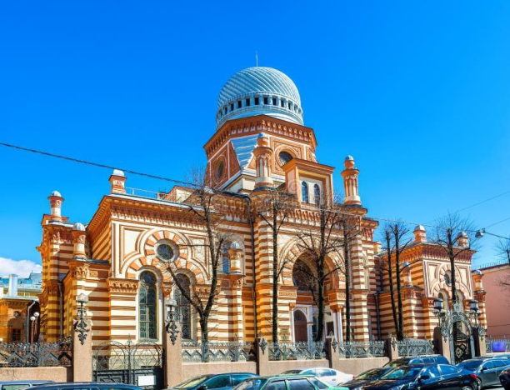
- The Great Choral Synagogue | G)  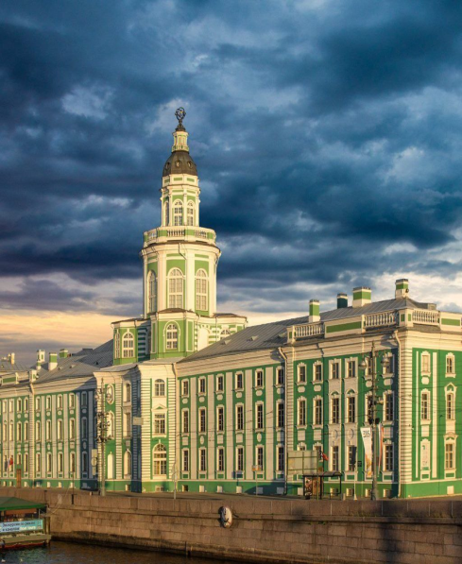
- Kazan Cathedral | H)  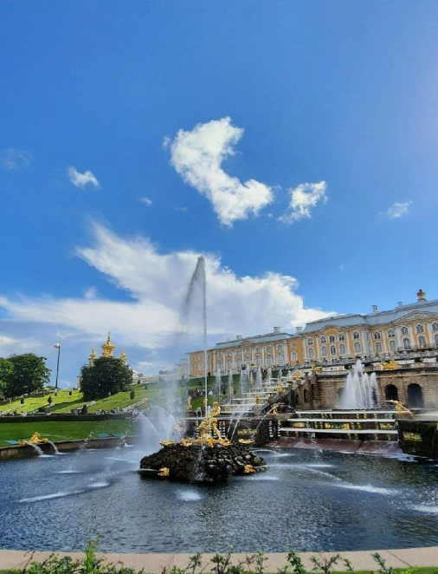

Answers:

Name (number) | 1 | 2 | 3 | 4 | 5 | 6 | 7 | 8
Sight (letter)

Задание 3. The resort capital of Russia
- John liked the description of one of the resort cities, which is presented below. Read the text and name the city.
А resort town is located on the Black Sea coast of the Krasnodar Territory. This resort area stretches for 145 km along the seashore – from the village of Magri to the border with Abkhazia. After the Olympics in 2014, the flow of tourists to this city has only increased
Rest in this place is interesting at any time of the year. In summer, tourists are attracted here by the warm sea, beaches, hot sun and a riot of subtropical vegetation. In winter, it surprises with its contrasts. It can be very warm and green on the coast. At the same time, in the Krasnaya Polyana area, the mountain slopes are covered with snow, and tourists are skiing.

_____________ is the resort capital of Russia .
(Отгадать по описанию Сочи)
- Reading for specific information (Sochi).
Прочитайте тексты и установите соответствие между текстами и их заголовками: к каждому тексту, обозначенному буквами А-G, подберите соответствующий заголовок, обозначенный цифрами 1-8. Используйте каждую цифру только один раз. В задании есть один лишний заголовок.

1. The future of the Olympic City |  | 5. The sports festival
2. Where the name comes from |  | 6. A Russian resort
3. Mentioned in myths |  | 7. Getting ready for the great sports event
4. Suitable for summer and winter sports |  | 8. Famous for its collection of plants

A |  | Sochi is the second longest city in the world stretching for 145 kilometers along the shores of the Black Sea. The city is located at the same latitude as the world famous resorts of Cannes, San-Remo and Nice, and has the same weather conditions, that’s why it’s also called the Russian Riviera. Sochi is one of very few cities in Russia where you can see real palms, eucalyptus, magnolias and fruit, such as figs and grapes, which is not typical of the average cold Russian climate.
B |  | Sochi is a relatively new name for the city. It was first called Sochi in 1896. The first Russian settlement on the site was called Fort Alexander. Historians say that the word Sochi has two possible meanings. It could be a variation of the term sshatche which was used by the local people to mean place by the sea. It is also believed that Sochi comes from shacha which locals used to mean sell a head because it used to be where slave markets were held.
C |  | Sochi is situated between the sea and mountains which creates a very favourable climate. The sea warms the coast, and the mountains protect the city from the cold north winds. Sochi’s summer is associated with the long swimming season. Winter temperatures are not often below 12 ºC, and ice hockey, figure skating, curling and speed skating are usually arranged as indoor events. However, up in the mountains it is much colder and there’s lots of snow, especially in February and March.
D |  | For several years Sochi and its citizens carefully prepared for the Olympic Games. The competitions were rganized in two clusters: a coastal cluster for ice events in Sochi, and a mountain cluster located in the Krasnaya Polyana Mountains. The mountain cluster hosted skiing and sliding sports. It took around 30 minutes to travel from the coastal to mountain cluster. Construction of the Olympic clusters took 7 years.
E |  | Ancient Rome and Athens aren’t the only places where Greek gods lived and performed their remarkable feats. It is known that Odysseus, a legendary Greek king of Ithaca, met his enemy, the one-eyed Cyclops, in Sochi. The city was also the site where Prometheus was chained and tortured. He was punished for granting fire to humans. Today a statue of Prometheus is placed on the top of Eagle’s Rock.
F |  | The Sochi botanic garden history goes back to the end of the 19th century. It is believed to be one of the most beautiful gardens in Russia. Over 1800 kinds of unique plants grow there. You can see the flora of various regions: China, Australia, South and North America, the Caucasus etc. The garden is located on a hillside and has two levels, from the top of which an impressive view can be seen.
G |  | The XXII Olympic Winter Games, a major international multi-sport event, were held in Sochi in 2014. It was the second Olympics in Russia after the 1980 Summer Olympics in Moscow. The Olympics in Sochi were distinguished primarily by the fact that these were the first winter games carried out in a city with a sub-tropical climate. 2780 athletes from different countries took part in the 98 events of the Games.

Запишите в таблицу выбранные цифры под соответствующими буквами
Текст | A | B | C | D | E | F | G
Место действия | 6 | 2 | 4 | 7 | 3 | 8 | 5

Задание 4. Kazan – the third capital of Russia
After warm Sochi, John decided to go to a beautiful city, the third capital of Russia - Kazan. Solve puzzles and help John understand the diverse culture of the city.

1. A local Kazan holiday:
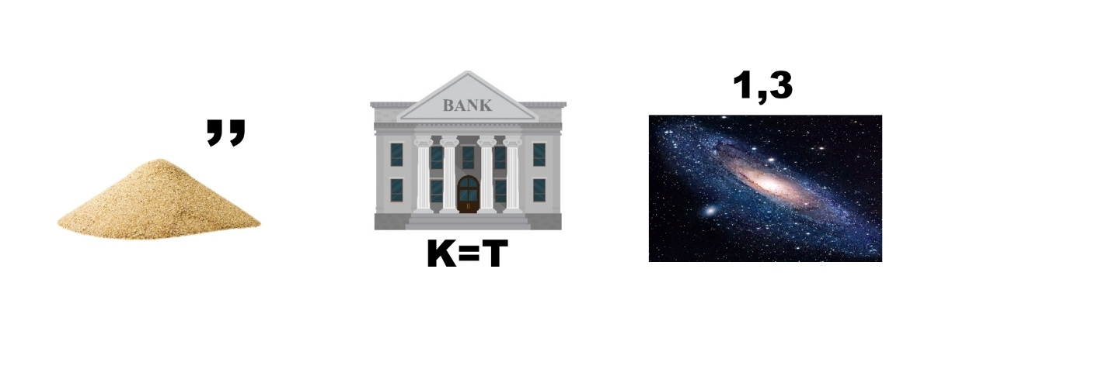
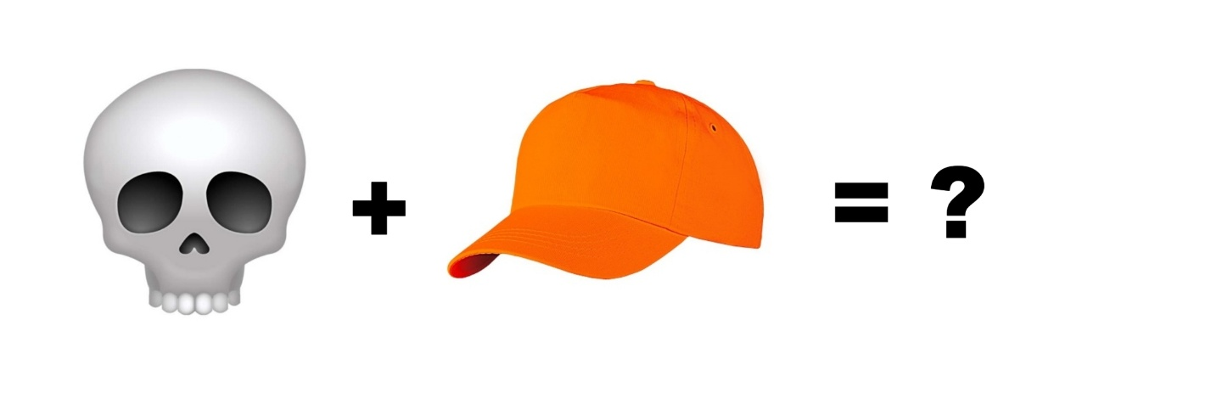
2. A national Kazan headdress:

3. The name of Kazan Ferris wheel (Three words):

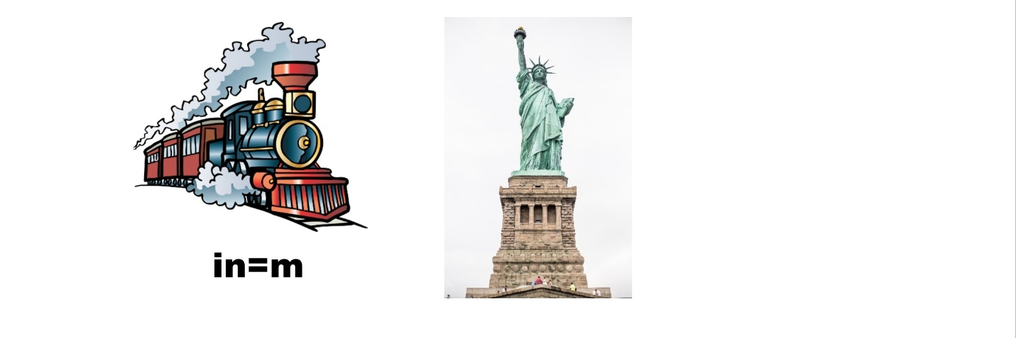
4. A famous attraction of Kazan (Two words):
5. The Kazan citadel (Two words):

Answers:
1. Sabantuy
2. Skullcap
3. «Around the World»
4. Tram Monument
5. Kazan Kremlin

Задание 5. Tsaritsyn – Stalingrad - Volgograd
From Kazan we’ve arrived in Volgograd – the Hero City!
We offer you to solve a crossword puzzle that includes facts about the city. You will help our guest get to know Volgograd better.
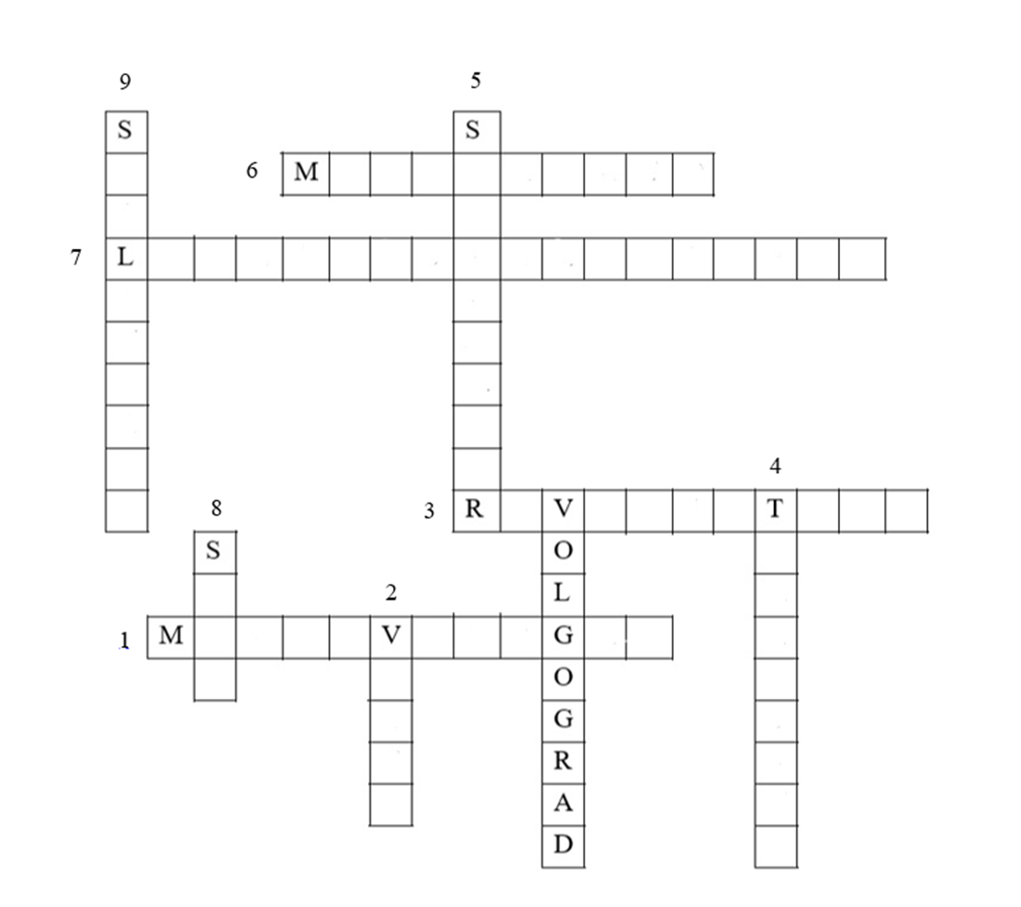
- What is the most famous sight of Volgograd?
- What river flows in the city of Volgograd?
- What place in Volgograd is the largest in Europe?
- What is the first name of the city Volgograd?
- In what month does Volgograd celebrate its city day?
- What is the tallest statue in Russia (85 meters) located in Volgograd?
- What was the first museum opened in Volgograd?
- What is on the coat of arms of Volgograd?
- What was the name of the city of Volgograd in the period from 1925 to 1961?
Answers:
- Mamaev Kurgan
- Volga
- River Station
- Tsaritsyn
- September
- Motherland
- Local History Museum
- Star
- Stalingrad

Задание 6. The Pearl of Siberia

And now we are going to Irkutsk region, which is famous for the deepest lake in Russia. Help John guess the name of this lake and use the diagrams to make two or three sentences about it.
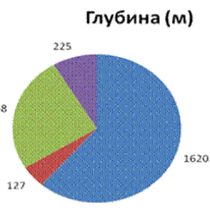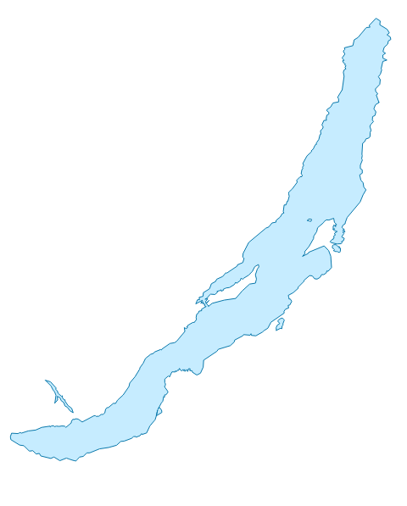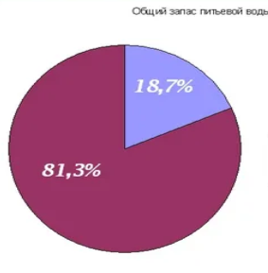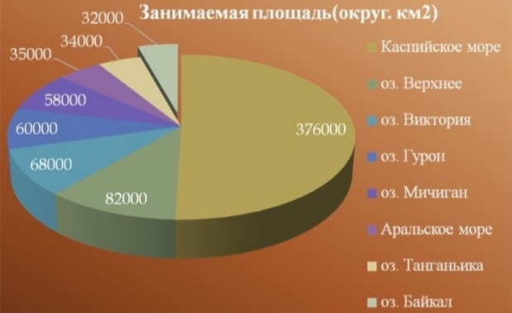
The name of the lake: __________________

Sentences about the lake:
(составить предложения по диаграммам - это возможно?)

Задание 7. The Ussuri taiga

Сhoose the correct statements about the Ussuri region – (True).
1. In the Ussuri Nature Reserve there is an animal listed in the Red Book.
2. In the territories belonging to the Ussuri region, mountainous terrain predominates.
3. The territories of the Ussuri region are washed by the waters of the Atlantic Ocean.
4. The Ussuri region annexed to Russia in 1830.
5. There are many rivers in the Ussuri region, the largest of which is the Ussuri.

Answers:
Выберите правильные утверждения об Уссурийском крае.
1. В Уссурийском заповеднике обитает животное, занесенное в Красную книгу. (верно)
2. На территориях, принадлежащих Уссурийскому краю, преобладает горный рельеф.(верно)
3. Территории Уссурийского края омываются водами Атлантического океана. (неверно)
4. Уссурийский край присоединен к России в 1830 году. (неверно)
5. В Уссурийском крае много рек, самая крупная из них — Уссури.(верно)

Задание 8. Volcano region
Read the text and make a plan - put the paragraph titles in the logical order.
Volcanoes of Kamchatka
The Kamchatka Peninsula is one of the most beautiful, though difficult—to-reach corners of Russia. There are virgin forests, pristine rivers, and amazingly beautiful mountains. And the volcanoes of Kamchatka are what it's worth coming here for, impressions will remain for a lifetime.
How many volcanoes are there? No one can answer for sure. Some reference books give a list of several hundred. Others number more than a thousand. The problem with counting is that there are no identical volcanoes on the peninsula. All of them differ in time of formation, shape, structure, and activity. The long-extinct ones are simply called hills or mountains. But these are volcanoes. Although they are exes. However, there are no former volcanoes, and sometimes long-extinct ones wake up and begin to show their rather short-tempered character.
Currently, only three dozen active volcanoes are distinguished from the many volcanoes in Kamchatka. But this does not mean that, like Vesuvius, which buried the ancient city of Pompeii, they spew tons of lava or, like the most active, emit ash, which is enough to paralyze air traffic on half the continent. Not at all.
Many volcanoes in Kamchatka really erupted several thousand years ago and are now fast asleep. However, they snore – they emit red-hot water vapor and a whole palette of accompanying gases from the vent. Scientifically, this is called fumarolic activity. However, there is a great chance to admire the awakened fiery mountain. But it's better from afar. Volcanoes are very irritable from sleep. And yet they are beautiful.
There are two volcanic belts on the territory. The Middle East Kamchatka volcanic belt, which stretches along the watershed of the ridge of the same name, is more ancient, and therefore there are few active volcanoes there. The East Kamchatka volcanic belt, which stretches from north to south along the entire peninsula, is younger and is a concentration of volcanic activity.
You don't have to go to the edge of the world to admire the beauty. Part of the volcanoes is located literally next to the capital of the peninsula – Petropavlovsk-Kamchatsky. That's what they're called — homemade.

(Поставьте пункты плана в логическом порядке)
1- The place that is being described
2- Activity of dormant volcanoes
3- The number of volcanoes and the problem of counting them
4- A place where you can admire volcanoes.
5- Volcanic belts on the territory of Kamchatka
6- The number of active volcanoes and their characteristics

Answers:
Верный ответ – 136254
- Место, о котором рассказывается
- Количество вулканов и проблема их подсчёта
- Количество действующих вулканов и их характеристика
- Активность спящих вулканов
- Вулканические пояса на территории Камчатки
- Место где можно полюбоваться вулканами

Путевой лист команды
МОУ «_____»

Название станции | Номер аудитории | Количество  баллов | Подпись организатора
- The Pearl of Siberia | 301
- The capital of our Motherland | 302
3. The Ussuri taiga | 303
4. Tsaritsyn – Stalingrad | 304
5. The northern capital of Russia | 305
6. The third capital of Russia | 306
7. The resort town of Russia | 307
8. Volcano region | 308
Итого:

Анкета обратной связи
Вам понравилась квест-игра? _____________________________
Какая станция вам понравилась больше всего? _________ _________________________________________________
На какой станции задания показались самыми простыми?
_________________________________________________
А на какой сложными? _____________________________

