Сценарий лингвистической игры «Поле чудес» с элементами сравнительного краеведения (США – Дальний Восток России)

From the Harvest Festival to Thanksgiving Day

Целевая аудитория – обучающиеся 8 класса
Цель мероприятия: сформировать у обучающихся представление об истоках Дня Благодарения в США через игровую деятельность и провести межкультурную параллель с историей освоения Дальнего Востока России.
Задачи мероприятия
Образовательные:
- Познакомить с историей возникновения Дня Благодарения в США.
- Научить сравнивать исторические события США и России (экспедиция Ивана Москвитина и других первопроходцев).
- Активизировать лексику по темам «Путешествия», «Праздники», «Еда».
Развивающие:
- Развивать навыки языковой догадки через игровой формат.
- Тренировать умение работать в группе и принимать коллективное решение.
- Развивать навык чтения с пониманием основного содержания.
Воспитательные:
- Воспитывать уважение к истории и традициям разных народов.
- Показать ценность взаимопомощи.
- Формировать чувство гордости за русских первопроходцев.

Приложение:
1) тексты заданий;
2) презентация.

План мероприятия
Этап 1. Организационный момент и объяснение правил игры
Учитель приветствует класс.
Good afternoon, dear friends! I’m not Leonid Yakubovich and it is not Friday today, but I am happy to see you at the World of Wonders now.
Этап целеполагания.
The game is dedicated to one of the oldest holidays in the USA which is celebrated on the 4th Thursday in November. Do you have any ideas what day it is? You will have to guess some words related to this celebration. But not only. (слайд 1)

Объяснение правил. (После объявления задания дети по очереди должны называть по одной букве, чтобы отгадать слово.)
You are divided into 2 groups. After reading the task you will have to name one letter to guess the word.
Этап 2. Основной
Задание 1. Тема: Название корабля пилигримов
As you know, everything in our life has a starting point, and this celebration started as a harvest celebration. A little bit of history first. (Кто-то из детей читает историческую справку на экране, у детей также есть текст на листах.) In September 1620, a small cargo ship left Plymouth, England, carrying 102 passengers on board. They were puritans who set sail to America for religious, political and economic reasons. They were dissatisfied with the Anglican Church, its rituals. Also, it was an opportunity for them to get land in the USA from the Virginia Company. In addition, the Puritans did not accept the political regime of Charles I in England. So, the pilgrims crossed the Atlantic Ocean and it took them 66 long and difficult days. (слайды 2, 3)
What was the name of their ship? (Ответ: Mayflower)
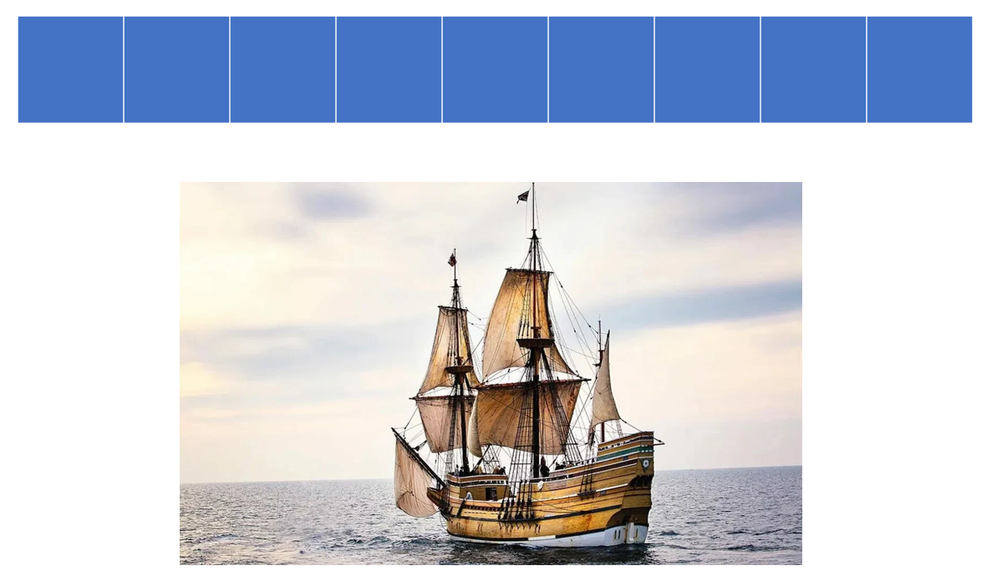
После угадывания слова проводится параллель с Дальним Востоком.
Now I suggest that we draw a parallel with some events that happened a little bit later in Russia in the Far East. (Портрет Ивана Москвитина на экране, слайд 4) Have you ever heard of Ivan Yurievich Moskvitin? (Ученик читает текст на экране или на листе) A group of 31 men led by the Cossack Ivan Moskvitin went to explore the Far East in 1639. The group sailed down the Aldan River and reached the Sea of Okhotsk and their journey was long and difficult. Ivan Moskvitin was the first Russian to reach the Pacific Ocean, to learn about the Shantar Islands, Amur, Sakhalin. (слайд 5)
Вопрос для обеих групп для обсуждения:
- In your opinion, what character qualities do the English pilgrims and Ivan Moskvitin have in common? (На слайде представлены разные прилагательные. Дети, выбирая подходящие, рассказывают о пилигримах и о первопроходце Иване Москвитине.) (слайд 6)
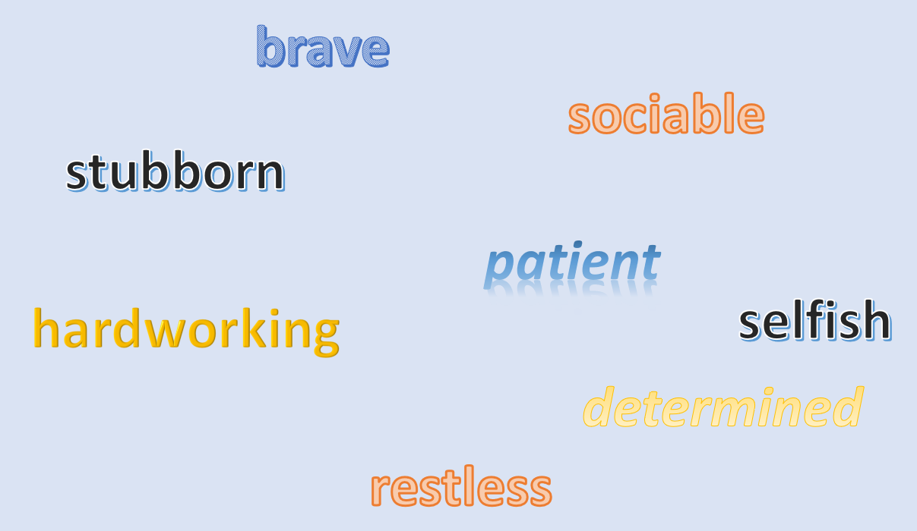
- Did they achieve what they planned?
- Did the pilgrims finally cross the Atlantic Ocean?
- Did Ivan Moskvitin with his Cossacks reach the Pacific Ocean?

Задание 2. Тема: Название первого поселения пилигримов
(Дети читают текст на экране или на листах.) So, after their long and hard voyage the pilgrims first landed at what is now modern-day Provincetown. After some skirmishes (fights) with the local Native American tribes there, they decided to sail to a nearby place called …, settle there and establish a colony. There is a popular sight now, a Rock, which symbolizes the place where the pilgrims first settled. This place has the same name as the place they left from in England.
(слайды 7, 8)
What is the name of this place? (Ответ: Plymouth)
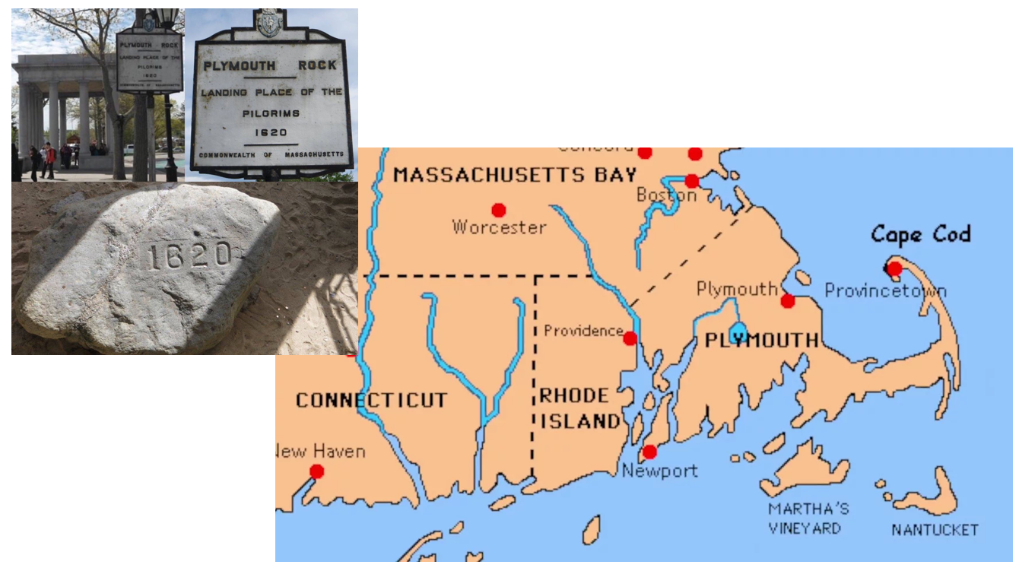

Далее проводится параллель с Дальним Востоком. Работа с картой Амурской области. (слайды 9, 10)
Let’s return to Ivan Moskvitin again. What village named after this pioneer do you drive by when going to Blagoveshchensk? (Moskvitino) Actually, there are several places in the Amur region named after the explorers of the Far East. Take a look at the map and find them, please. (Poyarkovo was established by the Cossack settlers from the river Argun and named after Vasily Danilovich Poyarkov, a Russian pioneer. You can also see the station Erofei Pavlovich on the map. Erofei Khabarov was a Russian pioneer best known for his exploring the Amur river region.)
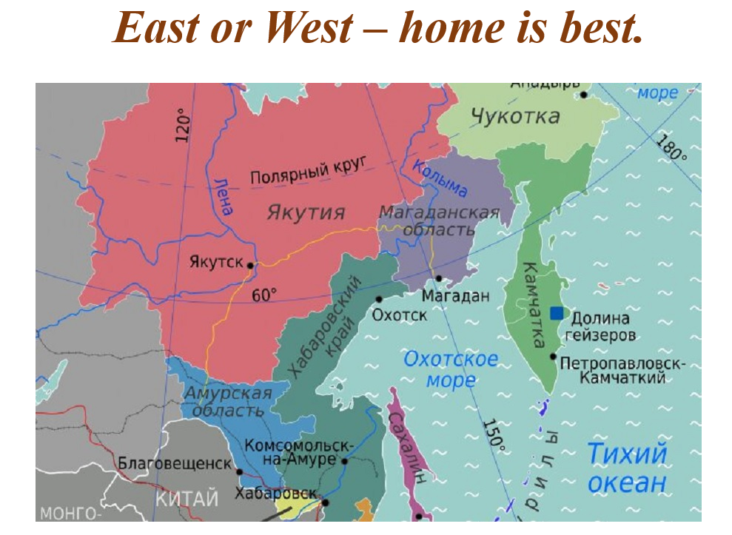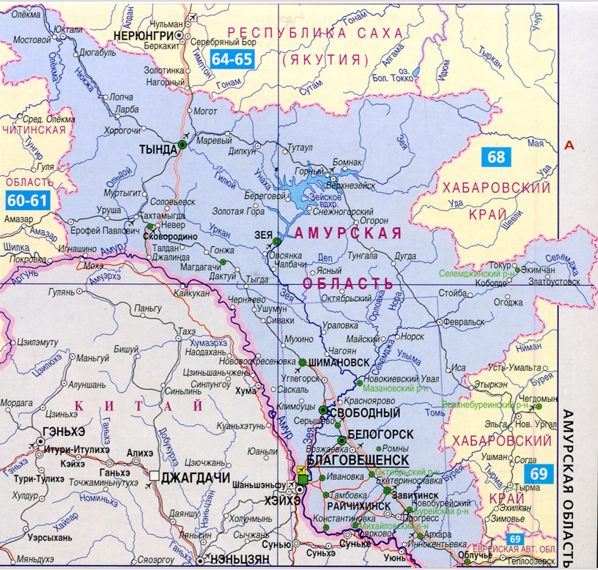

Задание 3. Тема: Еда
(Дети читают текст на экране или на листах.) When the pilgrims landed in Plymouth, many of them were already weak from disease and lack of food. Over the course of winter, the colony lost almost half of its people due to disease and starvation. Native Indians helped them – gave some food, taught how to catch fish and grow corn. After their first harvest pilgrims and Indians had a 3-day celebration with lots of food. Nowadays, traditional food on Thanksgiving Day is as follows: a pumpkin pie, corn, roast turkey with some sauce. (слайды 11, 12)
What sauce is it? (Ответ: cranberry)


Параллель с Амурской областью.
(слайд 13)
By the way, what berry grows in the north of the Amur region? And what plant is widely used in cooking in the Far East? Each team can name any 2 letters. Now you are given 1 minute to think and discuss possible variants. (Ответ: cowberry, fern)
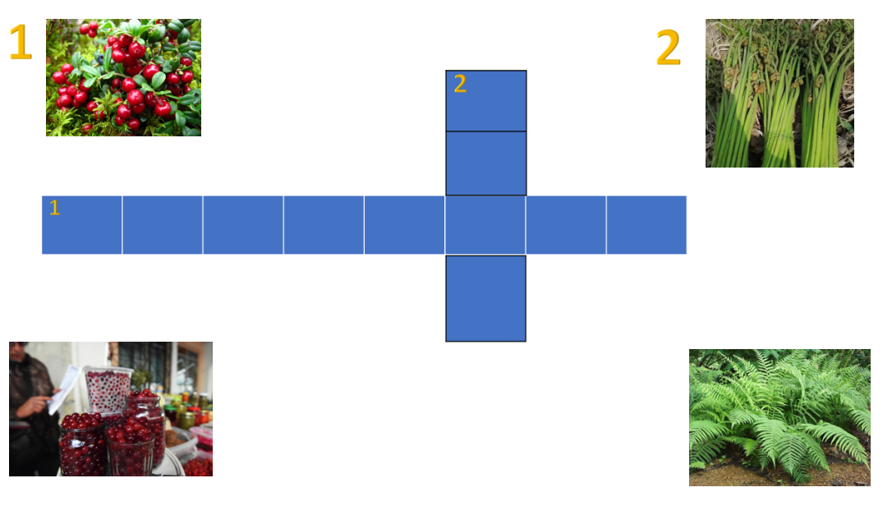
Завершение мероприятия. Этап рефлексии
(слайд 14)
So, what is the philosophy of Thanksgiving Day and all the events in the history of the USA and the Far East that we have just discussed? Will you please in groups finish the sentences to draw the conclusion of our lesson? (You will have difficulties in life but …) Дети называют свои варианты ответа.
В дополнение можно предложить следующие варианты на слайде:
… you are not alone – others can help you.
… there is always harvest after hard work.
… you can overcome them if you are brave and hardworking.
Ссылка для полного скачивания материала
https://disk.yandex.ru/d/aJCskU5DiHhZVg

