Module 19 Travelling

Week 1 Traveller types

Lesson plan*
- Warm-up: Speaking Task 3
- Vocabulary revision + Traveller types Quiz
- Writing Task 38 (correcting mistakes + writing + a sample answer)

*This lesson plan is a part of the full EGE Clinic course. We strongly recommend that your students do some work on the platform BEFORE they have this class. This flipped classroom approach allows revising vocabulary, assists better memorisation and leads to higher grades at the exam. For more information, please, go to https://ekaterinashadrova.ru/egeclinic . If your students join our EGE Clinic course, you’ll get all lesson plans free of charge and will get full methodology support from us.

Warm-up: Speaking Task 3 (10 min)

(In pairs – Student A and B) Ask and answer the questions. Say 2-3 sentences.

Student A
1 Do you enjoy travelling? Why or why not? What are the benefits of travelling?
2 Do you prefer winter or summer holidays? Why?
3 What are the best places you have been to?
4 Would you prefer to have a trip in your own country or in a foreign country? Why?
5 Why do you think some people like going away with their family?
6 What places would you recommend visiting in your area?
7 What season is the best to visit your region and why?
8 Why do you think young people choose different holiday destinations from older people?

Student B
1 When was the last time you went on holiday (BrE)/vacation (AmE)? Can you describe it?
2 Where would you like to go to on your next holiday/vacation?
3 Where is the worst place you have been on holiday/vacation?
4 What would you recommend a foreign tourist to visit in your country?
5 What is the best means of transport to go on holiday? Why?
6 What sort of holiday do people from your region prefer?
7 Do you think your region is popular with tourists? Why do you think so?
8 Some people think that going on holiday is more tiring than staying at home. Do you agree?

Vocabulary revision (20-30 min)

1 (Individually) Complete the following sentences with the words/collocations below

all-inclusive holidays // backpacking // bucket list // city break // city slicker // culture vulture // meander across // off the beaten track/path // souvenir

1. We had a lovely ______ to Prague last summer.
2. North Korea is truly _______.
3. Hiking the Inca Trail to Machu Picchu is at the top of my _______.
4. Peter always buys fridge magnets as a _____ of his holidays.
5. Tanya has always dreamed of _____ around the world.
6. The only problem with ______ is that you feel like you're losing money if you leave the hotel to try one of the local restaurants.
7. If you're a ______, New York has everything you could want - opera, theatre, museums, and more.
8. Visitors to Hannover soon find themselves crossing a painted red line ________ pavements and squares.
9 A ______ often gains a culture shock when coming to the farm.

Keys
1 city break 2 off the beaten track/path 3 bucket list 4 souvenir 5 backpacking 6 all-inclusive holidays 7 culture vulture 8 meandering across 9 city slicker

Teacher’s Note:
You may want to discuss some of the difficult vocabulary. Ask Ss to do some search online, for example on some corpora websites to find sentences with these words/phrases to provide more context for using them.
https://skell.sketchengine.eu/
https://fraze.it/

city break (noun) – a holiday/vacation to a city, usually a short trip.
all-inclusive holiday (BrE) / vacation (AmE) (noun) – a holiday/vacation on a resort that includes all food and drink.
to backpack (verb), backpacking (noun) – a style of independent travel usually involving multiple destinations and low budget accommodation.
off the beaten path/track (phrase) – describes a tourist destination where not many people/tourists go.
souvenir (noun) – an object to remind someone of a place, person or event.
bucket list (noun) – a list of things a person would like to accomplish in their lifetime.
culture vulture (noun) – someone who is very interested in music, art, theatre, etc
meander /miˈændə/ across/along/through (verb) – to walk somewhere in a slow relaxed way rather than take the most direct way possible
city slicker (noun) – a person who lives in a city, and has no experience of or knowledge about living in the countryside

2 What kind of traveller are you? Do the quiz to find out.
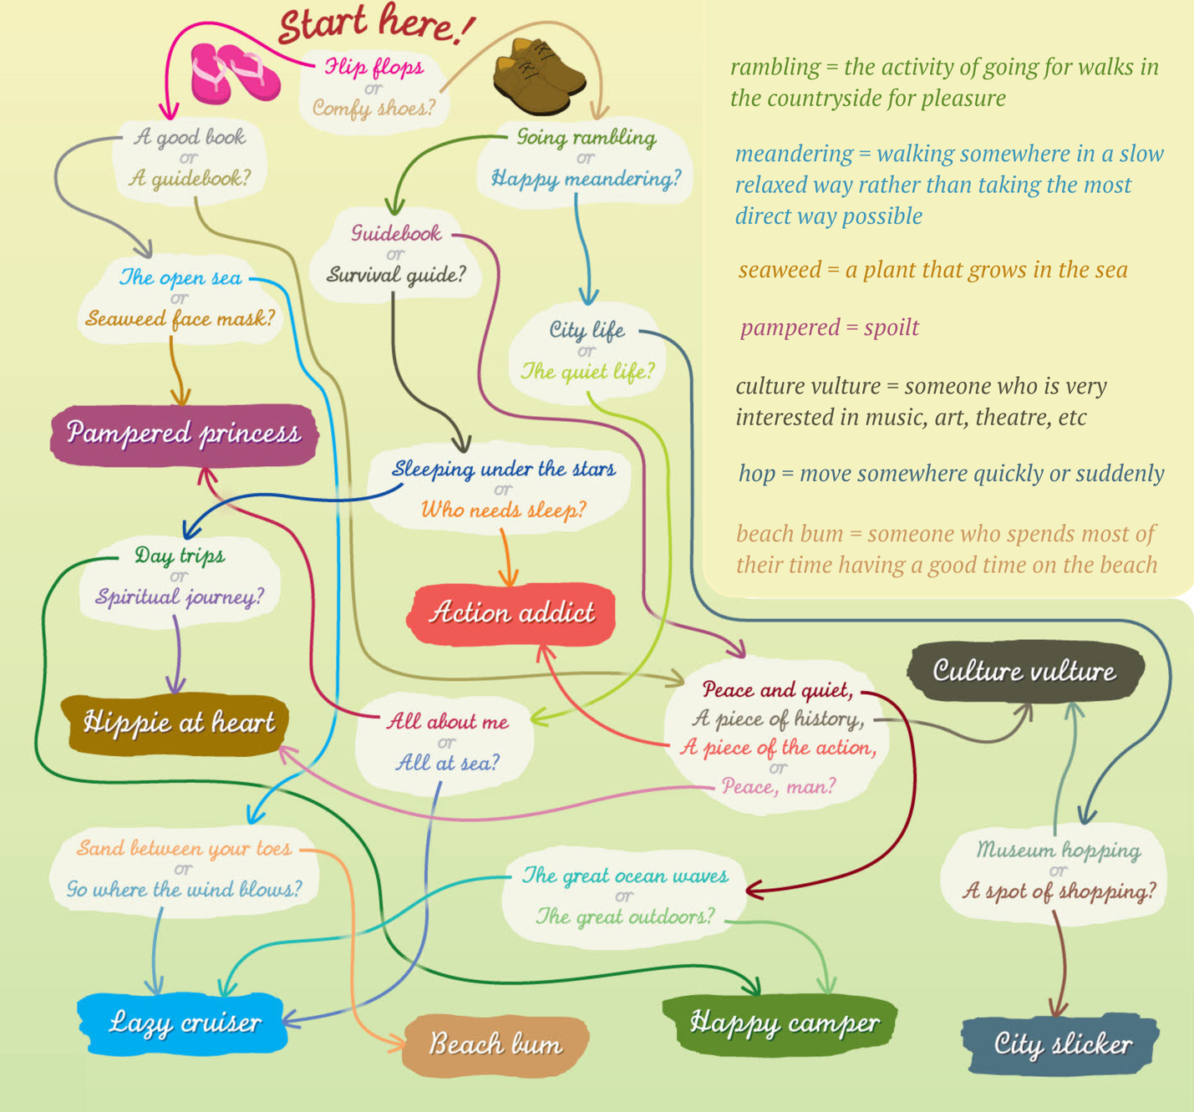
based on EF Advanced, 3rd ed

3 (In pairs) Read about your traveller type. Then compare with your partner. Are the descriptions accurate for you? Would you be good holiday companions?

Pampered princess | Hippie at heart
You're at your happiest when you're relaxing in the spa, indulging in beauty treatments, or simply curled up in a fluffy bathrobe sipping a fruit tea. You've worked hard all year, so it's time to put those freshly pedicured feet up and let everyone else take care of you. After all, you deserve it. | You're a free spirit and love discovering far-flung places. Whether travelling alone or with an equally laid-back companion, it's all about going where the mood takes you. You've got your guidebook and your roll-up mattress and the rest can take care of itself.
Lazy cruiser | Happy camper
You like to take things at a slower pace on holiday - doing as much or as little as you please. You love being out on the ocean waves and you enjoy exploring new places, but you're equally happy sitting on deck taking in a beautiful sunset. | You like to get away from it all and you'll happily swap your creature comforts for a sleeping bag if it means waking up to birdsong every morning. Whatever you fill your days with, you'll do it at your leisure. And if it happens to pour with rain, it's all part of the fun.
Action addict | Culture vulture
You're not the average holidaymaker and following the typical tourist trail is never enough for you. You can't sit still for a minute - even on holiday. Whether it's extreme sports or going right off the beaten track, you see every trip as an adventure. | You don't just want to visit a country, you want to immerse yourself in it. You'll see all the sights, learn the language, and find out about the history of a place. If you find the time to sit down, it's because you're sampling the local cuisine - no English menu for you, thanks very much!
Beach bum | City slicker
You're in your swimwear almost as soon as the plane touches down and once you're on that sun-lounger, you won't be moving far. Reaching for your pina colada is about as energetic as you get, and why not? That's what holidays are for, aren't they? | You love the buzz of the city and you'd rather hit the shops than the beach any day. You're happy to take in the famous sights and tick all the touristy boxes - but you've got to bring back a few souvenirs, right? It's the best way to explore a new city...

4 (In pairs/small groups) Read about other types. Discuss the collocations in bold. Ask your teacher if you’re not sure you understand their meaning correctly. Think of ONE person who is one of the types. Tell your partner about them.

5 (In pairs – Change partners) Discuss these questions:

1. Where would you like to go for a city break?
2. Have you ever been on an all-inclusive holiday? How was it? What are the pros and cons of this kind of trip?
3. Would you like to go backpacking? Why or why not?
4. Have you ever been off the beaten track? Where did you go?
5. Do you bring souvenirs back from holiday? Do you have any favourite ones?
6. Which countries are on your bucket list? Why? What do you want to see there?
7.What would influence your choice of sipping pina colada or fruit tea?
8.What would you swap your creature comforts for while travelling?
9.What is the best cuisine you’ve ever sampled on holiday?

Writing Task 38 (60-70 min)

1 (In pairs) Study the exam task below. Discuss
- the statistics (2-3 facts + 1-2 comparisons)
- the problem that can arise with travelling
- the solution to the problem

Imagine that you are doing a project on what travel styles are popular in Zetland. You have found some data on the subject – the results of the opinion polls (see the diagram below). Comment on the data in the table and give your opinion on the subject of the project.

Travel Style | Number of travellers (%)
Group Tour | 21
Backpacking / Camping | 38
Luxury Travel | 3
Beach Holiday | 26
Historical Tourism | 12
What is your favourite travel style?

Write 200–250 words. Use the following plan:
- make an opening statement on the subject of the project
- select and report 2–3 facts
- make 1–2 comparisons where relevant and give your comments
- outline a problem that can arise with travelling and suggest a way of solving it
- conclude by giving and explaining your opinion on the role of travelling in the modern world

2 (In pairs) Read an essay written by one of our students. Find what is wrong according to the Communicative achievement (РКЗ) and Spelling criteria (Орфография). How many points (out of 14) would you give as an expert?

Travelling has always been an integral part of people's lives. As part of my project aiming to explore what travel styles are popular in Zetland, I have found a table with the results of some opinion polls. In my essay, I am going to analyze the data and express my opinion on the role of traveling in the modern world.

As can be seen from the data, many respondents (38%) consider backpacking and camping styles of travelling to be the most popular ones. They are closely followed by beach holidays, which are chosen by 26%. Another key fact is that less than a fifth report luxury travel, placing it at the bottom of the table.

Comparing the other listed facts, I would like to specify that the difference between historical tourism (12%) and group tour styles (21%) is not drastic and makes up only 9 percentage points.

While travelling is deemed to be beneficial in terms of making people more open-minded, there is a significant problem associated with it. A lot of money is spent on accomodation, food, excursions, so more and more people cannot afford travelling. Fortunately, this problem can be solved by booking hot tours on verified websites.

In conclusion, travelling plays a crucial role in modern people's lives. It helps us to avoid boredom and makes us more cheerful.

Keys
Travelling (BrE) has always been an integral part of people's lives. As part of my project aiming to explore what travel styles are popular in Zetland, I have found a table with the results of some opinion polls. In my essay, I am going to analyze (AmE - analyse) the data and express my opinion on the role of traveling (AmE - travelling) in the modern world. (Если в начале работы орфография выбрана британского варианта, то ее нужно придерживаться. Смешение с американским вариантом будет считаться лексической или орфографической ош)

As can be seen from the data, the vast majority of the respondents (38%) consider backpacking and camping styles of travelling to be the most popular ones. They are closely followed by beach holidays, which are chosen by 26%. Another key fact is that less than a fifth report luxury travel, placing it at the bottom of the table.

Comparing the other listed facts, I would like to specify that the difference between historical tourism (12%) and group tour styles (21%) is not drastic and makes up only 9 percentage points. В такой форме сравнение эксперты не примут. Лучше употребить сравнительную (more common/popular) или превосходную степень (the most / the least popular) или сравнительные конструкции (… while … // as opposed to …) Отсутствует комментарий к сравнению, например, It can be assumed that people in Zetland mostly choose travelling with other people.

While travelling is deemed to be beneficial in terms of making people more open-minded, there is a significant problem associated with it. A lot of money is spent on accommodation, food, excursions, so more and more people cannot afford travelling. Fortunately, this problem can be solved by booking hot tours on verified websites.

In conclusion, travelling plays a crucial role in modern people's lives. It helps us to avoid boredom and makes us more cheerful. (Отсутствует фраза, указывающая на мнение, например In my opinion, // I believe)

Итоговый балл:
РКЗ 2 (1 аспект не раскрыт и 1 аспект раскрыт неточно)
Орг текста 3
Лекс 3
Грам 3
Орф 1 (3 ош) = 12/14

3 (Individually) Write an essay for the task below.

Imagine that you are doing a project on what traveller types people in Zetland are. You have found some data on the subject – the results of the opinion polls (see the table below). Comment on the data in the table and give your opinion on the subject of the project.

Traveller types | Number of respondents (%)
Pampered princess | 5%
Happy camper | 10%
Culture vulture | 25%
Beach bum | 25%
City slicker | 35%
What travel type are you?

Write 200–250 words. Use the following plan:
- make an opening statement on the subject of the project
- select and report 2–3 facts
- make 1–2 comparisons where relevant and give your comments
- outline a problem that can arise with choosing a holiday companion and suggest a way of solving it
- conclude by giving and explaining your opinion on the best holiday companion for teenagers

Suggested answer
Many people like travelling. As part of my project aiming to find out what traveller types people in Zetland are, I have found a table containing the results of some opinion polls. I am going to analyse the results of some opinion polls and express my opinion on the best holiday companion for teenagers.
As can be seen from the table, the most popular traveller type is a city slicker, with 35% of the respondents choosing it. There are two groups of responses with the same number of choices. A quarter of the respondents in Zetland consider themselves either a culture vulture (25%) or a beach bum (25%).
Comparing the other listed types, a happy camper is twice as common as a pampered princess (10% and 5% respectively). It can indicate that people in Zetland would rather spend their holidays more actively rather than relaxing in a spa or receiving massages.
Although travelling is extremely popular, there may be some potential problems with choosing the right companion. For example, if you have completely different preferences, the holiday will become a disaster resulting in endless rows or even fights. To solve this problem, it is recommended to have a detailed discussion with a potential companion about your and their expectations from a holiday.
In conclusion, I believe that the best holiday companion for teenagers is their peers, people of the same age, and preferably of the same interests. Going on holidays with such a person should be an unforgettable experience.
(243 words)

4 (In pairs - Peer correction) Read your partner’s essay. Check:

1. Has the writer introduced a table/diagram? Is the subject of the project mentioned?
2. Has the writer given 2-3 facts in §2? Are ...% given?
3. Has the writer made 1-2 comparisons in §3? Is there an explanation/a comment on the choice of comparisons?
4. Does the writer outline a problem and suggest a solution? Are they according to the task?
5. Does the writer express his/her opinion in Conclusion? Is the opinion given according to the task?
6. Is the essay written in a neutral (or formal) style? Is it consistent in BrE or AmE spelling/vocabulary?
7. Are there any grammar, vocabulary, spelling mistakes?

5 ORAL ESSAYS (For fast finishers*)

In pairs discuss an essay as if you were writing Task 38. Is there anything different from the essay you have just written?

Imagine that you are doing a project on what difficulties people in Zetland face while travelling. You have found some data on the subject – the results of the opinion polls (see the table below). Comment on the data in the table and give your opinion on the subject of the project.

Difficulties | Number of respondents (%)
Cancelled or delayed transportation | 36%
Forgotten can’t-live-without items | 22%
Currency exchange | 12%
Language barriers | 25%
Luggage weight limits | 5%
What difficulties do you face while travelling?

Write 200–250 words. Use the following plan:
- make an opening statement on the subject of the project
- select and report 2–3 facts
- make 1–2 comparisons where relevant and give your comments
- outline a problem that can arise with transportation and suggest a way of solving it
- conclude by giving and explaining your opinion on the best way to deal with travel difficulties

Teacher’s Note:
If you teach online, assign Ss to breakout rooms and monitor their discussions. Help them with the emerging language or ideas where necessary. If you teach one-to-one, first ask a student to brainstorm the ideas orally, then give some time to write their ideas. Give feedback by providing better language and showing how to achieve better scores at the exam.

