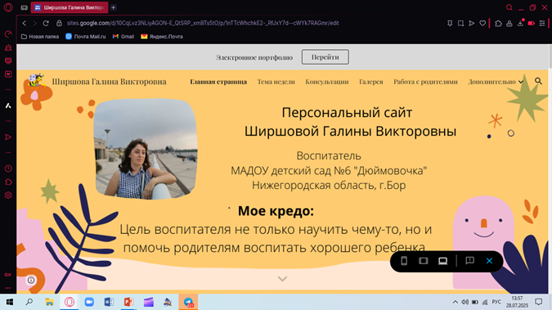
https://sites.google.com/view/sirsova43/%D1%8D%D0%BB%D0%B5%D0%BA%D1%82%D1%80%D0%BE%D0%BD%D0%BD%D0%BE%D0%B5-%D0%BF%D0%BE%D1%80%D1%82%D1%84%D0%BE%D0%BB%D0%B8%D0%BE

