Short term plan

Unit 8. Journey into space |  | School: № 6
Date: |  | Teacher name: Zommerfeld A.A.
Grade: 4 |  | Number present: 15 | absent:
Lesson title | Solar System
Learning objectives | 4.L5 identify initial, middle and final phonemes and blends  4.R3 recognize basic opinions in short, simple texts on an increasing range of general range of general and some curricular topics  4.W7 spell most familiar high-frequency words accurately when writing independently
Lesson objectives | -Recognize the specific –tion- , -ck- , -au- , -sh- letter combinations.  -Identify key words in sentences of a Solar System text and identify details of a text.  -Write words correctly which refer to the Solar System and space. Make sentences with them.
Level of thin  king skills | Knowledge, comprehension, application

Stages / Time | Teachers actions | Students actions | Assessment | Resources
Greeting. Organization moment.  Beginning of the lesson. | Teacher greets students.  Hello children! We are glad to see each other as always and are ready for creative work together. In front of you on the tables are colored smiles: red, blue, green.    Look at them carefully and choose the one that matches your emotional mood right now.  Red color - you are full of energy, ready to work actively.  Green color - you are calm, you don't care what happens in the lesson.  Blue colour - you want to learn something new.  .  Task. 1. Teacher gives cards to the students with task which refers to the previous theme.  Teacher asks to complete the sentences using familiar vocabulary from the previous lesson.  - Healthy food are…(cabbage, mushrooms etc. )  - Unhealthy food are…(fries, cola etc.)  Differentiation for children with special educational needs:  Low motivation (in step 2 children will work in pairs and help each other, in step three the groups will check the answers and help each other.)  This is the differentiation with student`s support.  Task.2 Pre-listening task.  Teacher shows the pictures and asks to listen and repeat the new words twice. After that the teacher shows the gestures which connected with words and asks students to repeat the words and gestures. At third time teacher asks to the students to name the words watching the pictures and making gestures.  Space 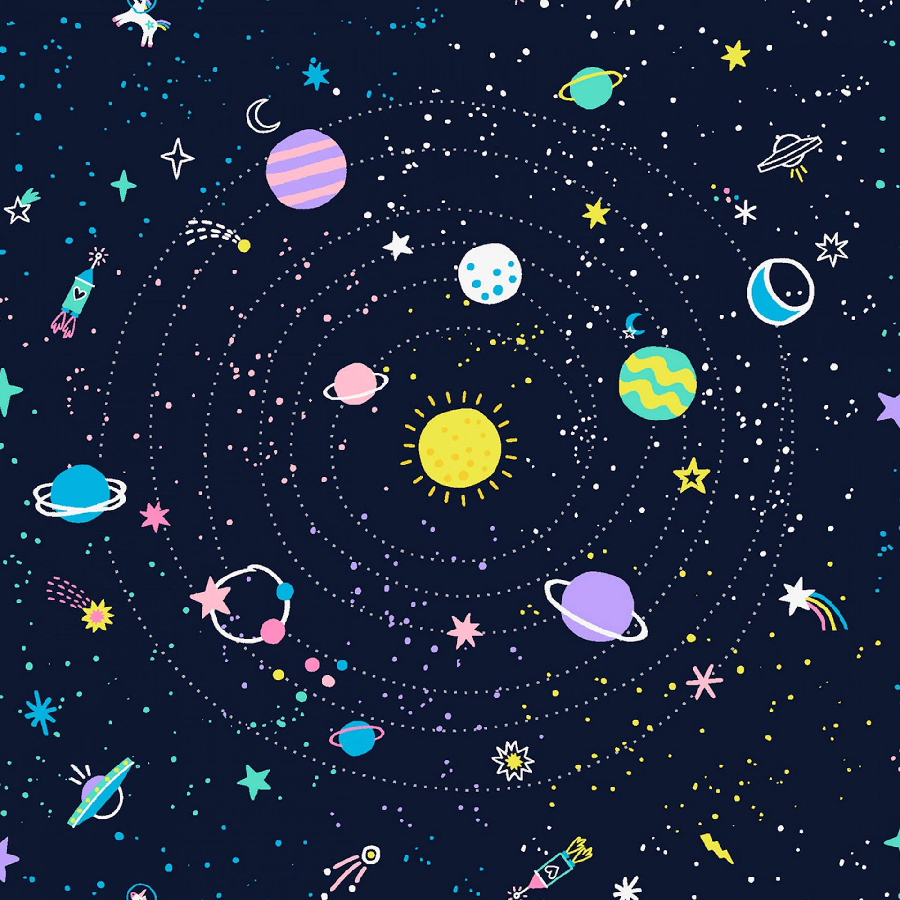  Solar system 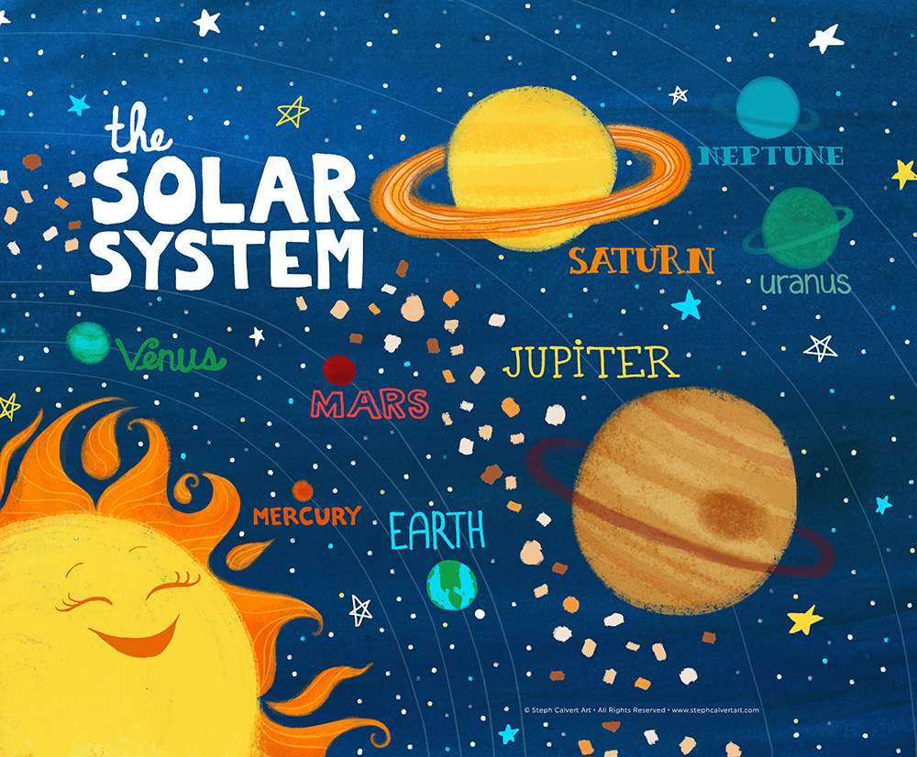  Telescope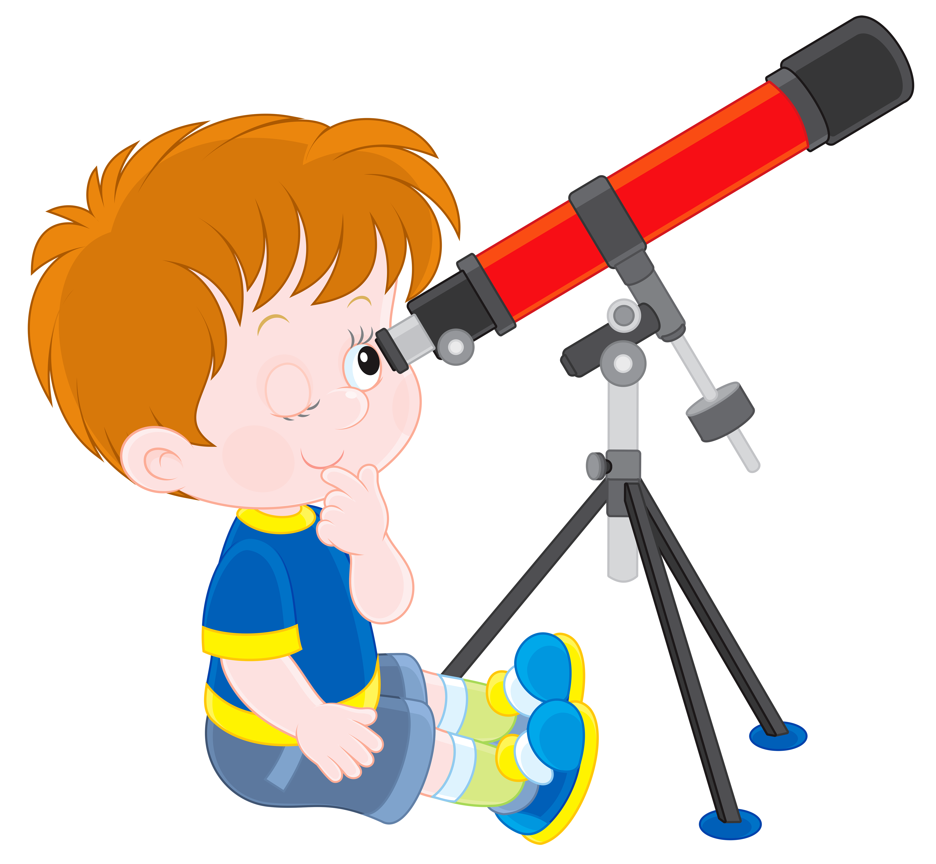  Spacesuit  Ailien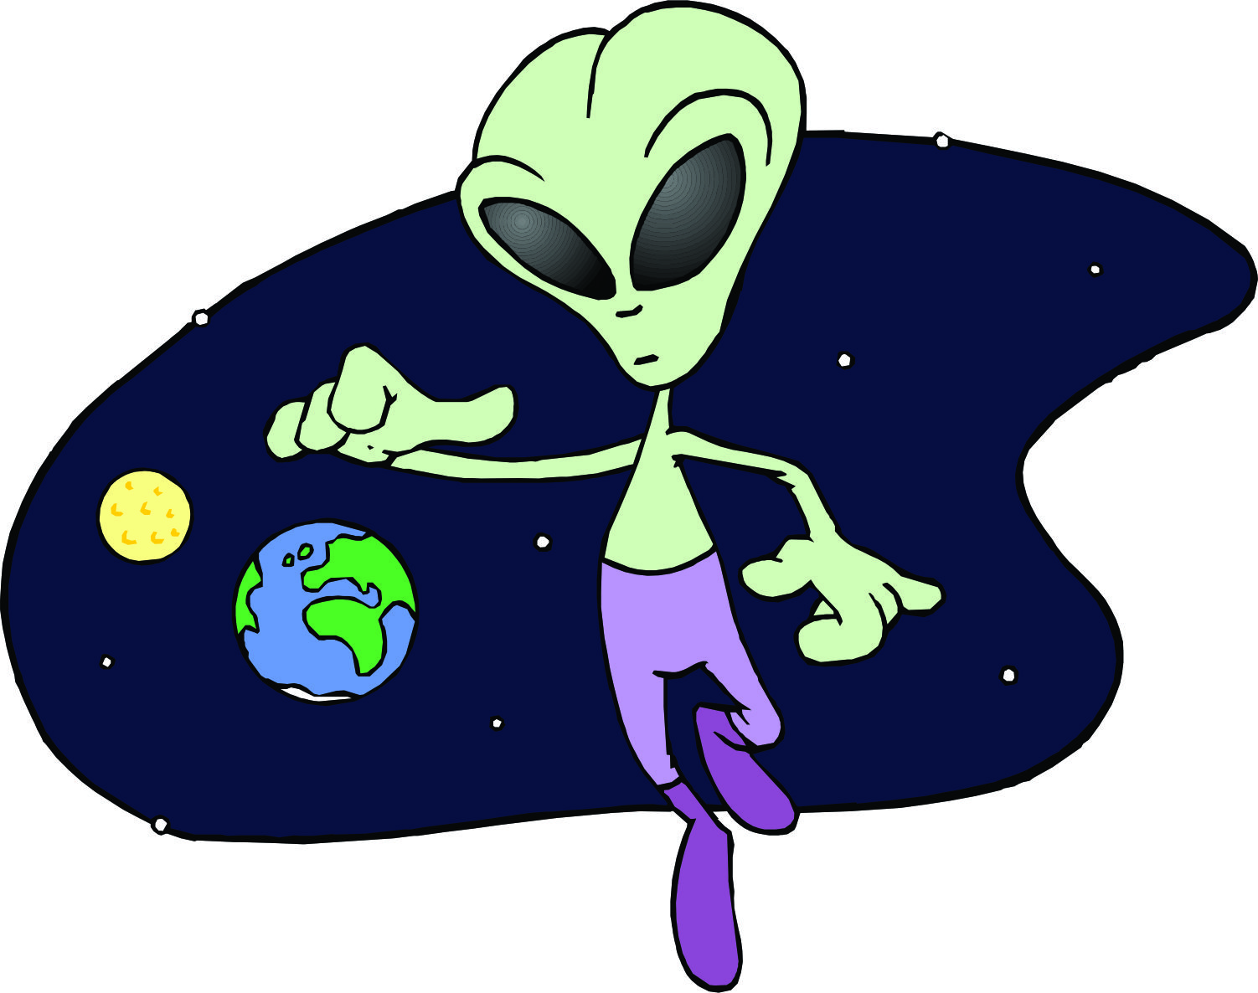  Planet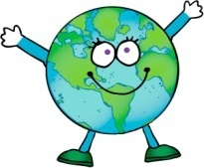  Astronaut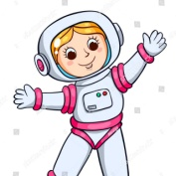  Spaceship  Comet   Task.3 Pre –reading task.  Now listen and read the text about space.  Post- reading task.  After reading answer the questions.  CCQ :  - 1. Where do we live?  - 2. What is the closest planet to the sun?  - 3. Which planet is extremely hot?  - 4. Which planet has the same size as Earth?  - 5. Which planet is bigger than the moon?  Differentiation by teacher`s support (teacher can help to construct the sentence using the modeling:  Example: This is a third planet from the sun in Solar System  This is____ planet from the sun in ________)  Task4.  Modeling: Teacher asks students to write their own 5 sentences in mini groups about any planet in Solar System using the previous text as an example.  Differentiation by teacher support( teacher gives the sentence structures and some instructions in addition. Teacher gives more time to do the task. ) | Students greet teacher. Everyone choose and show the smile to whole class which describes their emotional mood at that moment of a lesson.  Step 1. For two minutes, the student fills in the passes individually.  Step 2. The next two minutes, students work in pairs, check answers with each other, help, advise each other.  Step 3. Two minutes of work in mini-groups. Students have time to check the answers against each other.  Students listen to the words twice, repeat them and show the words by the gestures.  Students listen and read the text and answer the questions at will or in turn.  Group assessment.  Students divide into 3 groups, choose the planet and write down the information. It is allowed to use the Internet.  Students should present their work to the class. | Self- assessment  Feedback. Teacher-students.  Thank you! I hope that today in the lesson everyone will work well and by the end of the lesson everyone will be in a good mood  Formative assessment  Individual task  Pair –assessment  Group assessment  Assessment criteria  - To complete the sentences using familiar vocabulary.  Descriptor  A learner:  Use appropriate subject-specific vocabulary while writing.  Total physical response  Assessment criteria  - Identify initial, middle and final phonemes and blends  Descriptor  - A learner:  Listen and repeat the new words correctly  Feedback. Teacher- students.  Well done!  You had a good result!  Try again!  Assessment criteria  Identify key words in sentences of a Solar System text and identify details of a text.  Descriptor  1-Earth  2- Mercury  3- Mercury  4-Venus  5-Earth  (5 points)  Assessment criteria  Write words correctly which refer to the Solar System and make sentences with them.  Descriptor  A learner:  -Writes correctly the familiar words  -makes sentences with familiar words | Handout 1. Cards with smiles.  Handout 2.  Sheet of paper with the first task  Handout 3.  Pictures with new words  Handout 4.  Audio material:  https://english-practice.net/practice-listening-and-speaking-english-for-daily-communication-the-planets-of-our-solar-system/
Ending of the lesson | At the end of a lesson I propose you to make a cluster  on the Space topic. Write all you have learned about space in a brief form, in one or two words.  Space  At the end of our lesson you can write down your home work. It will be page70 in your activity book. Don`t forget to learn the new words.  Our lesson is over. Have a good day! Goodbye! | Students go to the board and write the words which have association with the space.  Pupils listen the teachers instructions and say goodbye to him(her). | Individual work  Assessment criteria  - To fill the cluster using familiar vocabulary.  Descriptor  A learner:  Use appropriate  subject- specific vocabulary while writing. | Handout 5.  Cluster on the board

