Внеклассное мероприятие по английскому языку для 6-7 классов «Victory Day»
Цели: активизировать фонетические и лексические навыки; развивать навыки чтения; прививать чувство патриотизма, любви к Родине; воспитывать у учащихся чувство ответственности за судьбу Родины; развивать уважение и признательность к людям, отдавшим жизни за мир на земле; утверждение общечеловеческих нравственных принципов.
Ход занятия
Этапы занятия | Деятельность учителя | Деятельность учащихся
1 Организация начала урока | Good afternoon boys and girls. I`m glad to see you. Sit down, please. | Приветствуют учителя.
2 Определение темы занятия | Now listen to the song(звучит песня День Победы на английском языке)  How do you think, what about we will speak today?  The topic of our meeting is “Victory Day” | Слушают песню.  Определяют тему занятия.
3 Разминка | Look at the screen. Let`s read these words.  Defeat  Victory  Influence  Soldier  To commemorate  Enemy  To surrender  Repeat these words three times.  Now match these words to their definitions (таблица на карточке Приложение 1)
4 Актуализация знаний | (Подготовленный заранее ученик рассказывает стихотворение “War is full of people dying” на английском языке)  War is full of people dying,  War is full of relatives crying,  Peace makes people happy, not sad,  Things like Peace are good, not bad.  War is dismal, dark and bloody,  In trenches deep, but small and muddy.  Peace is beautiful, quiet and clean,  When people are kind, no one is mean.  War is terrible, no matter what kind,  Peace is a lot nicer, I`m sure you`ll find.  Peace and happiness come hand in hand,  Sparkling and golden like the desert sand.  Peace and joy are like a team,  Each one like a bright sunbeam.  Eighty years ago our grandfathers and great-grandfathers won the Great Patriotic War. Thanks to our country the Second World War ended and peace was restored. Let's honor their memory with a minute of silence. Почтим их память минутой молчания. | Слушают стихотворение.
5 Составление монологического высказывания по картинке | Now children look at the pictures. What can you see at these pictures?  Describe these pictures. (Картинки для описания Приложение 2)  It`s time to work in groups.  1 – describe the picture 1.  2 – describe the picture 2.  You can begin with these words: I want to tell you about the picture number 1. On this picture we can see …(кто изображён на картинке)  This is a plan (на карточке)  1 the place (место, где человек находится)  2 the action (действие, что человек делает)  3 the person`s appearance (внешность, как человек выглядит)  4 whether you like the picture or not (нравится вам картинка или нет)  5 why (почему вам нравится картинка или почему не нравится) | Рассматривают картинки.  Составляют рассказ по картинке.  Работают в группах.
6 Аудирование | Now let`s do the listening task. Listen to the song “Katusha” in English and choose the words to complete this song (на карточке Приложение 3)  You hear this song 2 times.  Apple trees and pear trees were a (shower, flower)  River mist was rising all around.  Young Katusha went strolling by the hour  On the steep (banks, thanks)  O'er the rocky ground.  By the river's bank she sang a love song  Of her hero in a distant land.  Of the one she'd dearly loved for so (strong, long),  Holding tight his letters in her hand.  Oh, my song, song of a maiden's true love,  To my dear one travel with the (sun, run)  To the one with whom Katusha knew love,  Bring my greetings to him, one by one.  Let him know that I am true and faithful,  Let him hear the love song that I (send, friend).  Tell him as he defends our home that grateful,  True Katusha our love will (trend, defend).  Check yourself.  Now let`s sing this song all together. | Слушают песню «Катюша» и выбирают пропущенное слово, чтобы заполнить пропуски.  Выполняют самопроверку.
7 Прослушивание стихотворений | People wrote not only songs about the war, but also poems. The most famous poem about the war is “Wait for me” You`ve probably heard it. Let`s remember this poem. (на слайде - слова из стихотворения и аудиозапись чтения стихотворения на русском)  Жди меня, и я вернусь.  Только очень жди,  Жди, когда наводят грусть  Желтые дожди,  Жди, когда снега метут,  Жди, когда жара,  Жди, когда других не ждут,  Позабыв вчера.  Жди, когда из дальних мест  Писем не придет,  Жди, когда уж надоест  Всем, кто вместе ждет.  - . Wait for me, and I'll come back!  Wait with all you've got!  2. Wait, when dreary yellow rains  Tell you, you should not.  3. Wait when snow is falling fast,  Wait when summer's hot,  4. Wait when yesterdays are past,  Others are forgot.  5. Wait, when from that far-off place,  Letters don't arrive.  6. Wait, when those with whom you wait  Doubt if I'm alive.  - . Wait for me, and I'll come back!  Wait with all you've got!  2. Wait, when dreary yellow rains  Tell you, you should not.  3. Wait when snow is falling fast,  Wait when summer's hot,  4. Wait when yesterdays are past,  Others are forgot.  5. Wait, when from that far-off place,  Letters don't arrive.  6. Wait, when those with whom you wait  Doubt if I'm alive.  - . Wait for me, and I'll come back!  Wait with all you've got!  2. Wait, when dreary yellow rains  Tell you, you should not.  3. Wait when snow is falling fast,  Wait when summer's hot,  4. Wait when yesterdays are past,  Others are forgot.  5. Wait, when from that far-off place,  Letters don't arrive.  6. Wait, when those with whom you wait  Doubt if I'm alive.  - . Wait for me, and I'll come back!  Wait with all you've got!  2. Wait, when dreary yellow rains  Tell you, you should not.  3. Wait when snow is falling fast,  Wait when summer's hot,  4. Wait when yesterdays are past,  Others are forgot.  5. Wait, when from that far-off place,  Letters don't arrive.  6. Wait, when those with whom you wait  Doubt if I'm alive.  - . Wait for me, and I'll come back!  Wait with all you've got!  2. Wait, when dreary yellow rains  Tell you, you should not.  3. Wait when snow is falling fast,  Wait when summer's hot,  4. Wait when yesterdays are past,  Others are forgot.  5. Wait, when from that far-off place,  Letters don't arrive.  6. Wait, when those with whom you wait  Doubt if I'm alive.  This poem has been translated into many world languages including English. Listen to this poem.  Wait for me, and I’ll be back,  Should you wait me strong.  Wait for me when sky is black  And the sun has gone,  Wait for me when it is cold,  And when it is hot,  Wait for me when others don’t,  ’Cause they just forgot.  Wait in case you don’t receive  Letters from the front,  Wait, and I will outlive,  If you really want.  Wait for me, and I’ll be back.  Don’t you talk to those  Gluing me a dead man tag.  That’s a wrong suppose.  Let my relatives believe  That I am the past,  Let my friends forget and give  Funeral repast.  They will drink a glass of wine  For the peace of soul...  You just wait and don’t make time,  Do not raise the bowl.  Wait for me, and I’ll be back,  Disregard the fate,  In the morning with my bag,  Should you only wait.  They will hardly understand,  How I could survive.  Waiting me from foreign land,  You have saved my life.  Let them say that it’s too late.  What you feeling tells?  I’ll be back, because you wait  Like nobody else. (Подготовленный заранее ученик рассказывает это стихотворение на английском языке) | Вспоминают стихотворение К. Симонова «Жди меня и я вернусь».  Слушают это стихотворение на английском языке.
8 Работа по грамматике, словообразованию и развитие социокультурных компетенций | Many countries took part in World War II. Name me these countries.  Look at the screen. You can see countries, nations and languages. Fill in the table with the missing information (на слайде - названия стран, наций и языков; таблицы -на карточках)  Russia, Italian, the British, the USA, Poland, English, the Americans, the UK, the Polish, the Russians, Polish, the Italians, Italy, Germany, the French, English, Japan, the Japanese, French, the Germans, Russian, Japanese, German, France  In our country there are memorable sights. Look at the photos and find the name of the place in the photo. Give the Russian equivalents to them (фото – на слайде)  Red Square  The Kremlin  The Tomb of Unknown Soldier  Motherland Calls Monument (на карточке Приложение 4) | Заполняют таблицу, используя предложенные названия стран, наций и языков.
  Country | Nations | Language
  Russia
8 Работа с текстом | Victory Day is Russia's main national holiday. Let`s read the text and learn some information about the traditions of the celebration Victory Day. (текст – на карточках)  Victory Day  In Russia and other countries Victory Day, or 9th May, is one of the great holidays of the year. It is a holiday of all people. In all towns there are decorations, flags and posters in the streets, in the shop windows and on the front of large buildings. On Victory Day morning there are meetings and demonstrations of the veterans who fought in the Great Patriotic War. On that day there is military parade in all big cities of our country. Flowers and souvenirs are given to those who took part in the Great Patriotic War. There are a lot of people in the streets and squares, at theatres, cinemas and concert halls. They are all celebrating their holiday. Many people go to see their friends or go for walks in the parks. In the evening there is a holiday salute and a minute of silence to remember all those who did not come back from the war.  Are these sentences true or false?  1.Victory Day is celebrated only by Russia.  2. People prepare for Victory Day a lot.  3.There is military parade on Victory Day.  4. A few people celebrate Victory Day.  5. People like to see salute and follow a minute of silence to remember all those who did not come back from the war in the evening. | Читают текст и предложения после текста.  Определяют, верны ли утверждения после текста.
9 Итог занятия | And now you are to choose a smile – happy or sad – according to your attitude to today’s lesson. It you like our lesson and have learned a lot choose the green smile, please. If you like it but not very much choose the yellow smile, please. If you don’t like it choose the red smile, please.    The lesson is over. Thank you, dear guests and dear children! | Выбирают карточки со смайликами.  Осуществляют рефлексию.

Приложение 1
1 Defeat | a)Влияние
2 Victory | b)Враг
3 Influence | c)Почтить память
4 Soldier | d)Победа
5 To commemorate | e)Поражение
6 Enemy | f)Солдат
7 To surrender | g)Сдаваться

Приложение 2
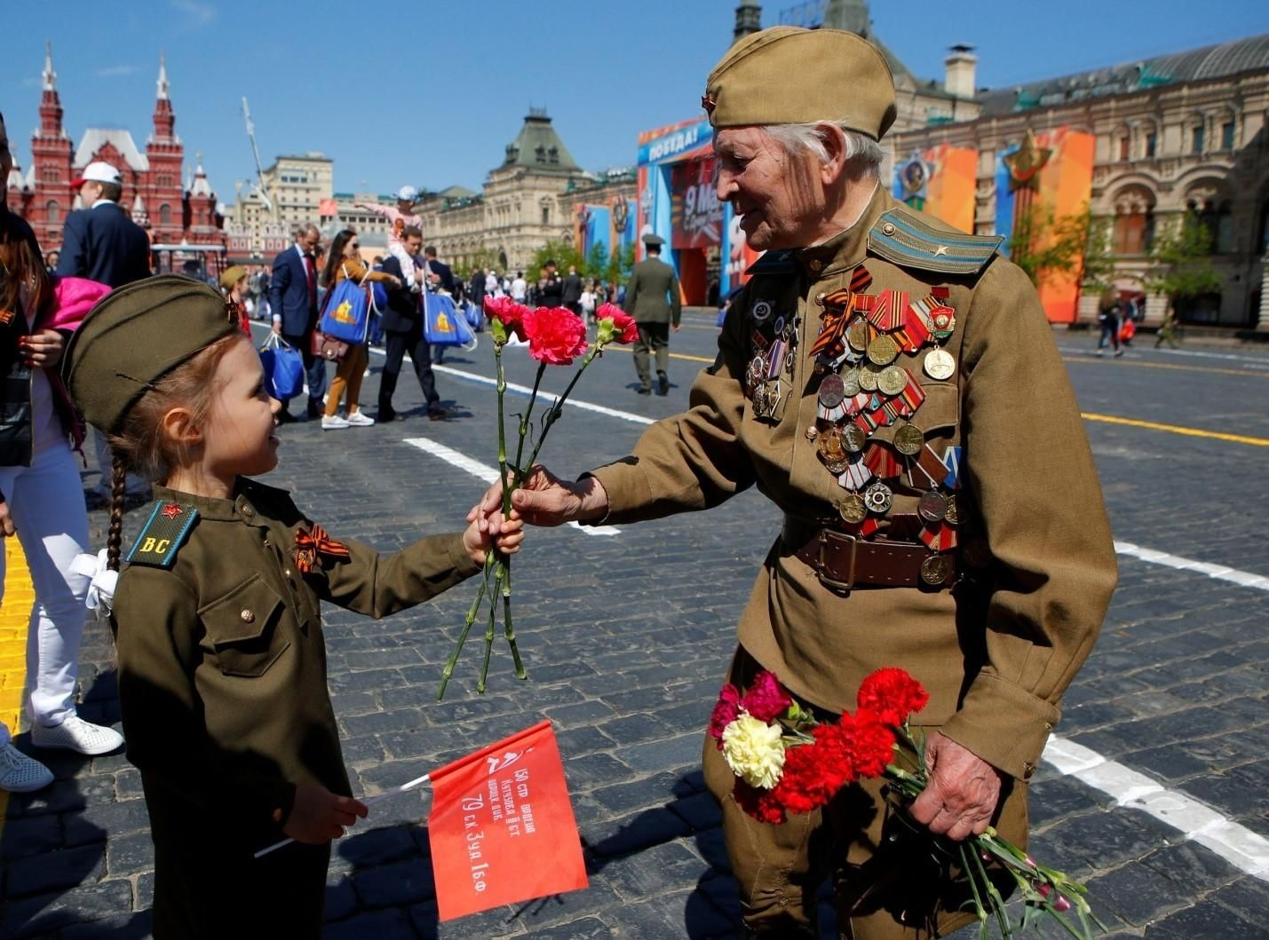
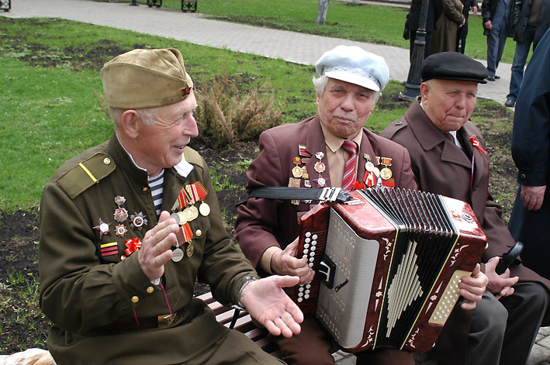

Приложение 3
Apple trees and pear trees were a (shower, flower)
River mist was rising all around.
Young Katusha went strolling by the hour
On the steep (banks, thanks)
O'er the rocky ground.
By the river's bank she sang a love song
Of her hero in a distant land.
Of the one she'd dearly loved for so (strong, long),
Holding tight his letters in her hand.
Oh, my song, song of a maiden's true love,
To my dear one travel with the (sun, run)
To the one with whom Katusha knew love,
Bring my greetings to him, one by one.
Let him know that I am true and faithful,
Let him hear the love song that I (send, friend).
Tell him as he defends our home that grateful,
True Katusha our love will (trend, defend).

Приложение 4


