Приветствие: (1мин)
Good morning children. I’m glad to see you. How are you today?
Sit down. Lets start our lesson.
Речевая разминка: (словесное облако) pre-reading
You have got a card with vocabulary. Find and translate the words from Russian into English.
Now translate from English into Russian
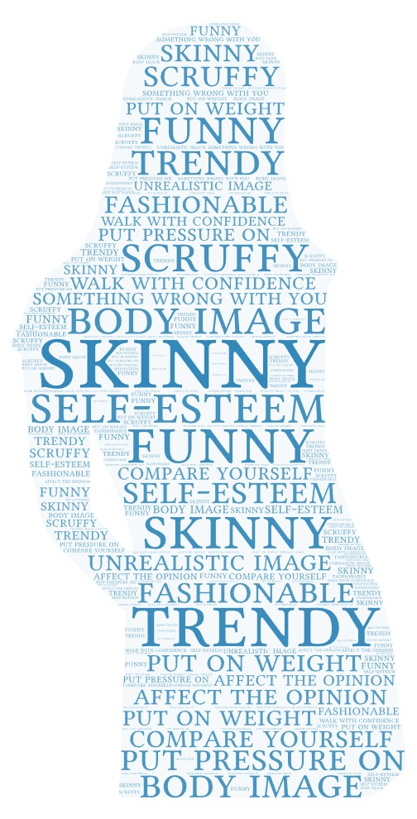
Now we are going to read the text. Read and do the task.
Чтение.
Tale the paper. Here you have a task. We are going to read the text. Match the texts with its headings, then decide whether statements true, false or not stated
Brainstorming
Now lets discuss some questions.
Проект
Its time to do a cteative task . Lets make a project.
You will work in groups.
Your task is to create , design, choose the clothes for occasions and create a dialogue.
Make up a dialogue, don’t forget about MATERIAL and PARTEN!
- Today we are going to the……(beach/ office/wedding party/camping/disco) I don’t know what to wear .
- Do you have anything in mind?
- I was thinking of wearing ….. ….. What do you think?
- Good idea. And what about….
- Thank you for you advice
- You will look….. (casual/ modern/ fashionable/gorgeous/ smart/elegant)

1) Headlines:
A. The Tyranny of the "Perfect" Pimple
B. The power of positive self-talk
C. Body image and the pursuit of thinness
D. Finding confidence in your own way
E. Social Media's influence
Texts:
1. Social media is full of perfect individuals, creating an unrealistic image that many young people compare themselves to. These images put pressure on you because you start to compare yourself. It can affect your self-esteem, leading to feelings of depression and anxiety. (тревожность). Also, social media and advertising draw attention to physical appearance. A single pimple can send some teenagers into a bad mood. It can affect your opinion of yourself and your confidence.
2. The fashion industry often promotes a narrow definition of beauty, leading people to feel that something is wrong with them if they don't fit that unrealistic image. Fashion is everywhere. We see it in magazines, on TV Fashion magazines and advertisements often show models who are too skinny, putting pressure on young people to change their body image. This can lead to extreme diets. Also, people become to obsessed with weight training. It causes serious health problems.
3. Clothes are important they show who we are, or who we want to be. Advertisements often show perfect models wearing beautiful clothes, making us believe that if we buy these clothes, we will be happy and popular. But is it true? Sometimes fashion can make us feel bad if we can’t afford the latest trends. It’s important to remember that true style is about feeling comfortable and confident in what you wear, not following every trend.
4. Not paying attention to this pressure, learn to walk with confidence. Remember that fashion standards change rather quickly. It’s rather expensive be on fashion. And trying to catch up with it you mustn’t forget about your individuality. Don’t forget about the power of self-acceptance and self-love. Being yourself is always fashionable. Clothes don’t make a man.
1 | 2 | 3 | 4
2) Now, decide whether the statement true, false or not stated.
1. Social media always presents realistic images of people
2. Fashion magazines always portray models who are too skinny
3. You can be disappointed by fashion
4. Be confident if you wear unfashionable clothes
3) Questions for discussion:
1 Do you try to keep up with the latest fashion or express your own style?
2 Do fashionable clothes really change the way the person looks?
3 What kind of clothes/material/patterns/ do you like to wear?
4 What kind of clothes do you wear when you go on special occasion?

