Промежуточная контрольная работа по английскому языку
5 класс (углубленный уровень)
А. Vocabulary
Choose the correct item.
1. Anna is good ........ basketball.
A for B to C from D at
2. Tom is a(n) ........ at the local restaurant.
A architect B electrician C vet D waiter
3. The Maasai people are an African ........ .
A tribe B nation C group D team
4. J.K Rowling is a famous ........ . Her books are amazing!
A astronaut B electrician C author D fire fighter
5. He isn’t fat, he’s just a little ........ .
A middle- aged B of medium height C plump D fair
6. Her favourite day of the week is ........ .
A October B Sunday C May D April
7. You can see the New York ........ from the top of the skyscraper.
A view B sight C skyline D shape
8. The hotel is ........ with tourists.
A unique B simple C popular D unusual
9. Go to the ........ and get me some medicine, please.
A florist’s B baker’s C butcher’s D chemist’s
10. There are a lot of plants in the ........ .
A beach B desert C forest D waterfall

B. Complete the sentences with the correct word.
dark , friendly, cosy, dream, stamps, sink, bath, landmark, house, cliff, wealth, river, hero, home.

1 My .................... is to become a famous actress.
2 The Leaning Tower of Pisa is a famous ........... .
3 My .................... is the famous tennis player, Serena Williams.
4 In many cultures, gold jewellery is a sign of ........................ and beauty.
5 Many people from Africa have got .................... skin.
6 Wash the dishes in the …. , please.
7 There is a boat on the …. .
8 Their house it …. to the environment.
9 The city is …. to three million people.
10 At the post office you can buy … .

С. Grammar
1. Jane is ........ than Mary. A tall B taller C tallest
2. ........ names are Daniel and Jim. A They B Their C His
3. Pedro ........ Spanish. He’s Mexican. A isn’t B aren’t C ‘m not
4. They ........ got a computer. A ‘s B ‘m C ‘ve
5. This is my notebook. ........ blue. A Its B It’s C It
6. Hockey is the ........ sport in Canada. A popular B more popular C most popular
7. Anna and Celeste are from Italy. ....... are Italian. A Their B They C We
8. This is Peter. ........ favourite sport is tennis. A He B His C My
9. ........ a carpet on the floor? A There are B There is C Is there
10. ........ cameras are very expensive. A That B These C This
11. There are some ........ in the garden. A leaf B leaves C leafs
12. Walk ........ the bridge and turn right. A into B over C through
13. Is there ........ baker’s in your neighbourhood? A the B – C a
14. Ted is ........ the dining room. A on B in C under
15. There aren’t ........ pillows on the bed. A some B any C the

D. Reading
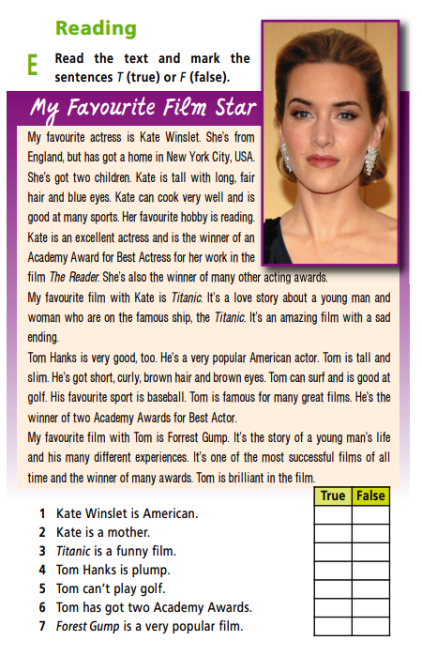

Ключи к промежуточной контрольной работе английскому языку за I полугодие
2024-2025
1 .Система оценивания отдельных заданий и работы в целом
Максимальное количество баллов, которое может получить обучающийся – 42 б.
Каждый правильный ответ в задании оценивается в 1 балла. За неверный ответ или его отсутствие выставляется 0 баллов. Исправления, сделанные обучающимися, ошибкой не считается. Работа оценивается по пятибалльной системе.
2 . УМК - Starlight 5 (Звездный английский. 5 класс). Учебник - Баранова К.М., Дули Д., Копылова В.В. и др. для учащихся 5 класса общеобразовательных организаций и школ с углублённым изучением английского языка.
3 . Критерии оценивания заданий.
«отлично» – 42 – 36 баллов;
«хорошо» – 35 – 29 баллов;
«удовлетворительно» – 28 – 21 баллов;
«неудовлетворительно» – 20 и меньше

Keys
А.  - d  - d  - a  - c  - c  - b  - a  - c  - d  - c | B.  - dream  - landmark  - hero  - wealth  - dark  - sink  - river  - friendly  - home  - stamps | C.  - b  - b  - a  - c  - b  - c  - b  - b  - c  - b  - b  - b  - c  - b  - b | d.  - f  - t  - f  - f  - f  - t  - t

