План урока для 8 класса:
Учитель:
Класс: 8
Тема урока: Jobs of the future:
Тип урока: урок «открытия» новых знаний с применением ИКТ технологий.
Форма урока: комбинированный.
Оборудование: учебник «Spotlight», доска, интерактивная доска, ноутбук, карточки.

Цели урока:
Oбучающие: развивать навыки говорения о разных профессиях, работе; тренировать в чтении с целью извлечения информации, способствовать расширению словарного запаса, умения использовать лексику и грамматический материал в речи и на письме;
Pазвивающие: развивать ууд во всех видах речевой деятельности, развивать умение работать в группе, способствовать умению выражать мысли;
Воспитательные: Воспитывать уважение к людям разных профессий, прививать воспитание любви к труду, работы в коллективе.
Содержание:
- Warm-up
- Lead-in
- Vocabulary practice
- Reading and discussing
- Vocabulary/collocations
- Grammar for lesson
- Grammar practice
- Sum up
- Home work

1.Warm Up
Начинаем warm-up с обсуждения цитаты:
“Choose a job you love, and you will never have to work a day in your life.”
© Chinese philosopher Confucius
Обсуждаем ее с учениками, задавая вопросы:
- Do you agree with this quote? Why?
- Is it hard to choose a job for a teenager? Why?
- What was your dream job in the childhood?
- Well, during this lesson we will find out a lot of cool jobs, train some skills and try to choose the dream job for you.

2. Lead in
Учащиеся получили информацию о теме урока, продолжаем вовлекать их в коммуникативную деятельность.
Let us read a message from a teenager who has similar problems.
Hi!
My name is John, I’m 13.
I am so miserable as I do not have enough pocket money if I want to buy something. My parents do not always give it to me. I think I should earn money myself and look for job opportunities but I do not know where to start.
- Can you help me?
- What is John’s problem?
- What should we do?

3.Vocabulary practice
What professions do you know? Here is a pictures of jobs. Match the names of the professions with their images and definitions:
1 2  3 
4 5  6 

7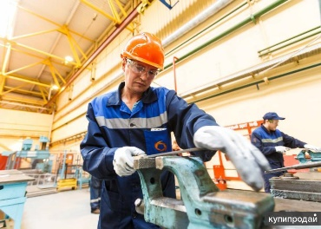 8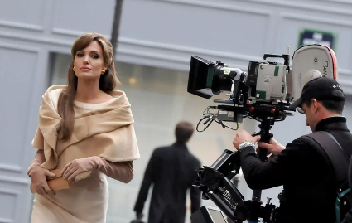 9 

10  11  12 
13 14  15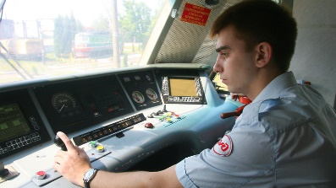
16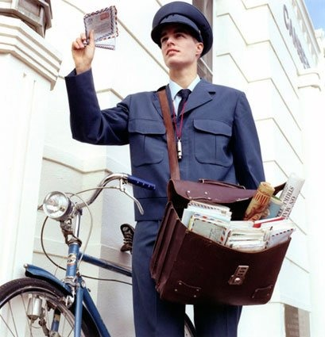

- Journalist
- Bricklayer
- Carpenter
- Manager
- Postman
- Engine-driver
- Plumber
- Calling
- Designer
- Nurse
- Pilot
- Interpreter
- Actor/Actress
- Locksmith
- Musician
- Architect

- a strong inner urge to follow an occupation, etc.; vocation
- a person who directs or manages an organization, industry, shop, etc
- a person trained or skilled in laying bricks
- a person who drives a railway locomotive; train driver
- a person who works in or takes care of a garden as an occupation or pastime
- a person who makes or repairs locks
- a person skilled in woodwork, esp in buildings, ships, etc
- a person who tends the sick, injured, or infirm
- a person who installs and repairs pipes, fixtures, etc., for water, drainage, and gas
- a person who acts in a play, film, broadcast, etc
- a person qualified to design buildings and to superintend their erection
- a person whose occupation is journalism
- a person who plays or composes music, esp as a profession
- A person whose work is to translate from one language to another in the oral form
- a person who is qualified to operate an aircraft or spacecraft in flight
- a person who carries and delivers mail as a profession

4. Reading and discussing
Let us read two stories how teenagers found work and got work experience.
Mary, 14
I didn’t know what to do to get some work experience. So, I spoke to my aunt, who is the owner of a shop. So I worked part-time there helping to arrange goods on the shelves. I worried and wasn’t sure I would be able to do the work. But all the staff helped me a lot and explained well. I learnt a lot of interesting things and know how a shop works from inside. I think that it was really important for me to get work experience because, thus, you can understand what employees actually do.
Peter, 13
I could not find any work during my summer holidays but all my neighbors know that I love pets so much. Every morning I walk my dog because I am a very responsible person. Some neighbors are very busy and do not have time to walk their dogs long enough. Others had holidays and did not have anyone to take care of their pets. There are also senior people who need some help with their pets. So, I did volunteer job but all people were kind to me and thanked me with some pocket money. So I saved enough to buy a new smartphone. I was helpful and not lazy. This work experience I got gave me some business ideas for future.
A. Who said it?
- I worked part-time. (M)
- I did volunteer job. (P)
- You can understand what employees actually do. (M)
- This work experience gave me some business ideas for future. (P)
- I saved enough money. (P)
B. Answer True / False
- Mary’s mum is the owner of the shop. (F)
- Mary helped to arrange goods on the shelves. (T)
- Mary did not understand what employees do in the shop. (F)
- Peter earned money walking dogs of neighbors. (T)
- Peter spent all money on ice-cream and cinema. (F)
- Peter does not have any ideas for future. (F)
C. Answer the questions.
- Where did Mary work?
- Where did Peter work?
- Did Mary like her experience? Was it useful? Why?
- Did Peter earn enough? What did he buy?
- Are these children responsible? Are they lazy?
- Did they spend their summer productively?

5. Vocabularly/Collocations
Let us have a look at three words: Job/ Work/Career
Read definitions.
A job is a regular and official activity that you do and earn money from.
It is also called a profession or an occupation.
You can have a full-time job or a part-time job.
The word «work» is more general than «job». It refers to general efforts and activities you do to reach a goal.
The word «work» also refers to the context of a place of employment.
We also use the word «work» as a verb in a context to do something as part of a job. We use it as a noun.
- I start work at 7 am. (not I start my job at 7 am.)
- I usually work from 10 am to 6 pm.
- A career is the total progression of a person’s professional life.
- You can have a career in a field.
- John has a career in politics.
A) Sort collocations.
job | work | career
to start,
to get salary from,
a well-paid,
to have a … in medicine,
to finish,
a low-paid,
a part-time,
a full-time,
a brilliant, a short.
B) Fill in the gaps.
- I start _____ at 9 o’clock.
- He gets _____ twice a month.
- My friend has a _____ in medicine. He is a famous doctor.
- My parents never finish _____ in time. They always overwork.
- All teenagers dream about well-paid _____ in future to be successful in life.
- Some students have a part-time _____ because they study.
- This footballer has got a brilliant _____. He is one of the most expensive players in the world.
Физкультминутка (https://www.youtube.com/watch?v=SrBowY8QPhc&list=RDbRpMZUylwfY&index=9)
6.Grammar for lesson
Отработаем простое будущее время (Future Simple).
Утверждение: will + смысловой глагол:
I will (I’ll) work as a bioengineer.
In the future we will (we’ll) have flying cars.
Отрицание: will + not + смысловой глагол:
I will not (I won’t) work as a bioengineer.
In the future, we will not (we won’t) fly cars.
Вопрос: will + подлежащее + смысловой глагол:
Will I work as a bioengineer?
Will we fly cars in the future?
Для лучшей отработки будущего времени используем слова-помощники:
tomorrow – завтра,
next week – на следующей неделе,
next year – в следующем году,
in two years (…days, …months…) – через два года (…дня, …месяца..).
7.Grammar practice
Exercise 1
Включаем видео “What will the future of jobs be like?“:
https://youtu.be/eH1fFdjzJAw
Предлагаю обсудить возможные будущие профессий, задавая наводящие вопросы:
- What professions (jobs) do you know?
- What professions do you think will appear after 2025?
- What professions can disappear after 2025?
Exercise 2
Заранее подготовила по теме карточки со словами и их определения на английском языке. Расположила их в разном порядке и попросила учеников подобрать слова и их точные определения.
Например, как тут:
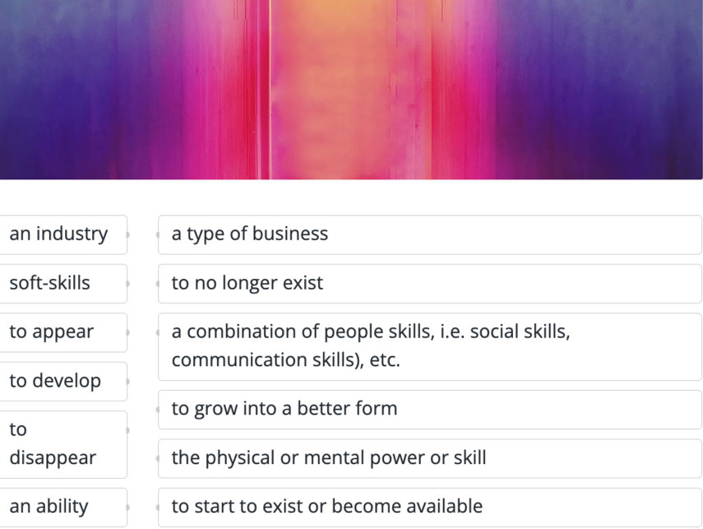

Exercise 3
Выполнение упражнения 2(а) стр.44 учащимся дается 3 минуты на выполнение этого упражнения, затем все вместе проверяют.
Выполнение упражнения 2(в)стр.44 учащимся дается 2 минуты на составления монологического высказывания о работе своих родителей.

Exercise 4
После общих обсуждений о будущем и профессиях поговорим о предпочтениях учеников и помогаю им приблизиться к выбору их профессий. Для разогрева рекомендую посмотреть вдохновляющую речь Стива Джобса https://www.youtube.com/watch?v=kWuDTSds_bI перед выпускниками Стэнфорда. Для беседы рекомендую использовать следующие вопросы:

- What criteria are important to me when choosing a job?
- What forms and types of activities are my priority?
- What do I want and what can I do?
- What format do I want to work in?
- What do representatives of the profession that interests me do?
- What are the disadvantages of this profession?
- Can I try to work now?
- Is there an actual chosen specialty in my city?
- What knowledge, skills and abilities are important for this profession?
- Which university to choose?
- What exams do you need to take? And how to increase the chances of admission?
- Will the profession be relevant by the time I graduate from the university?
Для обсуждения темы будущей профессии учеников также можно использовать вопросы:
- What kind of job would you like to have?
- What do you want to be and why?
- What do you need to have a good job?
- Is it difficult or easy to find a good job?

8.Sum up

Все о профессиях будущего на сайте “Atlas of Emerging Jobs”.
Worksheet “Revise the tenses for a successful job interview”.
Видео с международного экономического форума о профессиях и работе будущего “What is the Future of Work?”: hthttps://youtu.be/EuDnSqAo784ps://youtu.be/EuDnSqAo784
Видео “The World in 2050”:https://youtu.be/g_1oiJqE3OI

9.Нome work
упр.8 стр.45 (написать диалог о том, кем работают ваши родители с опорой на упр.3 стр.44)
Предлагаю ученикам дома так же поирать в интерактивную игру
https://www.eslgamesworld.com/members/games/vocabulary/memoryaudio/jobs%20high/index.html

