Викторина


Посвященная «Дню космонавтики» на английском языке для 5х классов.
- When did the first man fly into space?
- 12.04.1961
- 04.04.1961
- 12.04.1962
- What was the name of the first cosmonaut?
- German Titov
- Yuri Gagarin
- Alexey Leonov
- What instrument is used to study the starry sky?
- Telescope
- Мicroscope
- Periscope
- How many times did Yuri Gagarin circle the globe?
- Twice
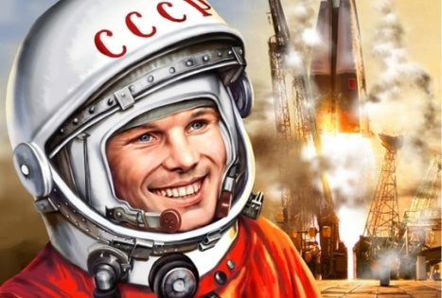
- Thrice
- Once
- How much time did Gagarin spend in space?
- 108 minutes
- 50 minutes
- 120 minutes
- Who was the first cosmonaut leaving the ship in outer space?
- German Titov
- Vladimir Komarov
- Alexey Leonov
- What was the name of Gagarin's ship?
- Vostok -1
- Vokhod -1
- West -1
- What was the name of the first woman cosmonaut ?
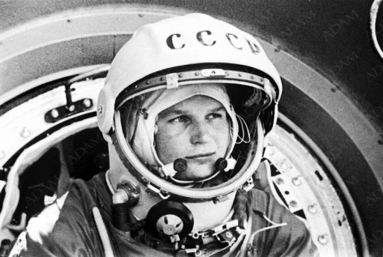
- Svetlana Savitskaya
- Elena Kondakova
- Valentina Tereshkova
- Who designed the first rocket?
- Konstantin Tsiolkovsky
- Sergey Korolev
- Andrey Tupolev
- What was the name of the first cosmonaut's dog that never returned from space?
- Laika
- Belka
- Strelka
- The Blue planet is ……….
- Earth
- Mars
- Jupiter
- Do the puzzle.
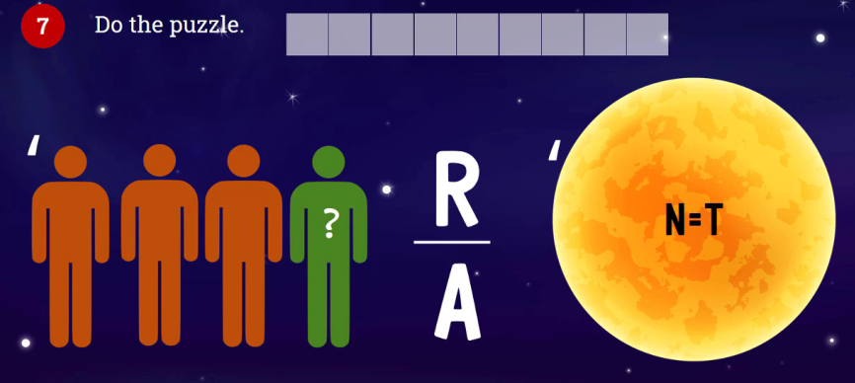
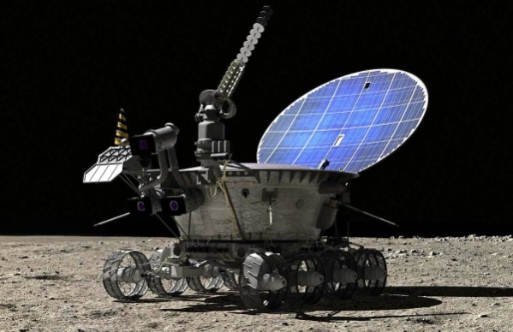
- What was first remote-controlled robot called? It was landed on another world in 1970 by the Soviet Union.
- The second letter in PLANET.
- The first letter in UNIVERSE.
- The sixth letter in COSMONAUT.
- The second/third letter in MOON.
- The fourth letter in MILKY.
- The seventh letter in ATMOSPHERE.
- The second letter in SOLAR.
- The first letter in DISTANCE.
- The smallest planet in the Solar system………
- Mercury
- Earth
- Venus
- The biggest planet in the Solar system ……….
- Uranus
- Saturn
- Jupiter
- Do the crossword. Find 8 «space» words.
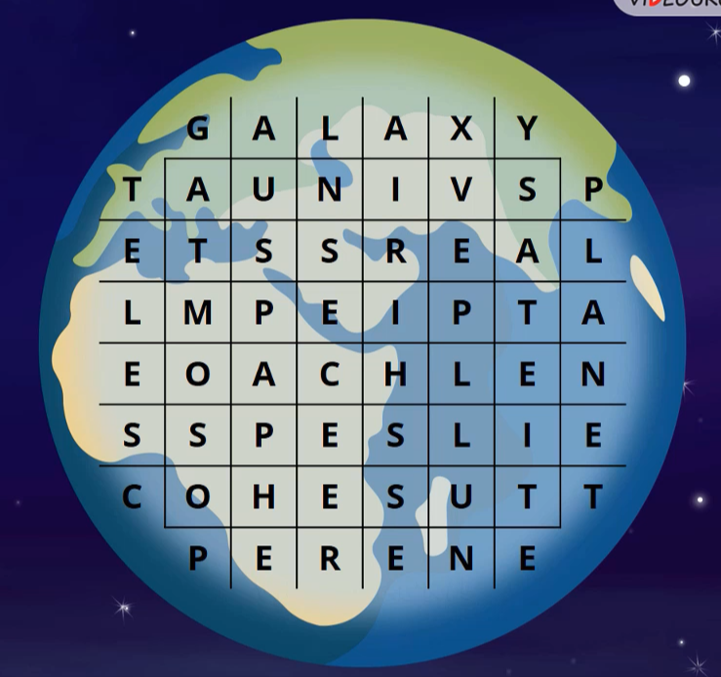
8..
7.
6.
5.
4.
3.
2.
1.

17) The first animals to make an orbital flight and return safely to Earth.
a) Belka and Strelka
b) Mars and Dezik
c) Ugolek and Veterok
18) Put the planets of the solar system in their order starting from the closest to the Sun.
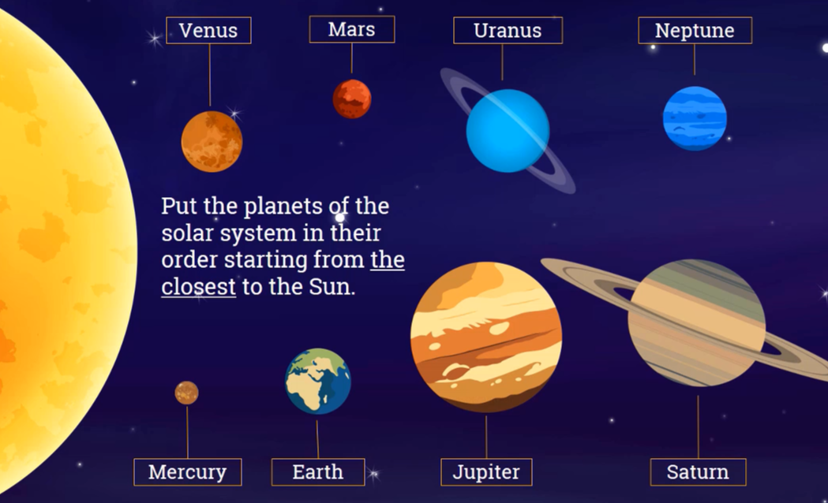
1._____________ 2.____________ 3.______________ 4.______________
5.______________ 6.______________ 7. ______________ 8.________________
THE END

