Тема: «Обобщающее занятие по предмету «Иностранный язык в профессиональной деятельности»;
Полное название разработки: «Обобщающее занятие по предмету «Иностранный язык в профессиональной деятельности для специальностей ППССЗ «Поварское и кондитерское дело» и «Технология продукции общественного питания»;
Область применения: английский язык;
Возрастная группа: 4-5 курс ППССЗ.
Форма урока: урок-соревнование.
Данная форма урока выбрана с целью повысить интерес студентов к изучаемому предмету, познавательную активность студентов и мотивировать их к общению на английском языке, охватить большой объем материала.
Тип урока: урок контроля и учета знаний.
Мы выбрали «урок контроля и учета знаний», так как он предоставляет наиболее широкие возможности для варьирования материала, раскрывает перед преподавателем возможность опираться на ранее полученные знания студентами и определить уровень владения лексикой.
Цели урока:
- образовательная: активизировать ранее приобретенные знания о видах меню, способах приготовления пищи, функциях работников ресторана, составление меню, сервировки стола, проконтролировать степень усвоения учебного материала и сформированность предметных, метапредметных умений.
- воспитательная: формирование личностных УУД в условиях решения учебных задач, развивать навыки чтения, говорения, посредством построения предложений, высказываний по опоре с использованием профессиональной лексики.
- развивающая: развитие познавательных, коммуникативных, регулятивных УУД, развитие положительного отношения к предмету, формирование эмоционально-чувственного восприятия культур зарубежных стран.
Место урока: завершающий урок.
Дидактические принципы: наглядность, научность, доступность, прочность, связь теории и практики.
Формы организации учебной деятельности: фронтальная, групповая, индивидуальная.
Оборудование: средства ТСО, раздаточный материал (рабочие листы «Приложение 1).
Структура урока:
- Организационный этап.
- Постановка цели и задач урока, планирование тактики. Мотивация учебной деятельности студентов.
- Решение проблемы (проверка сформированности у студентов общеучебных умений с использованием различных форм организации учебной деятельности).
- Самостоятельное (индивидуальное) выполнение заданий.
- Рефлексия (подведение итогов занятия, оценивание).
Ход урока:
Студенты разделяются на 4 группы. Первый этап – активизация лексики по теме «Персонал ресторана». Проверка владения лексикой и умение работать в команде.
Второй этап урока – повторение различных видов меню, составление меню по предложенной схеме с последующим представлением меню перед всей группой. На данном этапе студенты должны продемонстрировать владение профессиональной лексикой, основами критического мышления, умение составить небольшое монологическое высказывание.
Следующий этап урока – работа в группах по дополнению рецептов с использованием лексики по теме «Способы приготовления пищи.
Далее идет проверка знаний типов предприятий общественного питания, а также основных правил сервировки стола.
Заключительный этап – индивидуальное выполнение заданий с использованием интернет-сайта LiveWorksheets с автоматической проверкой и отправкой результатов каждого студента на электронную почту преподавателя (https://www.liveworksheets.com). Тест был заранее разработан преподавателями. Ссылка на итоговый тест: https://www.liveworksheets.com/dx2913144hj.
Рабочие листы - «Приложение 1». Ключи к рабочим листам – «Приложение 2».

Приложение 1.
1) MATCH THE RESTAURANT STAFF WITH ITS RESPONSIBILITIES

Restaurant staff | Responsibilities
- chef de cuisine (head chef) | - He substitutes the sous chef in smaller restaurants. They are technicians, who prepare the dishes, check the quality of raw materials and the maintenance and hygiene of the equipment and premises like the sous chefs. Besides that, he assigns the tasks, manages orders and deliveries from suppliers.
- sous chef | - He manages the kitchen, gives directions on dish preparation, takes decisions about portions and service to the public, he is responsible for planning menus and buying raw materials.
- chef de partie | - He is second in command and supervises service in a particular area of a restaurant, but in smaller restaurants carries out the tasks of the maitre d'hotel.
- commis chef | - He is responsible for managing bookings, finding tables for customers, assigning serving areas to waiting staff and supervising their work as well as dealing with any customer complaints.
- maitre d'hotel | - He is responsible for the overall running of a restaurant: planning the menu with the chef de cuisine; creating the right atmosphere; hiring staff; managing bookings; and meeting and greeting customers.
- head waiter | - He supports the chef de cuisine and substitute him/her when absent. He also checks maintenance and hygiene of equipment, as well as communication between the different kitchen sectors.
- captain (chef de rang) | - He is responsible for running one area of the restaurant and supervising the work of two or three staff members. In particular the communication between the kitchen and the front-of-house, allocating tasks and monitoring service.
- waiter | - They do basic tasks such as clearing tables or bringing bread and water to the tables.
- busboys and busgirls | - He works at an operational level. He takes care of meal preparation, organizes basic ingredients and carries out simple activities during the preparation of dishes. He must also check quality of products, quantity of food and correct functioning of equipment.
- food and beverage manager | - He prepares drinks for customers during their meal, giving them to the waiters to take to the tables.
- host/hostess | - He is responsible for choosing wines, recommending and serving them to customers.
- wine waiter (sommelier) | - He serves the customers during their meal by taking orders, setting the tables and bringing out food when it is ready.
- bartender | - He takes bookings, welcomes customers to the restaurant and shows them to their tables.

2) STRUCTURE OF THE MENU
Look through the scheme of the menu and try to complete it correctly. Write your ideas for dishes.

Black tea, green tea, black coffee, white coffee, latte.
Borshch, okroshka, cream cheese soup, chicken soup with noodles.
Soups
Beverages/ drinks

3) TYPES OF MENUS
- Тable D’hote | - This menu is a list of dishes that are served on this day only. Customers can choose from this list which may be given to them as a menu card. It means «a dish of the day.
- Cycle menu | - This menu allows the customer to choose the number and type of dishes. This menu has a list of all dishes, arranged in courses and each dish has its price. The dishes are cooked in order.
- A La Carte | - It usually offers a limited choice of dishes. Three or four dishes are offered in each course and the guest pays a fixed price for the whole meal, «business lunch», for example. It is named “hosts` table”
- Card Du Jour Menu | - It is a group of menus, which are repeated in a certain cycle.  This menu can be weekly, bi-weekly or monthly.

Read the recipe 3 “Okroshka (serves 4)” and complete with the cooking verbs:

Wash, add, are diced, put (x2), can add, slice, are cut, keep.

Ingredients:
1 liter kvass,
100 gr boiled beef or boiled sausage,
50 gr lean ham,
2 hard-boiled eggs,
1 medium size fresh cucumber,
100 gr spring onions.

1)____________ cucumber and spring onions and 2)_____________ them. Boiled beef and ham 3)_____________. Hard-boiled eggs 4)__________ into large pieces. Put everything in the kvass and 5)___________a salt to taste. You 6)_________ a little potato boiled and diced. Before serving 7)______ okroshka in a cool place or refrigerator for 2 hours. When serving okroshka 8)_____ two spoonfuls of thick sour cream and shredded parsley and dill into each plate.

Read the recipe 1 “Green beans with olive oil and

tomatoes (serves 4)” and complete with the cooking verbs:

Bring, add, cook (x2), boil, season, simmer, drain, heat, cool.

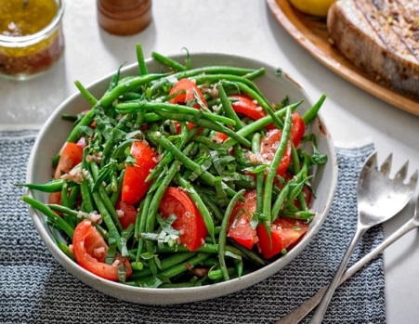
Ingredients
400-500g green beans
2 red onions, peeled and chopped
3-4 tablespoons extra virgin olive oil
4 chopped tomatoes, basil leaves
Salt and freshly ground black pepper
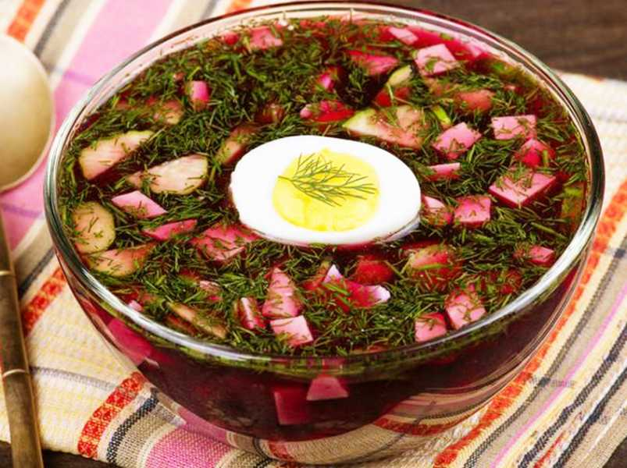

1)_________ a pan of lightly salted water to 2)_________. 3) _________ the green beans for 2 minutes and 4)________ them. Meanwhile, 5)_______ a little olive oil in a pan and gently 6)______ the onions for 3-4 minutes until soft. 7)______ the tomatoes, beans and a few basil leaves. 8)________, cover with a lid and let 9)___________ for 30 minutes. Give the beans a stir every so often, until they are tender. Remove the lid and leave the beans to 10)___________.

Read the recipe 4 “Shchi with fresh Cabbage” (serves 4) and complete with the cooking verbs:

Serve, Slice, Boil, fry, Simmer, take…away, put (x3)

Ingredients:
1 kg beef or pork,
1 kg fresh white cabbage,
200 gr brown onions,
200 gr fresh tomatoes,
Celery
Parsley
Bay leaf
Dill
Spring onions
Salt (to taste)
Water.

1)________ the meat for an hour or two until half ready. 2)_________ shredded fresh cabbage into the broth. 3)________ all the vegetables and 4)______ them for twenty minutes in the frying-pan. Then 5)______ them into the saucepan. 6)________ for three hours. 7)__________ bay leaf at the end of cooking and 8)______ it _______ after shchi is ready. 9)__________ shchi with sour cream, cut small spring onions and dill.
Read the recipe 3 “Chicken stir-fry” (serves 4) and complete with the cooking verbs:

Mix, coat, shake, heat, cook, remove, serve, add, stir.

Ingredients
2 chicken breasts cut into strips
3 tablespoons flour
1 teaspoon ground ginger and garlic powder
3 tablespoons cooking oil + 2 tablespoons soy sauce
1 cup sliced celery and carrots
1 small chopped onion
1 cup chicken stock
1)____________ the chicken with the flour and place in a plastic bag. 2)_________ the soy sauce, ginger and garlic powder, and add the mixture to the bag. 3)________ well and refrigerate for 30 minutes. In a large wok, 4)______ two tablespoons of oil, and stir-fry the chicken for about 3-5 minutes, until it is no longer pink. 5)___________ the meat and keep warm. 6)________ the remaining oil and stir-fry the celery, carrots and onion for about 4-5 minutes. Add all
the chicken stock and return the chicken to the pan. 7)__________ and 8)__________ until thickened and bubbling. It should ready to 9)____________ with rice.

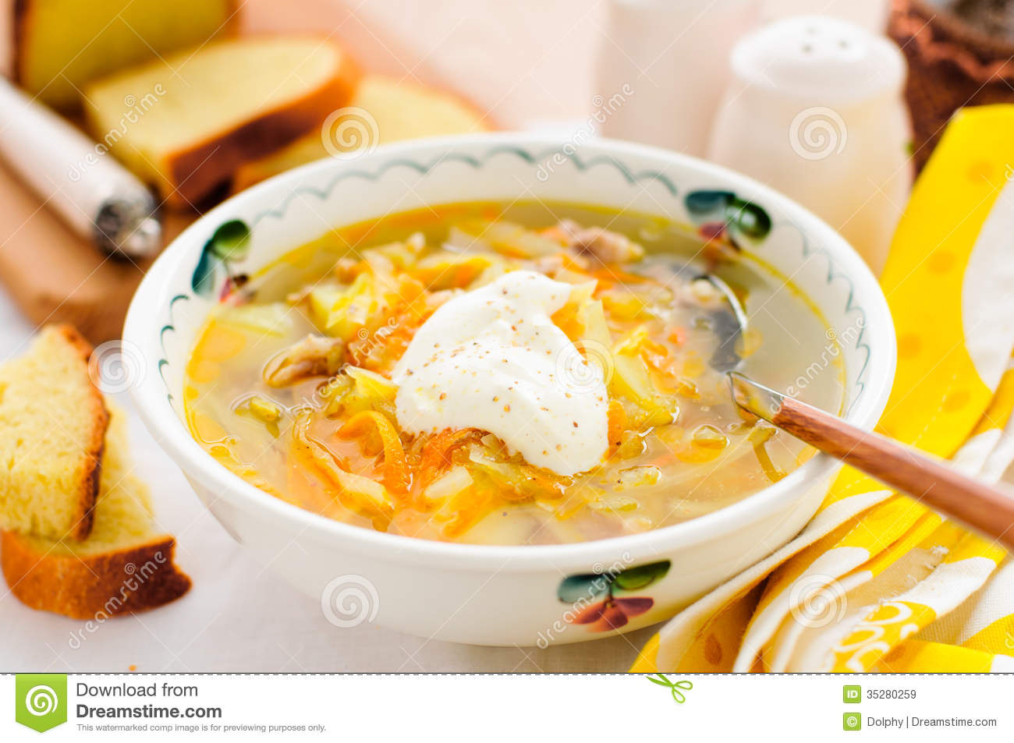

Complete your own menu using the following dishes and beverages. What kind of the menu have you done?
name of the restaurant/café:

Mushroom soup  (mushroom, potatoes, onion, carrots, greens)  Salad-cream or sour-cream for guest`s taste | Breakfast: hard-boiled eggs, vanilla yoghurt, fruit tea  Lunch: pea soup, garlic toast  Dinner: baked pork, fried vegetables, apple pie.  Snacks: apple crisps | Cabbage salad with cucumbers and carrots  Chicken salad  Vegetable puree soup with rusks  Chicken soup with beans  Pork chop with cheese and tomatoes. Boiled rice.  Vareniki with potatoes and cabbage, served with sour cream. | Tomato cream soup  Vegetable soup  Chicken soup with rice
Chicken soup with noodles  (chicken broth, noodles, greens) | Breakfast: ham and cheese sandwiches, orange juice.  Lunch: pea soup, white bread with grilled mushrooms  Dinner: lasagna with broccoli, beef and 3 kinds of cheese  Snacks: sugar biscuits |  | Lamb chops with French fries  Chicken chops with mashed potatoes  Fried oysters, tartar sauce, French fries
Cheese cream soup with croutons  (chicken broth, cheese, potatoes, carrots, croutons)  Greens for guest`s taste |  | Crab salad with salad cream  Russian Salad (traditional)  Fish soup with tomatoes and paprika  Okroshka  Stewed cod with mashed potatoes | Day dish  Stuffed prunes with nuts under the whipped cream
Greek salad  (lettuce, cucumbers, tomatoes, paprika, black olives, feta cheese, greens, olive oil) | Breakfast: toast with peanut butter, fruit salad, tea  Lunch: creamy chicken soup with noodles  Dinner: lasagna with broccoli, beef and 3 kinds of cheese, Greek salad  Snacks: chocolate balls |  | Yorkshire pudding  Cherry panna cotta  Rice pudding with sweet sauce
Russian Salad (traditional)  (boiled beets, potatoes, carrots, salted cucumbers, green peas, spring onions) |  | Green beans with olive oil and tomatoes  Beetroot salad  Puree soup with rice and mushrooms  Home made chicken soup with noodles  Grilled chicken with baked potatoes | Ham omelette  Cheese omelette  Spanish omelette  Mushroom omelette
Fish Assortment plate  (Smoked halibut, salted salmon, marinated cod) | Breakfast: cheese omelette, coffee  Lunch: shchi with fresh cabbage, spice potato fries  Dinner: baked chicken with soy sauce, potato salad  Snacks: cherry brownie | Russian Salad with mushrooms  Greek salad  Cod cream soup with croutons  Pea soup  Fried trout with steamed vegetables, tar-tar sauce  Chicken stir fry | Cappuccino  Americano  Coffee latte  Mocco  Herbal tea  Black tea with lemon
Pancakes with meat
(Russian style pancakes with beef meat served with cream mushroom sauce)
Russian Vareniki  (choice of potato, cottage cheese or cherry) | Breakfast: fried eggs sausages, milky coffee  Lunch: French onion soup, grilled bread  Dinner: pasta with bacon and sour cream sauce  Snacks: chocolate muffin | Jellied pork  Chicken salad with pineapple  Fish solyanka with greens  Vegetable soup with pelmeni  Stuffed croquets with cheese and eggs, mashed potatoes, cream sauce  Meat balls, pasta, tomato sauce | Cappuccino  Americano  Coffee latte  Mocco  Herbal tea  Black tea with lemon
Russian pancakes served with red caviar | Meat salad  Mix salad  Russian salad | Fruit juice  Black tea  Herbal tea | Cappuccino  Americano  Coffee latte  Mocco  Herbal tea  Black tea with lemon  Cappuccino  Americano  Coffee latte  Mocco  Herbal tea  Black tea with lemon
Napoleon  Puff dough, custard  Cream | Meat salad  Mix salad  Russian salad | Fruit juice  Black tea  Herbal tea
Cranberry dessert  Meringue with nuts, chocolate cream, cranberry | Meat salad  Mix salad  Russian salad | Fruit juice  Black tea  Herbal tea
Pork chop with cheese and tomatoes. | Stuffed croquets with cheese and eggs | Meat balls with tomato sauce | Stuffed duck with apples
Boiled rice. | Mashed potatoes | Pasta | Grilled vegetables
Appetizers | Soups | Monday | Thursday
Main courses | Beverages | Monday | Friday
Desserts | entrees | Tuesday | Thursday
Beverages | Day dish | Tuesday | Friday
Garnishes | Soups | Wednesday | entrees
Main courses | Desserts | Wednesday
Menu A-la cart |  | Cycle menu
Menu card du jour |  | Table d`hote menu

4) Setting the table
Look at the pictures and find the mistakes
1
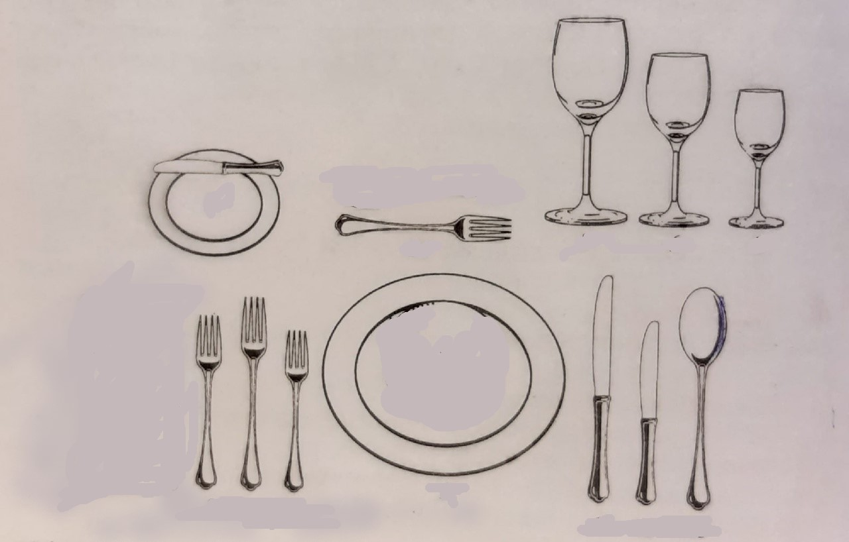
2
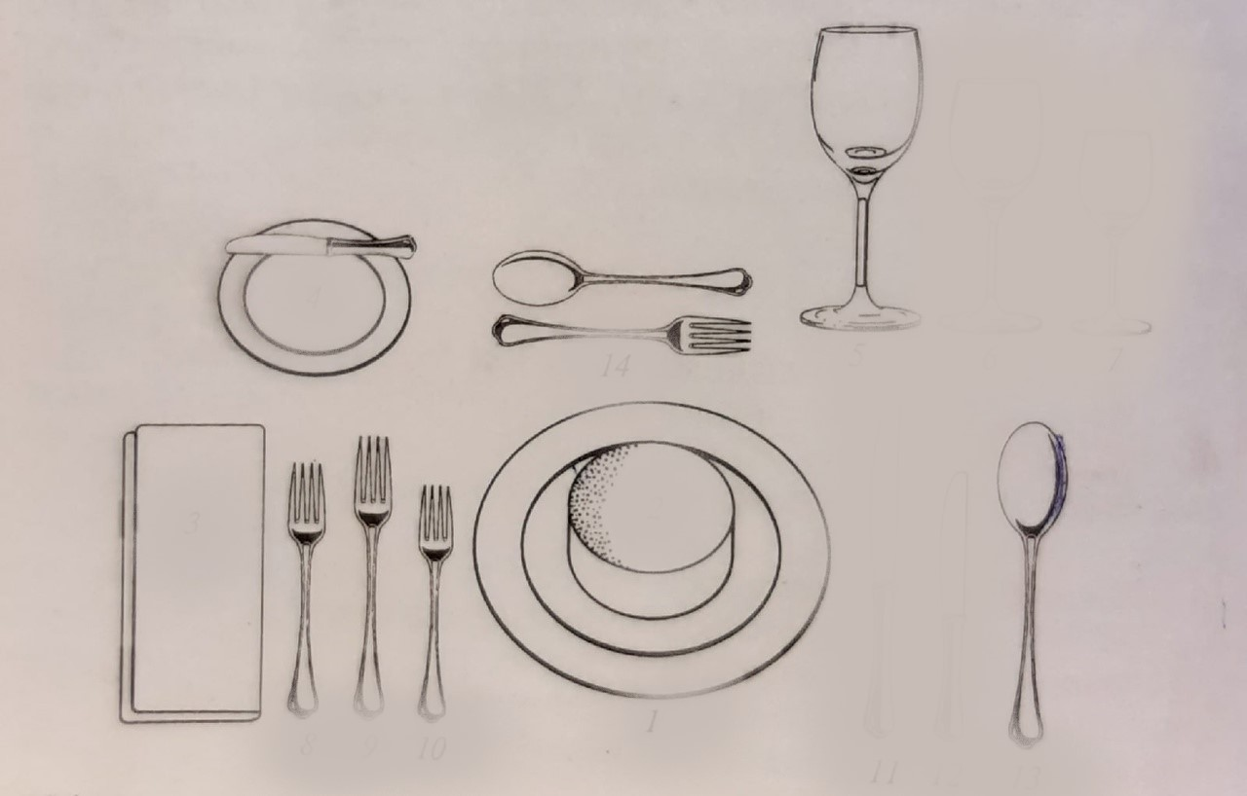
3
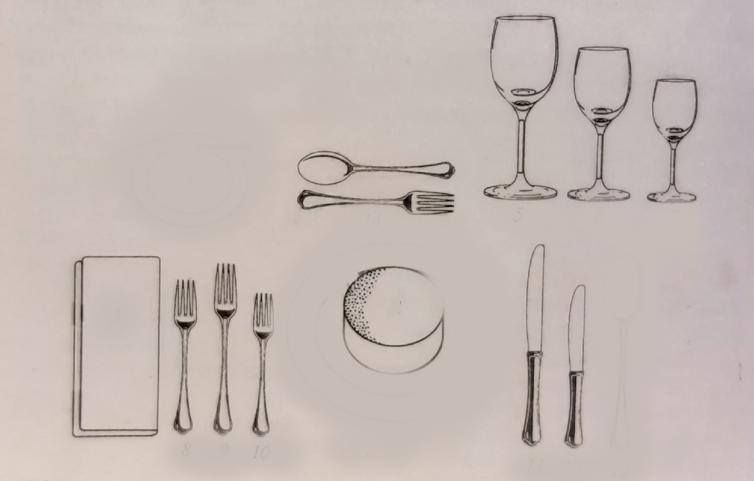

4
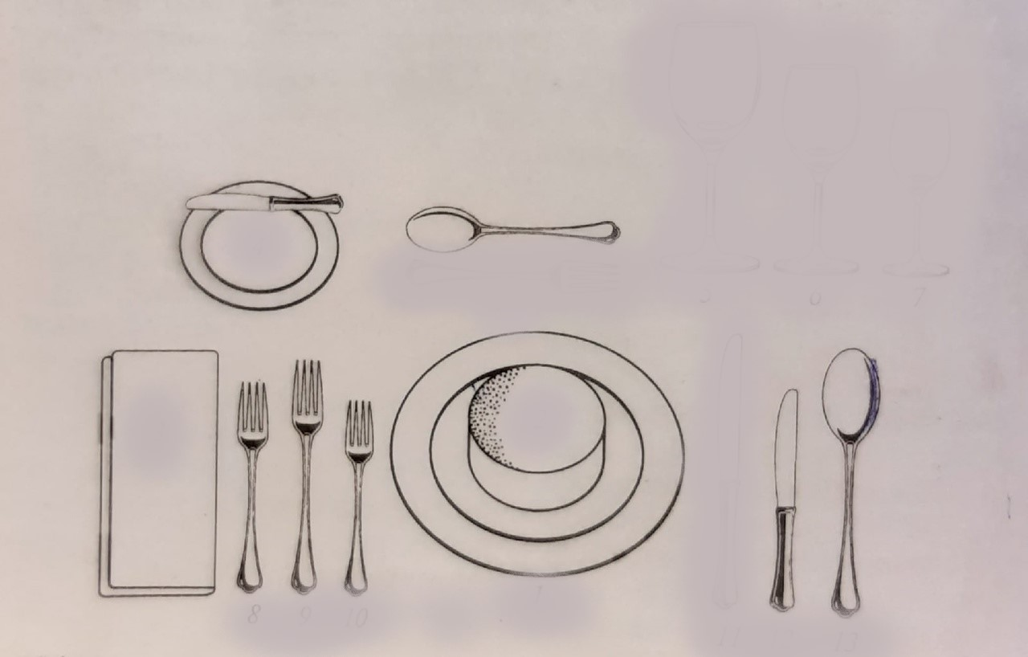

5) Food Service Establishments
MATCH THE FOOD SERVICE ESTABLISHMENTS WITH THEIR DESCRIPTIONS
- a la carte restaurants | - They also provide catering although the focus may be more on drinking than eating.
- gourmet restaurants | - The examples are steakhouses, seafood or vegetarian restaurants.
- specialist restaurants | - They are the most expensive, reflecting the high quality of food and beverages and the fact they often have recommendations from important food critics and organizations, which are highly prized.
- ethnic restaurants | - They with fixed-priced menus, a set number of courses with choices within each course. Items on the menu are ready at the same time, rather than made to order. This kind of restaurant is often family-run with an informal atmosphere.
- fast-food restaurants | - They are prepare food which is served and eaten quickly. These can either be eat-in restaurants, which are mostly self-service, or takeaway restaurants where you buy cooked food to eat somewhere else, or sometimes both.
- table d'hote menu restaurants | - They provide food and drink from a particular country.
- cafes, coffee bars, bars and pubs | - They are so-called because of the type of menu which lists and prices all items individually and prepares dishes to order. Service is generally of a very high standard with waiters as well as specialist bar staff and wine waiters and the atmosphere is formal.

CATERING SURVEY
- What kind of restaurants are available in Murmansk?
a la carte restaurants ___ (please specify: __________________)
gourmet restaurants ___ (please specify: _________________)
specialist restaurants ___ (please specify: _________________)
ethnic restaurants ___ (please specify: _________________)
fast-food restaurants ___ (please specify: ________________)
table d'hote menu restaurants ___ (please specify: _________________)
cafes, coffee bars, bars and pubs ___ (please specify: ________________)
- Choose any Murmansk’s restaurant you like and answer the questions given below.
- What is its title? _______________________________________________
- What kind of restaurant is it? _____________________________________
- Is the service good there? _______________________________________________________
- How much does an average meal cost?
- Is it easy to reach it using public transport?
- What is good about it? (cost, atmosphere, service, food and drink, other) ______________________________________________________________
- What could be improved in it? ______________________________________________________________________________________________________________________________________________________________________________________________________

Приложение 2.
KEYS
- Restaurant staff and its duties
1 B | 2 F | 3 A | 4 I | 5 D | 6 C | 7 G | 8 L | 9 H | 10 E | 11 M | 12 K | 13 J
- The structure of the menu
- APPETIZERS (STARTERS)
- SOUPS
- ENTREES
- MAIN COURSES
- GARNISHES (SIDE DISHES)
- DESSERTS
- BEVERAGES (DRINKS)
- Types of menus
Тable D’hote  Cycle menu  A La Carte  Carte Du Jour | C  D  B  A
- Recipes
1. Green beans with olive oil and tomatoes
1) BRING a pan of lightly salted water to 2) BOIL. 3) COOK the green beans for 2 minutes and 4) DRAIN them. Meanwhile, 5) HEAT a little olive oil in a pan and gently 6) COOK the onions for 3-4 minutes until soft. 7) ADD the tomatoes, beans and a few basil leaves. 8) SEASON , cover with a lid and let 9) SIMMER for 30 minutes. Give the beans a stir every so often, until they are tender. Remove the lid and leave the beans to 10) COOL.
2. Okroshka
1) WASH cucumber and spring onions and 2) SLICE them. Boiled beef and ham 3) ARE DICED. Hard-boiled eggs 4) ARE CUT into large pieces. Put everything in the kvass and 5) ADD a salt to taste. You can 6) ADD little potato boiled and diced. Before serving 7) KEEP okroshka in a cool place or refrigerator for 2 hours. When serving okroshka 8) PUT two spoonfuls of thick sour cream and shredded parsley and dill into each plate.
3. Chicken stir-fry
1) COAT the chicken with the flour and place in a plastic bag. 2) COMBINE the soy sauce, ginger and garlic powder, and add the mixture to the bag. 3) SHAKE well and refrigerate for 30 minutes. In a large wok, 4) HEAT two tablespoons of oil, and stir-fry the chicken for about 3-5 minutes, until it is no longer pink. 5) REMOVE the meat and keep warm. 6) ADD the remaining oil and stir-fry the celery, carrots and onion for about 4-5 minutes. Add all the chicken stock and return the chicken to the pan. 7) COOK and 8) STIR until thickened and bubbling. It should ready to 9) SERVE with rice.
4. Shchi with French Cabbage
1) BOIL the meat for an hour or two until half ready. 2) PUT shredded fresh cabbage into the broth. 3) SLICE all the vegetables and 4) FRY them for twenty minutes in the frying-pan. Then 5) PUT them into the saucepan. 6) SIMMER for three hours. 7) PUT bay leaf at the end of cooking and 8) TAKE it AWAY after shchi is ready. 9) SERVE shchi with sour cream, cut small spring onions and dill.
5) Setting the table
1. There is no dessert spoon in the picture. It is placed above the service place. There is no soup bowl. It is placed on the service plate. There is no napkin. It is to the left of the forks.
2. There are no wine glasses (for white and for red wines). There is no fish and service knife. The service knife is placed to the right of the service plate with the edge to the inside. Then a fish knife is placed.
3. There is no service plate in the picture. It determines the position of the utensils. There is no soup spoon, it is placed to the right of the knives. There is no bread plate with the butter knife (spreader). They are placed to the left of the service plate above the forks. The butter knife is placed with the edge to the outside.
4. There are no glasses (stemware) in the picture (for water, white and red wine). They are placed on the right above the silverware (cutlery). There is no cake fork in the picture. It is placed above the service place. There is no service knife. The service knife is placed to the right of the service plate with the edge to the inside.
6) Food service establishments
1. a la carte restaurants  2. gourmet restaurants  3. specialist restaurants  4. ethnic restaurants  5. fast-food restaurants  6. table d'hote menu restaurants  7. cafes, coffee bars, bars and pubs | G  C  B  F  E  D  A

