Муниципальное бюджетное общеобразовательное учреждение
«Гимназия № 1 им. Н.М. Пржевальского» города Смоленска

Урок по теме «Экология»
6 класс

Выполнила
Иванова Елена Анатольевна
Учитель английского языка

УМК: И.Н. Верещагина, О.В. Афанасьева «Английский язык» VI класс.
Тема урока: “A Man and the Natural World: Pollution”
Тип урока: урок систематизации и обобщения знаний.

Цель: Совершенствование навыков устной речи по теме «Экология»

Задачи:
- активизировать изученную лексику по теме “Экология ”
- развивать у учащихся умение творчески использовать усвоенный
материал в новых ситуациях общения;
- совершенствовать навыки диалогической и монологической речи;
- развивать коммуникативную компетенцию учащихся;
- развивать способность высказываться логично и связно;
- развивать умение анализировать и высказывать своё мнение;
- развивать умение работать в группах;

Урок был разработан на основе:
- технологии проблемного обучения, технологии коммуникативного обучения, технологии проектной деятельности;
- принципа личностно-ориентированного обучения, принципа деятельностного обучения, принципа наглядности, сознательности и творческого характера обучения.
Необходимое оборудование: учебные пособия, опорные карточки с лексикой, материалы для выполнения творческого задания.

I Организационный момент
Тeacher: Good morning, boys and girls. I am very glad to see you. And
how are you this morning? And you?
Is anybody absent today? How do you find the weather today?
- Does your mood depend on weather?
Are you ready for the lesson? It’s wonderful.
So, you are fine today, you are ready for the lesson, let's begin it.

II Определение темы урока и постановка задач
Teacher: Look at the picture and guess the topic of our lesson.

Well. And what about the aims of the lesson? What are we going to do at the lesson?
(Примерные ответы учащихся):
P2- I think we’ll speak English of course!
P3- Maybe, we’ll put questions and ask them.
P4-We are going to role- play.

T: Excellent! We’ll discuss many different things, concerning ecological situation on our planet, In that way you’ll develop your speaking skills on this topic, you’ll enlarge your vocabulary, broaden your mind. These are the aims of the lesson.
You see -we’ve got a lot to do.


III Речевая разминка
Teacher: Look at the picture again and say what ecological problems you know.
- Where does air pollution in the city come from?
- Why is it dangerous to dump industrial waste into the sea?
- Is ecological situation safe in our region?
- Have you ever washed your bike in a river or a lake?
- Do you waste any water\ energy?
- Have you ever made a fire in the forest?
- Have you ever left any litter after a picnic?
- Have you ever cleaned the place where you live?
- Have you ever planted trees?

IVАктуализация лексики по теме
Учитель организовывает работу учащихся в парах.
Teacher: Now you will work in pairs.
You’ll divide the words into 2 columns
Работа с вокабуляром в парах.

To protect Nature | To pollute Nature
Words: to dump, to waste, to save water, plant trees, save energy, recycle, nuclear weapon, to disappear, to destroy, clean rivers and lakes, environmental protection, to survive, cut down trees, pour toxic waste into rivers, acid rains, global warming, UV radiation.
Учащиеся зачитывают свои ответы.

V Работа в группах
Teacher: Thank you for your answers! I see you know what we should do to keep our planet safe. Imagine that you are members of the ecological club. Make up a list what people should or shouldn’t do to keep our planet clean and beautiful. You have 5 minutes to do the task.
Read your list of rules! Примерные ответы учеников:
- We should plant trees
- We must not waste water
- We must not make a fire in the forest
- We should plant trees
- We must clean the place after a picnic
- …
VI Аутогенная тренировка
Sit comfortably. Close your eyes. Breathe in. Breathe out. Let’s imagine it’s
summer. You are on a sandy beach.
The weather is fine.
(Включаю запись – шум моря, крики чаек)
The light wind is blowing from the sea. The birds are singing.
You have no troubles. No serious problems. You are quiet.
Your brain relaxes. There is calm in your body. Nothing diverts your attention.
You are relaxing. (Pause). You feel calm.
Your troubles float away. You can do everything. You are sure of yourself. You
are in good spirits.
Open your eyes. I hope you’ve relaxed, haven’t you? Let’s continue our lesson

VII Работа в парах. Применение знаний в новой ситуации. Развитие креативного мышления.
Teacher: Imagine that you are fashion designers. You want to attract people’s attention to ecological problems. Develop a print on a T-shirt. You have 8 minutes. Be ready to speak on the ecological problem, shown on your T-shirt and answer your classmates’ questions.
Ps: Работы учеников.
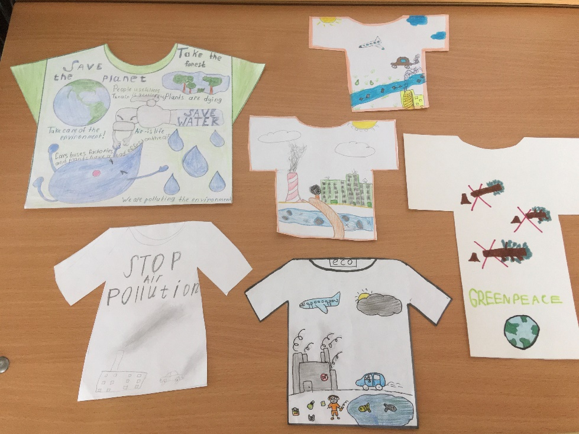
VIII Рефлексия учебной деятельности
Teacher: Did you learn any new and useful information?
-What new things have you learned today at the lesson?
-What was difficult for you?
-What kind of work was interesting?

IX Домашнее задание
Our lesson is coming to the end. It’s time to write down your homework.
Ex. 11 p. 75

