Викторина «Наука и технология»
Викторина по английскому языку «Наука и технология»
Описание материала: Вашему вниманию предлагаются викторина «Наука и технология», которая будет интересна и полезна как ученикам 8 -11 классов, так и учителям, которые стремятся добиться хороших результатов при изучении английского языка.
Цель: знакомство учащихся с интересными, известными открытиями, изобретениями и изобретателями
Задачи:
- формировать языковую компетенцию;
- развивать социокультурную компетенцию;
- повысить интерес и мотивацию к изучаемому языку;
- развивать речь, мышление;
- расширить кругозор учащихся.
Правила викторины: Участвует группа учащихся (15 человек), которая делится на 3 команды по 5 человек. Викторина состоит из 39 заданий. На обсуждение каждого задания дается 1-3 минуты в зависимости от уровня сложности. Очки получает та команда, которая первой даст правильный ответ. Если ответ был неправильный, у команды соперников есть возможность дать свой вариант ответа. Вопросы выбираются по желанию. В конце урока оглашаются результаты и называется команда победителей.
Ход викторины
Вступительное слово учителя
Teacher: Good morning dear boys and girls. Today we have an unusual lesson. You are going to have a quiz today devoted to Science and Technology. Three teams will take part in our quiz. The names of the teams will be colors. Let’s see the quiz and the number of points you can get for each part. It consists of three parts: inventers (21 points), inventions (6 points), space (12 points). The total number of points you can get is 13 (plus additional points). You can choose the part and the number of your question. You should choose the correct answer out of the three given a, b, c. The task will appear on the screen only for some seconds and then disappear, so you should think quickly. You will have 1-3 minutes. Write your answers on the answer sheets and say it. If your answer is wrong, the next team will answer the question. The first part is Inventers. The second part is Inventions. The third part is Space.
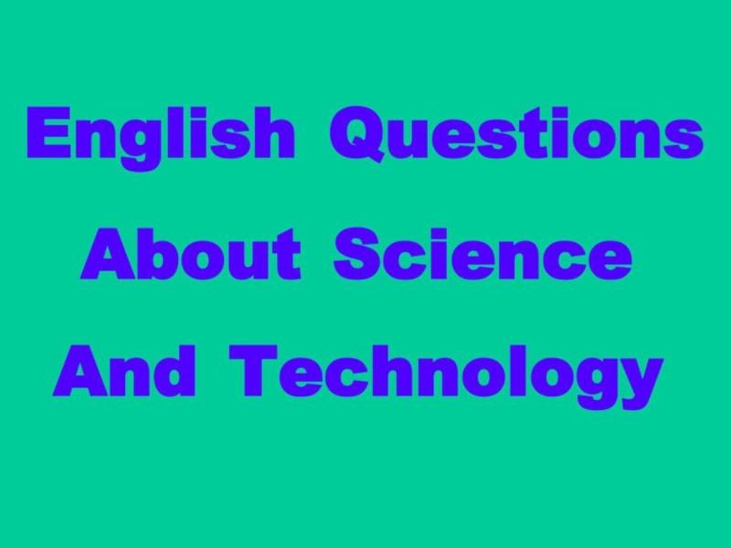
On the blackboard you see a table with the numbers of the questions, your task is to choose any number, answer the question and get a point. Be attentive! I wish you good luck!
I. Inventers
1 | 2 | 3 | 4 | 5 | 6
7 | 8 | 9 | 10 | 11 | 12
13 | 14 | 15 | 16 | 17 | 18
19 | 20 | 21
II. Inventions
1 | 2 | 3 | 4 | 5 | 6
III. Space
1 | 2 | 3 | 4 | 5 | 6
7 | 8 | 9 | 10 | 11 | 12
Teacher: do the quiz “Science and Technology”.
I.Inventers. Choose the right answer out of the three given a, b, c. 
1. Who invented the first telephone in 1876?
a) Alexander Popov b) Graham Bell c) Albert Einstein
2. Who invented the first multiple telegraph?
a) Alexander Bell b) Alexander Popov c) Albert Einstein
3. Who developed the first personal stereo – Sony Walkman?
a) Karl Benz b) Orville Wright c) Akito Morita
4. Who built the first vacuum cleaner?
a) James M. Spangler b) Akito Morita c) Alexander Bell
5. Who invented the first mechanical programmable computer?
a) Charles Babbage b) Alexander Popov c) Bill Gates
6. Who invented the first electronic programmable computer?
a) H.L.Hazen b) John William Mauchly c) Nikolai Lobachevsky
7. Who invented the first incandescent lamp?
а) Alexander Bell b) Alexander Popov с) Thomas Edison
8. Who invented the first radio?
a) Alexander Bell b) Alexander Popov с) Thomas Edison
9. Who created the world’s first car assembly line?
a) Henry Ford b) Akito Morita c) Bill Gates
10. Who made the table of chemical elements?
a) Alexander Popov b) Dmitry Mendeleev c) Ivan Pavlov
11. Who made the vaccines against cholera?
a) Louis Pasteur b) John Logie Baird c) Marie Curie
12. Who invented the diesel engine?
a) Alexander Bell b) Rudolf Engine c) Michael Faraday
13. Who created Microsoft-DOS?
a) Thomas Edison b) John Logie Baird c) Bill Gates
14. Who invented the first paper?
a) Ivan Pavlov b) Isaac Newton c) Ts’ai Lun
15. Who discovered gravity?
a) Isaac Newton b) Mendeleev c) Ivan Pavlov
16. Who invented electricity?
a) Michael Faraday b) Alexander Bell c) Isaac Newton
17. Who invented theory of relativity?
a) Ivan Pavlov b) Albert Einstein c) Karl Benz
18. Who produced the first petrol-driven motor car?
a) Karl Benz b) Akito Morita c) Bill Gates
19. Who was Albert Einstein?
a) chemist b) physicist c) biologist
20. Who invented the vaccines against cholera?
a) Louis Pasteur b) John Logie Baird c) Marie Curie
21. What country did Nicolas Copernic come from?
a) Italy b) Poland c) Greece

Do the quiz “Science and Technology”:

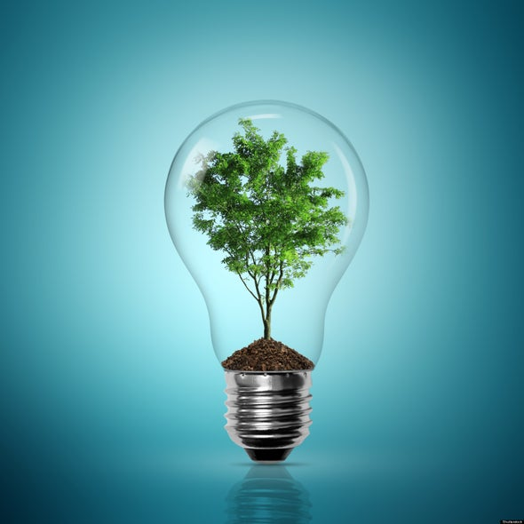
II. Inventions. Choose the right answer out of the three given a,b,c
1. What did Alexander Fleming discover?
a) Gravity b) mechanical watch c) penicillin
2. What did Marie Curie discover?
a) Radium b) laws of heredity c) theory of relativity
3. What did James Cook discover?
a) Hungary b) Germany c) Australia
4. What idea was developed by Scottish scientist Ian Wilmat?
a) typewriting b) cloning c) printing
5. What did Akito Morita develop?
a) Sony Walkman b) vacuum cleaner c) television
6. What did the Lumiere brothers invent?
a) a telescope b) a film projector c) a helicopter

Do the quiz “Science and Technology”:

III. Space. Choose the right answer out of the three given a, b, c.
1. What country was the first in sending a man into space?
a) the U.K b) the U.S.A c) the U.S.S.R
2. Who was Y. Gagarin?
a) Cosmonaut b) Tanker c) Scientist
3. Who flew into space on April 12, 1961?
a) Vladimir Komarov b) Neil Armstrong c) Yuri Gagarin
4. Who landed first on the moon?
a) Yuri Gagarin b) Neil Armstrong c) Jim Lovell
5. When did American astronaut land on the Moon?
a) 1982 b) 1979 c) 1985
6. What was the first animal to go to the space?
a) squirrel and arrow b) the dog Laika c) the monkey called Albert 1
7. What is the largest planet in the solar system?
- Jupiter b) Uran c) Venera
8. What is the nearest planet to the Sun in the Solar System?
а) Mercury b) Saturn с) Mars
9. Which country was the first in the world to send a satellite into space?
a) France b) the USSR c) England
10. When was the first satellite launched?
a) 1953 b) 1959 c) 1957
11. Who built the first airplane in 1903?
a) Wilbur and Orville Wright b) Sergei Korolyev c) Karl Benz
12. Who designed the first artificial satellite in 1957?
a) Orville Wright b) Sergei Korolyev c) Karl Benz
рисунок 1
Answers
I. Inventers
1b | 2a | 3c | 4a | 5a | 6b
7c | 8b | 9a | 10b | 11a | 12b
13c | 14c | 15a | 16a | 17b | 18a
19b | 20a | 21b
II. Inventions
1c | 2a | 3c | 4b | 5a | 6b
III. Space
1c | 2a | 3c | 4b | 5a | 6b
7a | 8a | 9b | 10c | 11a | 12b

Подведение итогов. Набравшая больше всего очков команда объявляется победителем и получает подарки (или пятёрки), другие - утешительные призы.

