NAME ________________________________
- Listen to the song and fill in the gaps:
A New Day Has Come (Celine Dion)
I was waiting for ___________
For a miracle to come
Everyone told me to be _______
Hold on and don't shed a tear

Through _________ and good times
I knew I'd make it through
And _________ thought I had it all
But I was waiting for you.

Hush, now I see a light in ________
Oh, it's almost blinding me
I can't believe I've been touched by _________ with love

Let the rain come down and wash away __________
Let it fill my soul and drown my ___________
Let it shatter the walls for a new __________
A new day has come

Where there was dark now there's ________
Where there was pain now there's __________
Where there was weakness I found my _________
All in the eyes of ____________
(13 points)

- Listen to the songs and fill in the gaps
- I want ______(break) free.
- When I’m home, everything seems _______(be) right.
- ‘Cause all of the stars, are fading away, just try ______(not worry) you’ll see them some day. Take what you need and be on your way and stop _______ (cry) your heart out.
- Listen, do you want _________ (know) a secret? Do you promise ___________ (not/tell)? Closer, let me whisper in your ear, say the words you long ___________(hear) – I’m in love with you.
- I can’t help __________(fall) in love with you.
- Keep ____________(roll).

- Valentine’s Day Word Scramble
1. erd sreso _____________________________
2. idcpu _________________________________
3. nolablos ______________________________
4. tlaccohoe _____________________________
5. yandc xbo ____________________________
6. beledvo ______________________________
7. odaer ________________________________
8. lveo __________________________________
9. urfeaybr ______________________________
10. isneetanvl yda ________________________

- Choose the right variant:
- ________ is the capital of the USA.
  - New York
  - Washington
  - London
- The largest country of the world by geographical area is ______.
  - Russia
  - Canada
  - China
- Charles _________ - an English naturalist and geologist, best known for his contributions to evolutionary theory.
  - Aznavour
  - Dickens
  - Darwin
- The Official Coat of Arms of the British Monarch
a)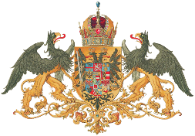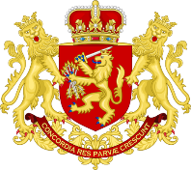b)
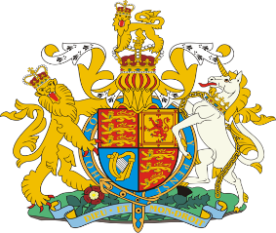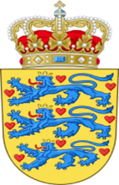
c) d)

- What is the smallest planet in the Solar System?
  - Jupiter
  - Mercury
  - Venus
- Vincent Willem van Gogh was a ______ post-Impressionist painter whose work had far-reaching influence on 20th-century art.
  - Dutch
  - English
  - French
- His novel Fathers and Sons (1862) is regarded as one of the major works of 19th-century fiction.
  - Leo Tolstoy
  - Fyodor Dostoyevsky
  - Ivan Turgenev
- Hercule Poirot is a fictional character, created by ___________.
  - Arthur Conan Doyle
  - Agatha Christie
  - Charlotte Brontë
- Sir Isaac Newton - an English physicist and mathematician, a key figure in the ___________ revolution.
  - Orange
  - October
  - scientific
- The Great Charter (Magna Carta) is a political document of the _____ century.
  - VIII
  - XIX
  - XIII
- There is one place the Queen (or King) of England can not enter. What is this place?
  - The House of Lords
  - The Tower
  - The House of Commons
- What's the name of the London underground?
  - Metro
  - Tube
  - Subway
  - Underground
- What is soccer?
  - American football
  - hockey
  - squash
  - boat-racing
- Who wrote "Winnie-the-Pooh"?
  - Carroll
  - O. Wilde
  - J.R. Tolkien
  - A. Milne
- The US consists of ... states.
  - 38
  - 49
  - 50
  - 51
- In the United States "down town" means ... .
  - away from the centre
  - in the centre
  - in a suburb
  - a small town
- Who is considered to be the Father of his country?

  - Abraham Lincoln;
  - Benjamin Franklin;
  - Thomas Jefferson;
  - George Washington.

18. The National Flag of Scotland
а)b)
c)  d)

- The American flag has...
a. 13 stripes
b. 50 stripes
c. 30 stripes
d. 51 stripes

- What is the official residence of the Prime Minister of the UK?
a. No.10 , Downing Street
b. No.10 , Fleet Street
c. 221b, Baker Street
21. What does this gesture mean?

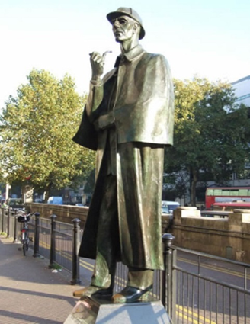
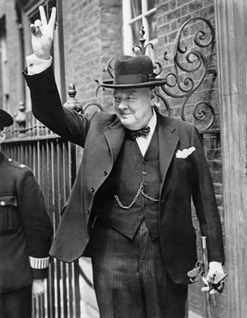
- What is the name of this person?

- How old is the Queen of Great Britain?

- Thomas Jefferson, George Washington, Abraham Lincoln, John Kennedy, Joseph Biden. What do all these people have in common?
- What is the Union Jack?

26. Match the parts of the names of the famous cities
Ox | fast
Liver | burgh
Cam | diff
Edin | bridge
Bel | ford
Car | pool

27. What do the following abbreviations stand for?
BC___________________________________________________
28. VIP __________________________________________________
29. UFO__________________________________________________
30. DIY___________________________________________________
31. IBM___________________________________________________
32. BBC___________________________________________________
33. mph ___________________________________________________
34. HAND __________________________________________________
35. What is the name of the London residence of Queen Elizabeth II?_________

36. How is the biggest international airport in London called?

37. What is the difference between English and Russian tea?

5. Match the following proverbs with their Russian equivalents:
1. Who breaks, pays | a. Молчи – за умного сойдешь.
2. What is bred in the bone will not go out of the flesh | b. Без труда не вытащишь и рыбку из пруда
3.То plough the sand | c. С глаз долой, из сердца вон
4. No pains, no gains | d. Делу- время, потехе- час.
5. To lock the stable-door after the horse is stolen | e. Горбатого могила исправит
6. Out of sight, out of mind. | f.После драки кулаками не машут
7. A silent fool is counted wise. | g.Сам заварил кашу, сам и расхлебывай
8. Business before pleasure | h. Толочь воду в ступе

1 | 2 | 3 | 4 | 5 | 6 | 7 | 8

