Ключи к заданиям 3 класс ( район)
Каждый правильный ответ оценивается в 1 балл. Максимальное количество баллов – 64.
I. Прочитайте текст. Выберите подходящий по смыслу ответ.

Ответы: 1) b 2) a 3)b 4)b 5) c

II. Выберите подходящий по смыслу ответ.

Ответы: 1) e 2) f 3)d 4) g 5)b 6) c 7) a

III. Соедини английские предложения с их русским переводом

Ответы: 1) f 2) d 3) g 4) c 5) a 6) b 7) e

IV. Поставь реплики диалога в правильной последовательности.

Ответы: 3, 5, 2, 1, 4

V. Выбери подходящую форму глагола.

Ответы: 1)b 2) b 3)b 4)a 5)b 6)a 7)b 8)b 9)a 10)b 11)b 12)c 13)a 14) b 15)a 16)b 17)c

VI. Выбери правильный ответ.

Ответы: 1)b 2)a 3)c

VII. Соотнеси цифры на картинках со словами.

Ответы: 1) h 2)i 3)a 4)f 5)e 6)b 7)d 8)g 9)c

VIII. Раздели текст на предложения. Сколько предложений получилось?

Ответы: 6

IX. Найдите слова, в которых содержится звук [dʒ].

Ответы: 3, 6, 7, 8, 10

X. Выбери правильный предлог
Ответы: 1) c 2)b 3)a 4)d 5)e

- Прочитайте текст. Выберите подходящий по смыслу ответ.

Christmas
The 25th of December is Christmas Day. It’s a happy holiday for many people in different countries.
Some weeks before Christmas English people are busy. They send greeting cards to all their relatives and friends. You can buy Christmas cards or you can make them. Many children make their cards at school.
People buy a Christmas tree and decorate it with toys, coloured balls and little coloured lights.
On Christmas Eve people put their presents under the tree. When children go to bed, they put their stockings near their beds.
At night Father Christmas comes. He has got a big bag of presents for children. He puts presents in the children’s stockings.

- Why are people busy some weeks before Christmas?
a) They send letters to all their relatives and friends.
b) They send greeting cards to all their relatives and friends.
c) They get greeting cards ftom their relatives and friends.
- How do people decorate a Christmas tree?
- People decorate a Christmas tree with toys, coloured balls and little coloured lights.
- People decorate a Christmas tree with toys, flowers and little coloured lights.
- People decorate a Christmas tree with flowers and coloured balls.
- Where do the English put Christmas presents?
a) On Christmas Eve people put their presents under the bed.
b) On Christmas Eve people put their presents under the Christmas tree.
c) On Christmas Eve people put their presents on the Christmas tree.
- What is there in Father Christmas’ bag?
- There are a lot of sweets and apples for children in Father Christmas’ bag .
- There are a lot of presents for children in Father Christmas’ bag .
- There is a lot of fruit for children in Father Christmas’ bag .
- Where does Father Christmas put the presents for children?
- He puts the presents on children’s beds.
- He puts the presents under the table.
- He puts the presents in the children’s stockings.

Ответы: 1) 2) 3) 4) 5)

II. Выберите подходящий по смыслу ответ.

1. Do English people like porridge?  2. How many meals a day do the English have?  3. Do English people drink a lot of tea?  4. What do the English sometimes eat bread with?  5. What do English people like to drink tea with?  6. What is English people’s last meal?  7. When is breakfast time in England? | a) In England breakfast time is between seven and nine.  b) They like to drink tea with milk.  c) Their last meal is dinner or supper.  d) Yes, they drink a lot of tea.  e) Yes, they do. English people like porridge very much.  f) They have four meals a day.  g) They sometimes eat bread with soup.

Ответы: 1) 2) 3) 4) 5) 6) 7)
III. Соедини английские предложения с их русским переводом

1. He lives in the cage. a) Некоторые попугаи живут дольше,
2. My parrot has a very loud voice. чем большинство собак и птиц.
3. He likes to chew rubber toys. b) Я учу его говорить.
4. He has a large beak, a short neck, two c) У него большой клюв, короткая шея,
beautiful wings and a long tail. два красивых крыла и длинный хвост.
5. Some parrots live longer than most d) У моего попугая очень громкий голос.
dogs and birds. e) Он - игривое, говорливое и удиви-
тельное животное.
6. I teach him to talk. f) Он живет в клетке.
7. He is playful, talkative and a great pet. g) Он любит жевать резиновые игрушки.

Ответы: 1) 2) 3) 4) 5) 6) 7)
IV. Поставь реплики диалога в правильной последовательности.

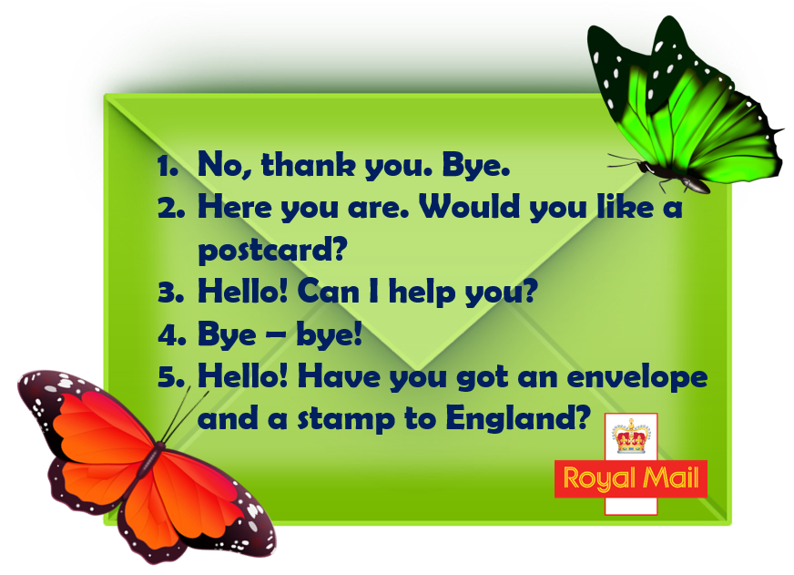
Ответы:
V. Выбери подходящую форму глагола.

1. The girl … ..cakes and sweets.
a) like b) likes
2. The duck ….. in the park.
a) live b) lives
3. My friend ….. smart.
a) am b) is c) are
4. They ….. got a new car.
a) have b) has
5 …..the crocodile eat meat?
a) Do b) Does
6. …..you like fish?
a) Do b) Does
7. Jane …. got a new bag.
a) have b) has
8. Bill ….got a red cat.
a) have b) has
9. They ….. got seven pencils.
a) have b) has
10. My Dad …. brave and smart.
a) am b) is c) are
11 …. he happy?
a) am b) is c) are
12. We ….not lazy.
a) am b) is c) are
13. His pupils ….well.
a)read b) reads
14. Jack …. a horse in the morning.
a) ride b) rides
15. Tim …. sing.
a)can b)has c) is.
16. Ann ….. ten pens.
a)can b)has c) is.
17. His pig …. big.
a)can b)has c) is.

Ответы: 1) 2) 3) 4) 5) 6) 7) 8) 9) 10) 11) 12) 13) 14) 15) 16) 17)

VI. Выбери правильный ответ.

1. Can dogs fly? 2. Do birds like corn? 3. Are you sad?

а) Yes, they do. b) No, they can’t. c) No, I’m not.

Ответы: 1) 2) 3)

VII. Соотнеси цифры на картинках со словами.
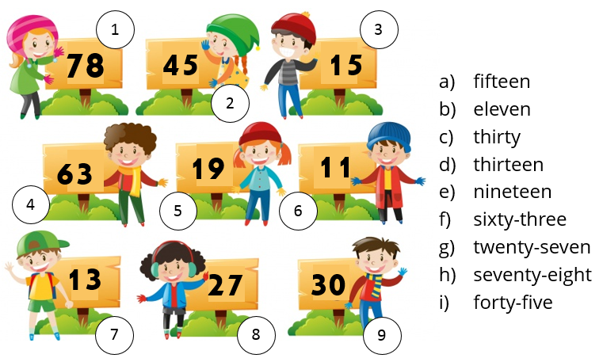
Ответы: 1) 2) 3) 4) 5) 6) 7) 8) 9)
VIII. Раздели текст на предложения. Сколько предложений получилось?
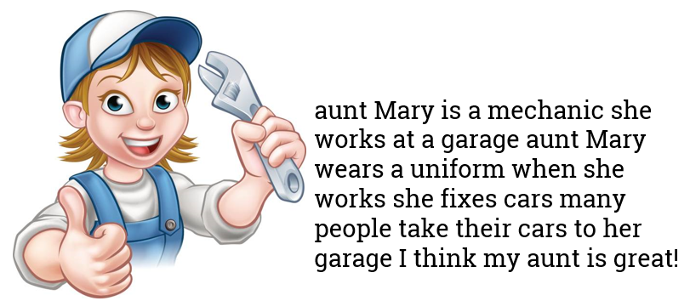

Ответы:
IX. Найдите слова, в которых содержится звук [dʒ].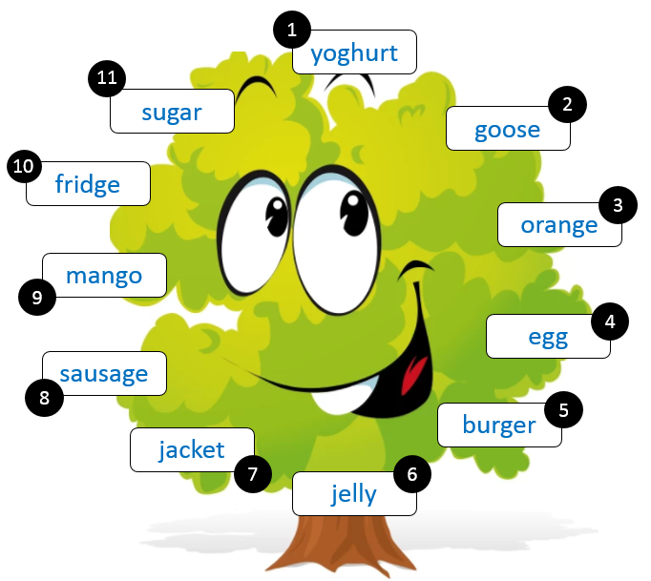
Ответы:

X. Выбери правильный предлог

 | - Above  - Under  - On  - Behind  - Next to
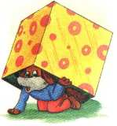 | - Above  - Under  - On  - Behind  - Next to
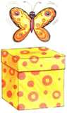 | - Above  - Under  - On  - Behind  - Next to
 | - Above  - Under  - On  - Behind  - Next to
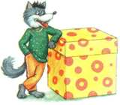  5. | - Above  - Under  - On  - Behind  - Next to  Ответы: 1) 2) 3) 4) 5)  Ключи к заданиям (школьный этап)для 3-их классов.  Каждый правильный ответ оценивается в 1 балл. Максимальное количество баллов – 55.  I. Прочитайте текст и ответьте на вопросы.  Ответы:  1. He is a farmer.  2. Work on the farm begins early.  3. The weather is terribly hot.  4. He invites his friend John to spend the day together.  II. Отгадайте загадки.  Ответы:  1.__a frog_________________ 2.____a bear___________________  3.__a rabbit (a hare)_________ 4._____a cow_________________  III. В каждой группе слов вычеркни лишнее слово  Ответы: 1) a carrot 2) Sunday 3) a cow 4) meat  IV. Выбери правильный ответ.  Ответы: 1. 1) b 2) c 3) a  Ответы: 2. 1) b 2) a 3) a  Ответы: 3. 1) a 2) b 3) b  Ответы: 4. 1) b 2) a 3) b  Ответы: 5. 1) a 2) g 3) d 4) f 5) c 6) b 7) e  Ответы: 6. 1) a 2) c 3) d 4) b  V. Соотнеси звуки со словами, в которых они произносятся.  Ответы: 1) d 2) b 3) a 4) c 5)e  VI. Каждой цифре в кружке соответствует буква. Найди, указанные в столбике словами цифры по порядку и получишь ключевое слово.  Ответ: grandpa  VII. Выбери предложения, которые соответствуют (True - T) или нет (False - F)  картинке.  1. True, 2. True, 3. False, 4. True, 5. False, 6. True, 7. True  VIII. Прочитай и выбери правильный вариант.  Ответы: 1) a 2) a 3) a 4) a 5) a 6) a 7) a  I. Прочитайте текст и ответьте на вопросы.  Mike is thirty-five. He is a farmer. He lives and works on a farm.  Every day he gets up very early, because work on the farm begins early whichever country you live in.  But today Mike wants to have a day off. The weather is terribly hot. He invites his friend John to spend the day together.  1. What is Mike?  2. Why does he get up very early?  3. Why does Mike want to have a day off?  4. Whom does he invite to spend the day together?  Ответы:  1.  2.  3.  4.  II. Отгадайте загадки.  1. It is a green animal. 2. It is brown.  It can swim and jump. It has got four legs.  It likes to eat flies. It sleeps in winter.  What is it? What is it?  3.It is grey or white. 4. It is big.  It likes to eat carrots and cabbage. It eats grass.  It can run and jump. It gives milk.  What is it? What is it?  Ответы:  1._________________________ 2._____________________________  3._________________________ 4._____________________________  III. В каждой группе слов вычеркни лишнее слово  - an apple, a banana, a carrot, a pear, a grape.  - winter, Sunday, spring, autumn, summer.  - a fox, a wolf, a bear, a cow, a zebra, an elephant.  - meat, juice, tea, coffee, milk, water  Ответы: 1) 2) 3) 4)  IV. Выбери правильный ответ.  1. a) am b) is c) are  1) My grandmother … a teacher.  2) You … nine years old.  3) I … a pupil. Ответы: 1) 2) 3)  2. a) have b) has  1) Ann … got two brothers.  2) … you got a pen?  3) They … got a nice cat. Ответы: 1) 2) 3)  3. a) likes b) like  1) She … to play football very much.  2) We … to play badminton.  3) Boys and girls … to play snowballs. Ответы: 1) 2) 3)  4. a) a b) an  1) My father is … engineer.  2) He is … pilot.  3) I’ve got … elephant. Ответы: 1) 2) 3)  5. a) my b) your c) his d) her e) its f) our g) their  1) I love … family.  2) They love … families.  3) The girl loves … family too.  4) We play with ….toys.  5) Grandpa reads ….book.  6) Are….pens on the table, Mike?  7) A cat drinks ….milk. Ответы: 1) 2) 3) 4) 5) 6) 7)  6. a) on b) in c) under d) near  1) The book is (на) the table.  2) The cat is (под) the table.  3) The chair is (около) the table.  4) The kitten is (в) the box. Ответы: 1) 2) 3) 4)  V. Соотнеси звуки со словами, в которых они произносятся.  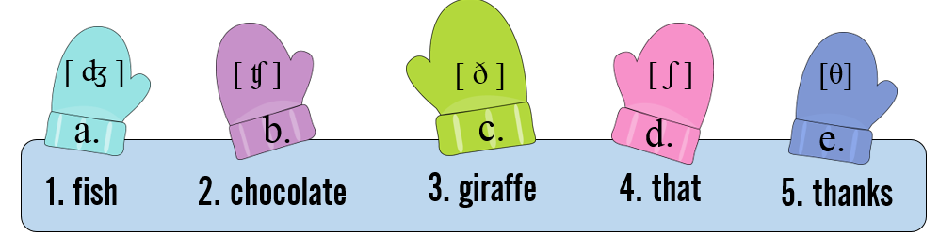  Ответы: 1) 2) 3) 4) 5)  VI. Каждой цифре в кружке соответствует буква. Найди, указанные в столбике словами цифры по порядку и получишь ключевое слово.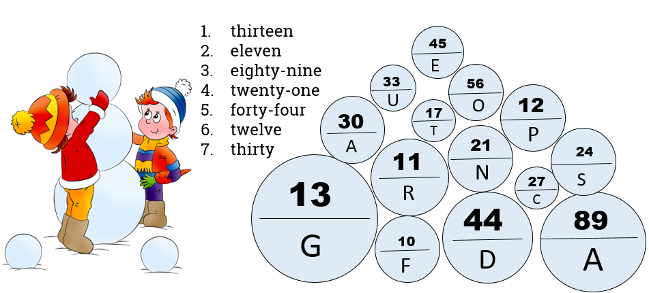  Ответ:__________________________________  VII. Выбери предложения, которые соответствуют (True - T) или нет (False - F) картинке.    1. There is a wardrobe in front of the clock.  2. There is a picture above the shelf.  3. There is a rug (коврик) under the sofa.  4. There is a sofa next to the window.  5. There are three boxes on the wardrobe.  6. There are books on the shelf.  7. There is a lamp under the clock.  Ответы: 1) 2) 3) 4) 5) 6) 7)  VIII. Прочитай и выбери правильный вариант.  1.a) We don’t like milk. b) We doesn’t like milk.  2.a) Does Mike like tomatoes? b) Does Mike likes tomatoes?  3.a) Sam, do you like ice cream? b) Sam, does you like ice cream?  4.a) Has she got a car? b) Have she got a car?  5.a) A: Do you like chips? B: No, I don’ b) A: Do you like chips? B: No, I doesn’t.  6.a) This is not my school. b) This are not my school.  7.a) My sister has got two children. b) My sister has got two childrens.  Ответы: 1) 2) 3) 4) 5) 6) 7)

Ключи к заданиям 4 класс ( районный этап).
Каждый правильный ответ оценивается в 1 балл. Максимальное количество баллов – 78.

I.Прочитайте текст. Выберите подходящий по смыслу ответ.

Ответы: 1)a 2) c 3) a 4) b 5)c

II. Выберите правильный ответ.

Ответы:1)b 2)b 3)b 4)a 5)b 6)c 7)b 8)b 9)a 10)b 11)a 12)a 13)c 14)b 15)b 16)c 17)a 18)a 19)b 20)b

III. Выберите подходящий по смыслу предлог.

Ответы: 1) c 2)b 3)a, b 4)c 5)d, b

IV. Соотнесите слова и числа.

Ответы: 1)d 2)a 3)b 4)c 5)g 6)e 7)f

V.Соотнесите места на картинках и слова, которые к ним относятся.

Ответы: 1) d 2)b 3)c 4)e 5)a 6)f

VI.Соотнесите запрещающие знаки и правила.

Ответы: 1)f 2)a 3)c 4)b 5)d 6)e

VII. Выберите подходящий по смыслу ответ.

Ответы: 1)f 2)g 3)a 4)e 5)b 6)c 7)d

VIII. Соедини английские предложения с их русским переводом

Ответы: 1)d 2)f 3)e 4)c 5)g 6)b 7)a

IX. Найди соответствие.

Ответы: 1)j 2)d 3)d 4)b 5)a 6)l 7)c 8)e

X. Найдите русский эквивалент к следующим пословицам.

Ответы: 1)e 2)d 3)f 4)g 5)a 6)b 7)c

I. Прочитайте текст. Выберите подходящий по смыслу ответ.

Brother Rabbit had got four carrots. He was very hungry. He wanted to eat the carrots. But then he thought that his friend Brother Goat was hungry too. So he ate only two carrots. He wanted to give the other two to Brother Goat.
He took the two carrots and ran to Brother Goat’s house. Brother Goat was not at home. So Brother Rabbit put the two carrots on the table and ran away.
When Brother Goat came home and saw the carrots on the table, he thought: “Oh, what good friends I’ve got! And I want to be a good friend too. I think that Brother Rabbit is hungry.”
So Brother Goat ate only one carrot, took the other and ran to Brother Goat’s house.
Brother Rabbit was not at home. Brother Goat put the carrot on the table and wrote a letter: “Dear Brother Rabbit! This carrot is for you. Love from Brother Goat.” When Brother Rabbit came home, he saw the carrot and the letter on the table. He read the letter, ate the carrot and thought: “Oh, what good friends I’ve got!”

1. What had Brother Rabbit got?
- Brother Rabbit had got four carrots.
- Brother Rabbit had got four bananas.
- Brother Rabbit had got two carrots.
2. Why did Brother Rabbit ran to Brother Goat’s house?
- He wanted to give the four bananas to Brother Goat.
- He wanted Brother Goat’s carrots.
- He wanted to give the two carrots to Brother Goat.
3. What did Brother Goat think when he saw the carrots on the table?
- “I think that Brother Rabbit is hungry.”
- “I think that Brother Bear is hungry.”
- “I think that Brother Rabbit is not hungry.”
4. What did Brother Rabbit see when he came home?
- He saw the carrot and the cake.
- He saw the carrot and the letter.
- He saw the meat and the letter.
5. What did Brother Goat write in the letter?
a) Brother Goat wrote: “ This carrot is for me.”
b) Brother Goat wrote: “ This orange is for you.”
c) Brother Goat wrote: “ This carrot is for you.”

Ответы: 1) 2) 3) 4) 5)

. II. Выберите правильный ответ.

- He … a pupil of the 4 form.
- am b) is c) are
- My friend … play football.
- may b) can c) make
- I … a beautiful doll.
- can b) have c) play
- We … a friendly family.
- are b) is c) am
- Where … she from?
- am b) is c) are
- … you a pupil ?
- am b) is c) are
- I … ride a bicycle.
- take b) can c) do
- He … a new computer.
- have b) has c) is
- Susan and Bob … to play together.
- like b) are c) have
- We … a beautiful park near the house.
- has b)have c) may
- Do you … to speak English ?
- like b) can c) likes
- I … a schoolgirl and I prefer to read books.
- am b) is c) are
- Paolo … a mobile phone in his bag.
- have b)make c)has
- You … travel by tram.
- are b) can’t c) meet
- I love New York! It … a very nice city.
- am b) is c) are
- You … water the flowers in a classroom.
- am b) finishes c) can
- She … going to the beach.
- is b) be c)am
- England … magic because it is a country of red rose.
- is b) be c)am
- There … a lot of old castles in England.
- is b) are c)am
- Wales … many old traditions.
a)have b) has c) is

Ответы:1) 2) 3) 4) 5) 6) 7) 8) 9) 10) 11) 12) 13) 14) 15) 16) 17) 18) 19) 20)

III. Выберите подходящий по смыслу предлог.

a) on; b) at; c) in; d) to
- … winter the weather is usually cold.
- Is your mother … home?
- … Sunday my parents are usually … home.
- We live … Cheboksary.
- He usually goes … school … eight o’clock.

Ответы: 1) 2) 3) 4) 5)

IV. Соотнесите слова и числа.
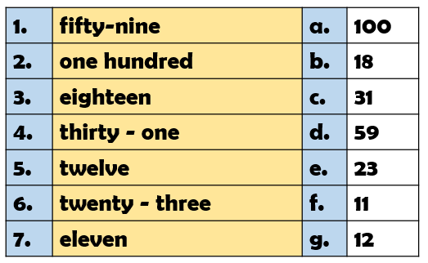
Ответы: 1) 2) 3) 4) 5) 6) 7)
V. Соотнесите места на картинках и слова, которые к ним относятся.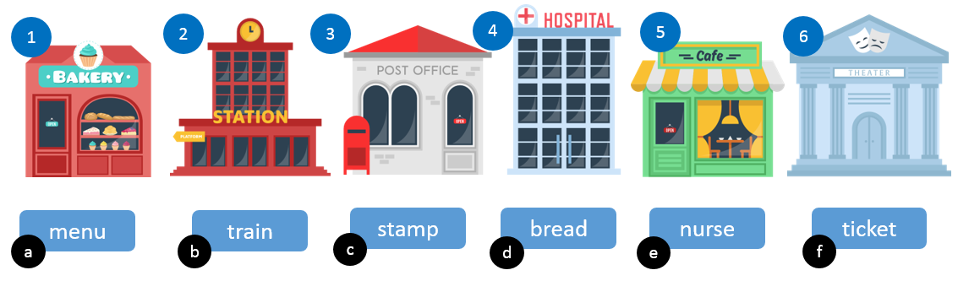

Ответы: 1) 2) 3) 4) 5) 6)

VI. Соотнесите запрещающие знаки и правила.
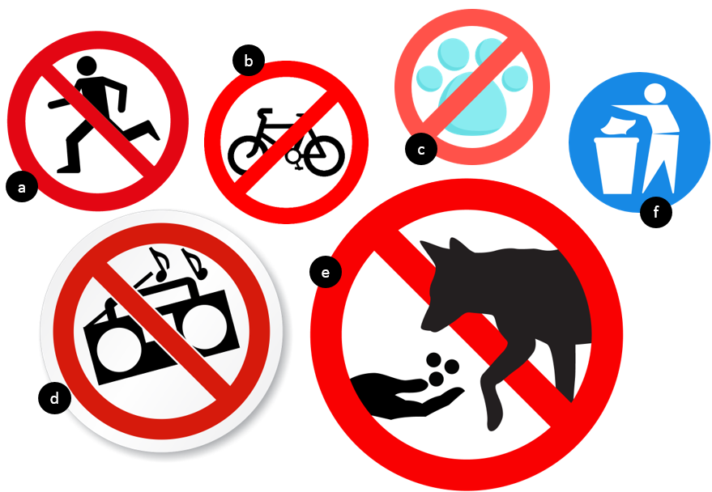
1. You must put your rubbish in the bin.
2. You mustn’t run.
3. You must leave your pets at home.
4. You mustn’t ride bikes.
5. You mustn’t play loud music.
6. You mustn’t feed the animals.

Ответы: 1) 2) 3) 4) 5) 6)

VII. Выберите подходящий по смыслу ответ.

1. Were you happy when you got a lot of presents?  2. When did you have your birthday party?  3. What presents did you get?  4. Do your parents send telegrams to their friends on their birthdays?  5. What holiday do you like best of all?  6. Can trees grow without water?  7. Different animals live in different countries, don’t they? | a) I got a big red and yellow ball and an English book as presents.  b) I like the New Year.  c) No, they can’t.  d) Yes, they do.  e) Yes, they usually do.  f) Yes, I was very happy.  g) Last month

Ответы: 1) 2) 3) 4) 5) 6) 7)

VIII. Соедини английские предложения с их русским переводом
1.One of the most popular activities a) Моя любимая игрушка- Винни Пух.
today is playing computer games. b) Игрушечные мишки и мягкие игрушки
2.His arms and legs move. также очень популярны.
3.Many of today’s toys use modern c) У него черный нос, черные глаза и
technology. маленькие уши.
4.It has a black nose, black eyes and little d) Oдним из наиболее популярных видов
ears. деятельности на сегодняшний день
5.I like my toy because it can carry является игра в компьютерные игры.
things around. e) Во многих современных игрушках
6.Teddy bears and soft toys are also very используют современные технологии.
popular. f) Его руки и ноги двигаются.
7.My favourite toy is Winnie the Pooh. g) Мне нравится моя игрушка, потому
что в ней можно носить вещи.

Ответы: 1) 2) 3) 4) 5) 6) 7)
IX. Найди соответствие.

- Hallowe’en  - April Fool’s Day  - Easter  - St. Valentine’s Day  - New Year  - Christmas  - Mother’s Day  - May Day | - January  - February  - March  - April  - May  - June  - July  - August  - September  - October  - November  - December

Ответы: 1) 2) 3) 4) 5) 6) 7) 8)
X. Найдите русский эквивалент к следующим пословицам.

- There is no place like home.  - East or West home is best.  - A friend in need is a friend indeed.  - An apple a day keeps the doctor away.  - The right thing in the right place.  - That’s another pair of shoes.  - Never put off till tomorrow what you can do today.  Ответы: 1) 2) 3) 4) 5) 6) 7)  Ключи к заданиям 4 класс (школьный этап).  Каждый правильный ответ оценивается в 1 балл.  Максимальное количество баллов – 74.  - Прочитайте текст. Выберите подходящее по смыслу слово.  1)c 2)a 3)d 4)b 5) a 6)b 7)c 8)a 9)c 10)b 11)a 12)b 13)c 14)d 15)a 16)a 17)b  II. Ответьте на вопросы по тексту.  1)b 2) b 3) a 4) d 5)a 6)d  III. Выберите подходящее по смыслу прилагательное .  1)more interesting 2)biggest 3)longer 4)the best 5)worse  - Выберите подходящее по смыслу слово  1)c 2)c 3) d 4)a 5)c 6)a 7)a 8)c 9)c 10)a 11)a 12)b 13)c 14)b 15)a 16)b  - Выберите подходящий по смыслу краткий ответ.  1)c 2)d 3)e 4) a 5)b 6)f  - Употребите a) some или b) any в следующих предложениях.  1) a 2)b 3) b 4) a 5b  VII.Употребите глаголы, данные в скобках, в нужном времени (Present Indefinite, Present Continuous, Past Indefinite, Future Indefinite).  - plays 2)am reading 3)drank 4)will come  VIII. Соотнеси слова и числа  1)g 2) a 3) c 4)d 5) e 6) b 7) f  IX. Расположите фразы телефонного разговора в правильном порядке.  1) b 2) g 3) e 4) d 5) a 6) c 7) f  - Прочитайте текст. Выберите подходящее по смыслу слово.  Ответы запишите после текста.  THE EARTH  We 1) … on the earth. It is very, very big. There is a lot of water 2) … the earth. It is in rivers, seas, and oceans. There are a lot 3) … forests and fields, hills and mountains on it.  The earth is full of wonders. Different animals live on the earth. Different plants grow on it. The earth 4) … beautiful.  There 5) … large countries and small countries. There are warm countries and cold countries. There are 6) … countries where there are four seasons in a year and some countries where there are only two.  When it is day 7) … one country it is night in another country. When the sun 8) … it is day, when the sun 9) … not shine it is night. You can see the 10) … and the stars in the sky at night.  People live in different 11) … . They speak 12) … languages.  Our country is one of the 13) … countries in the world. It is so large that when it is morning in the east, it is 14) … in the west. There are a lot of long rivers, beautiful lakes, large forests and fields and high mountains in 15) … country.  People who live in our country 16) … more than two hundred different 17) … .  1) a) lives b) life c) live d) love  2) a) on b) into c) with d) at  3) a) on b) into c) with d) of  4) a) are b) is c) am d) do  5) a) are b) is c) am d) do  6) a) any b) some c) no d) not  7) a) on b) into c) in d) under  8) a) shines b) shine c) shone d) shined  9) a) do b) did c) does d) done  10) a) sun b) moon c) birds d) animals  11) a) countries b) forests c) schools d) gardens  12) a) other b) different c) another d) much  13) a) large b) larger c) largest d) more large  14) a) morning b) day c) lunch d) evening  15) a) our b) their c) her d) your  16) a) speak b) speaks c) spoke d) spoken  17) a) language b) languages c) tongue d) tongues  Ответы: 1) 2) 3) 4) 5) 6) 7) 8) 9) 10) 11) 12) 13) 14) 15) 16) 17)  II Ответьте на вопросы по тексту.  - Where do people live?  a) on the moon b) on the earth c) on the stars d) in the sky  2) How many oceans are there on the earth?  a) two b) five c) four d) one  3) What are the oceans full of?  a) fish b) animals c) birds d) people  4) When can you see the moon in the sky?  a) in the morning b) in the evening c) in the afternoon d) at night  5) What country is the largest in the world?  a) Russia b) America c) Canada d) Australia  6) What language do people in Russia speak?  a) English b) French c) German d) Russian  Ответы: 1) 2) 3) 4) 5) 6)  III. Выберите и подчеркните подходящее по смыслу прилагательное .  - The film was (interesting, more interesting, the most interesting) than he thought.  - The (big, bigger, biggest) animal is the elephant.  - The tiger’s tail is (long, longer, the longest) than the dog’s.  - Peter is (good, better, the best) pupil in the class.  - Nick plays hockey (bad, worse, the worst) than Mike.  - Выберите подходящее по смыслу слово  - My grandmother… a teacher.  a) am; b) is; c) are; d) will  2) Mary… her breakfast at seven.  a) have; b) was; c) has; d) is  3) She… chocolate.  a) likes not; b) not like; c) don’t like; d) doesn’t like  4) Where… yesterday evening?  a) did you play; b) you did play; c) played you; d) did you played  5) Harry… TV every day.  a) is watching; b) watch; c) watches; d) are watching  6) He… a book now.  a) is reading; b) reads; c) are reading; d) read  7) Mary… at seven o’clock.  a) will come; b) come; c) is come; d) shall come  8) … read the text at the lesson tomorrow?  a) are they; b) shall they; c) will they; d) they will  9) My father is… engineer.  a) a; b) the; c) an; d) -  10) I am… pupil.  a) a; b) the; c) an; d) –  11) My brother is… than me.  a) older; b) more older; c) more old; d) oldest  12) This book is… than that one.  a) interesting; b) more interesting; c) interestinger; d) interestingest  13) I usually get up… eight.  a) in; b) on; c) at; d) under  14) The roses are …the vase.  a) on; b) in; c) at; d)  15) He is… Russia.  a) from; b) on; c) at; d) of  16) We live… Cheboksary.  a) from; b) in; c) on; d) of  Ответы: 1) 2) 3) 4) 5) 6) 7) 8) 9) 10) 11) 12) 13) 14) 15) 16) 17)  V. Выберите подходящий по смыслу краткий ответ.  1) Is she a doctor? a) Yes, it is.  2) Are they doctors? b) Yes, she has.  3) Does she want to be a doctor? c) Yes, she is.  4) Is it a dog? d) Yes, they are.  5) Has she got a dog? e) Yes, she does.  6) Do you like to play badminton? f) Yes, I do.  Ответы: 1) 2) 3) 4) 5) 6)  - Употребите a) some или b) any в следующих предложениях.  - I have … cheese.  - Is there … sugar in the cup?  - Are there … pencils in the box?  - There are … eggs on the plate.  - I don’t drink … milk. I like tea or coffee.  Ответы: 1) 2) 3) 4) 5)  - Употребите глаголы, данные в скобках, в нужном времени (Present Indefinite, Present Continuous, Past Indefinite, Future Indefinite).  - Tom (to play) football every day. ________________________________________________  - I (to read) an interesting book now. _______________________________________________  - My brother (to drink) coffee yesterday. ____________________________________________  - They (to come) to my place next week. ____________________________________________  - Соотнеси слова и числа  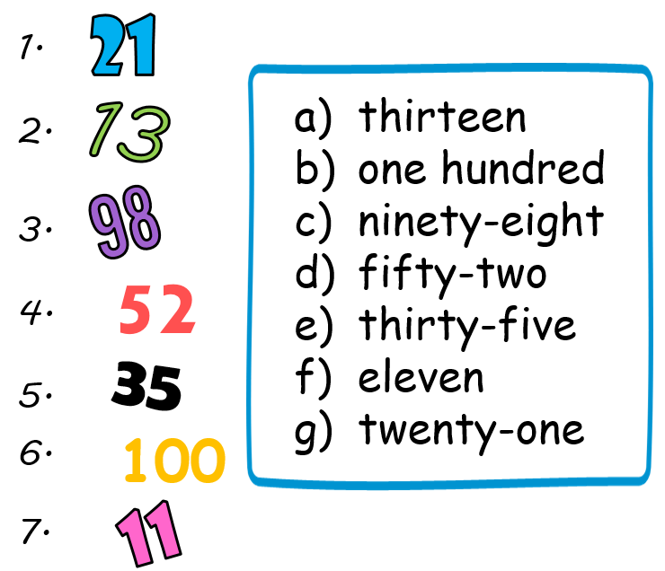  Ответы: 1) 2) 3) 4) 5) 6) 7)  IX. Расположите фразы телефонного разговора в правильном порядке.  a) Yes, he has.  b) Hi. It’s Jane here. Can I speak to Mark, please?  c) OK. Bye then.  d) Sure. Has he got your number?  e) Yes, please – can you ask him to ring me?  f) Thanks. Bye.  g) No, I’m sorry – he isn’t in. Can I take a message?  Ответы: 1) 2) 3) 4) 5) 6) 7)  . | a) Всему свое место.  b) Это совсем другое дело.  c) Завтра, завтра- не сегодня, так ленивцы говорят.  d) В гостях хорошо, а дома лучше.  e) Дома и стены помогают.  f) Друзья познаются в беде.  g) Кушай по яблоку в день и доктор не понадобится.

