HUMAN TEETH

Structure of Tooth

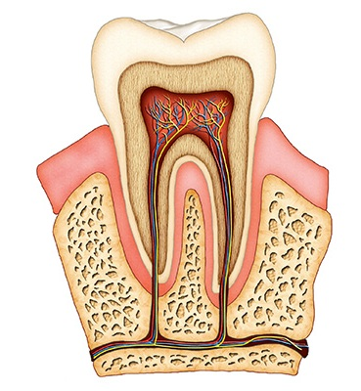

Fill in the gaps. There are two extra words.

Ex. 2 b, p. 116 A tooth has two main parts.  The 1) _____ is the part you can see and the 2) ______is the unseen part that is below the 3) ___ and fastens the tooth in the 4) _____.  The outer part of the tooth and the hardest substance in the body is 5) ____.  Underneath this is a layer of 6) _____which is softer than enamel but similar to bone. In the middle of the tooth is the 7) _____ . This contains cells, blood vessels and the nerve of the tooth. The pulp is protected by a layer called 8) ____which covers the root. | 1. crown  2.root  3.nerve  4.blood vessels  5.jaw bone  6.cementum  7.gum  8.dentin  9.pulp  10.enamel

toothache  enamel  calcium  toothpaste  fluoride  milk teeth  permanent teeth  tooth decay  acid bacteria | кислотная бактерия  фтор  зубная паста  кальций  эмаль  молочные зубы  гниение зубов  постоянные зубы  зубная боль

toothache  enamel  calcium  toothpaste  fluoride  milk teeth  permanent teeth  tooth decay  acid bacteria | кислотная бактерия  фтор  зубная паста  кальций  эмаль  молочные зубы  гниение зубов  постоянные зубы  зубная боль



