
Государственное бюджетное общеобразовательное учреждение
«Инженерно-технологическая школа №777» Санкт-Петербурга

Методическая разработка
урока английского языка в 7 классе
«Английский язык XIX века и его отличия от языка XXI века»

- Аннотация к уроку
«Английский язык XIX века и его отличия от языка XXI века» представляет собой одно из занятий тематической недели «Погружение в XIX век», которая проводится в ИТШ № 777 с 1 по 5 марта 2021 года. На уроке обучающиеся познакомятся с изменениями, которые произошли в литературном английском языке за двести лет, и получат опыт составления текстов на английском языке XIX века.

- Пояснительная записка к уроку
Автор | Денисенко Сергей Юрьевич, учитель английского языка ГБОУ «Инженерно-технологическая школа № 777»
Предмет | Английский язык
Класс | 7
Тема урока | Английский язык XIX века и его отличия от языка XXI века
Цель учителя | Формирование у обучающихся умения выбирать письменный язык, соответствующий эпохе
Планируемые результаты | Предметные:  - находить различия в лексике и грамматике в текстах разных веков;  - пользоваться словарём и подбирать лексику, соответствующую историческому времени;  - писать на литературном языке исторической эпохи.  Метапредметные:  Регулятивные: развивать способность к целеполаганию и устанавливать связь между целью деятельности и ее результатом, выполнять учебное задание в соответствии с заданным алгоритмом действий, контролировать и оценивать учебную деятельность и её результат.  Познавательные: анализировать примеры из литературных текстов, систематизировать полученные знания, составлять собственный текст заданного жанра.  Коммуникативные: развивать навыки общения с членами группы в процессе выполнения учебного задания, участвовать в продуктивном диалоге, слушать и понимать других, высказывать точку зрения по обсуждаемому вопросу; сотрудничать в совместном решении проблемы, представлять и защищать продукт своей деятельности.  Личностные: оценивать собственную учебную деятельность, проявлять уважительное и дружелюбное отношение к одноклассникам.
Технологии, используемые на уроке | - Информационно-коммуникативная технология;  - Здоровьесберегающая технология;  - Технология группового обучения;  - Игровая технология.
Методы и приемы | Проблемно-диалогический, учебно-практический.
Формы работы | Индивидуальная, парная, групповая, фронтальная.
Необходимое оборудование урока | Интерактивная доска, раздаточные материалы.

- Технологическая карта урока «Английский язык XIX века и его отличия от языка XXI века»

Содержание урока | Деятельность учителя | Деятельность обучающихся
Мотивационно-целевой этап урока
Эмоциональный настрой на урок. 1 мин. | Обеспечивает положительный настрой и мотивацию на урок за счет следующих вопросов:  - Good morning. How are you?  - Are you ready for the lesson? | Приветствуют учителя, описывают текущее настроение, готовятся к работе.
Актуализация знаний и фиксирования индивидуального затруднения в пробном действии. 4 мин.  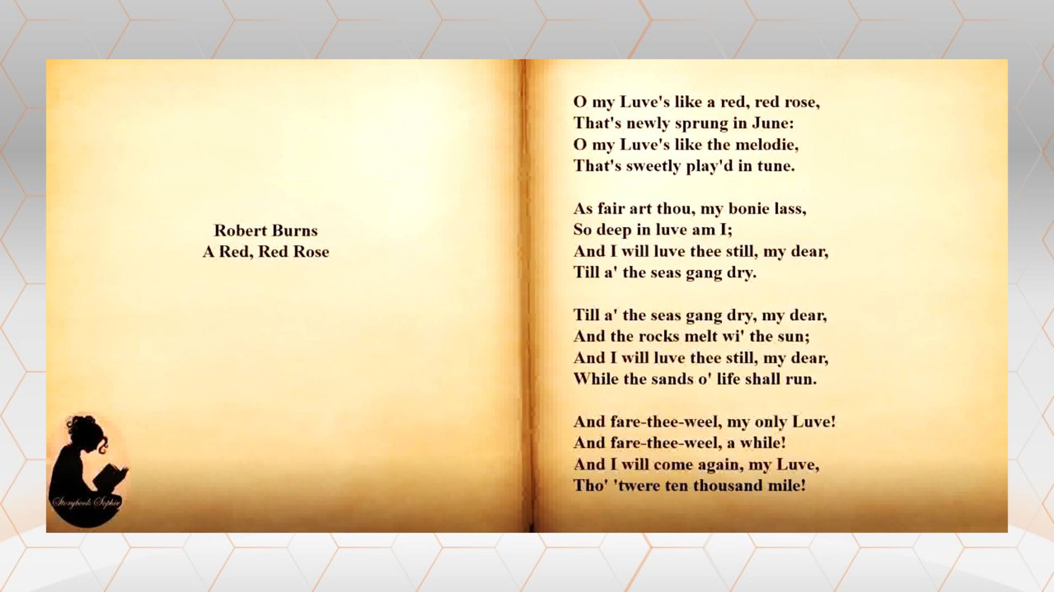 | Демонстрирует классу отрывок из произведения английского писателя XIX века, организует фронтальную беседу по следующим вопросам:  - Вы поняли текст?  - Что в нём было непонятно?  - Какова, по-вашему, причина этого? | Слушают записи, высказывают предположения, отвечают на вопросы, формулируют тему урока:  - Текст поняли частично.  - Встретилось много неизвестных слов.  - Непонятные слова, видимо, относятся к устаревшим.  - Язык со временем изменяется.  - Необходимо изучить различия между английским языком XIX и XXI веков.
Целеполагание и планирование действий обучающимися. 2 мин.  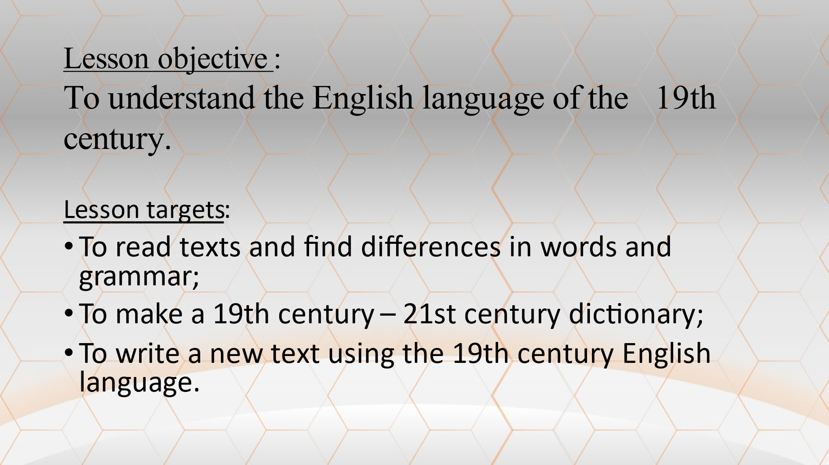 | Организует постановку целей и планирование действий обучающимися:  - Что нам потребуется, чтобы найти различия между языками XIX и XXI веков? | Формулируют цель деятельности, формулируют шаги по достижению цели:  - Изучить лексику и грамматику XIX века.  - Составить словарь.  - Написать учебный текст на языке XIX века.
Процессуальный этап урока
Первый шаг по достижению поставленной цели. Поиск устаревшей лексики. 5 мин.  Задание № 1 | Выдаёт учащимся рабочие листы (три варианта) и организует поиск устаревшей лексики в текстах:  - Найдите в текстах незнакомые (возможно, устаревшие) слова.  - Проявите языковую догадку: попытайтесь понять значение этих слов. | В парах изучают тексты, выписывают незнакомые слова, подбирают возможные значения этих слов.
Второй шаг по достижению поставленной цели. Составление мини-словаря английского автора XIX века. 10 мин.  Задание № 2 | Делит учащихся на три группы (по номерам вариантов) и предлагает им совместно составить мини-словарь автора (слово XIX века и соответствующее ему слово XXI века). | Работают в группах, обмениваются найденными лексическими единицами, составляют мини-словарь автора в алфавитном порядке.
Третий шаг по достижению поставленной цели. Закрепление полученных знаний. 10 мин.  Задания № 3 и 4. Словарь  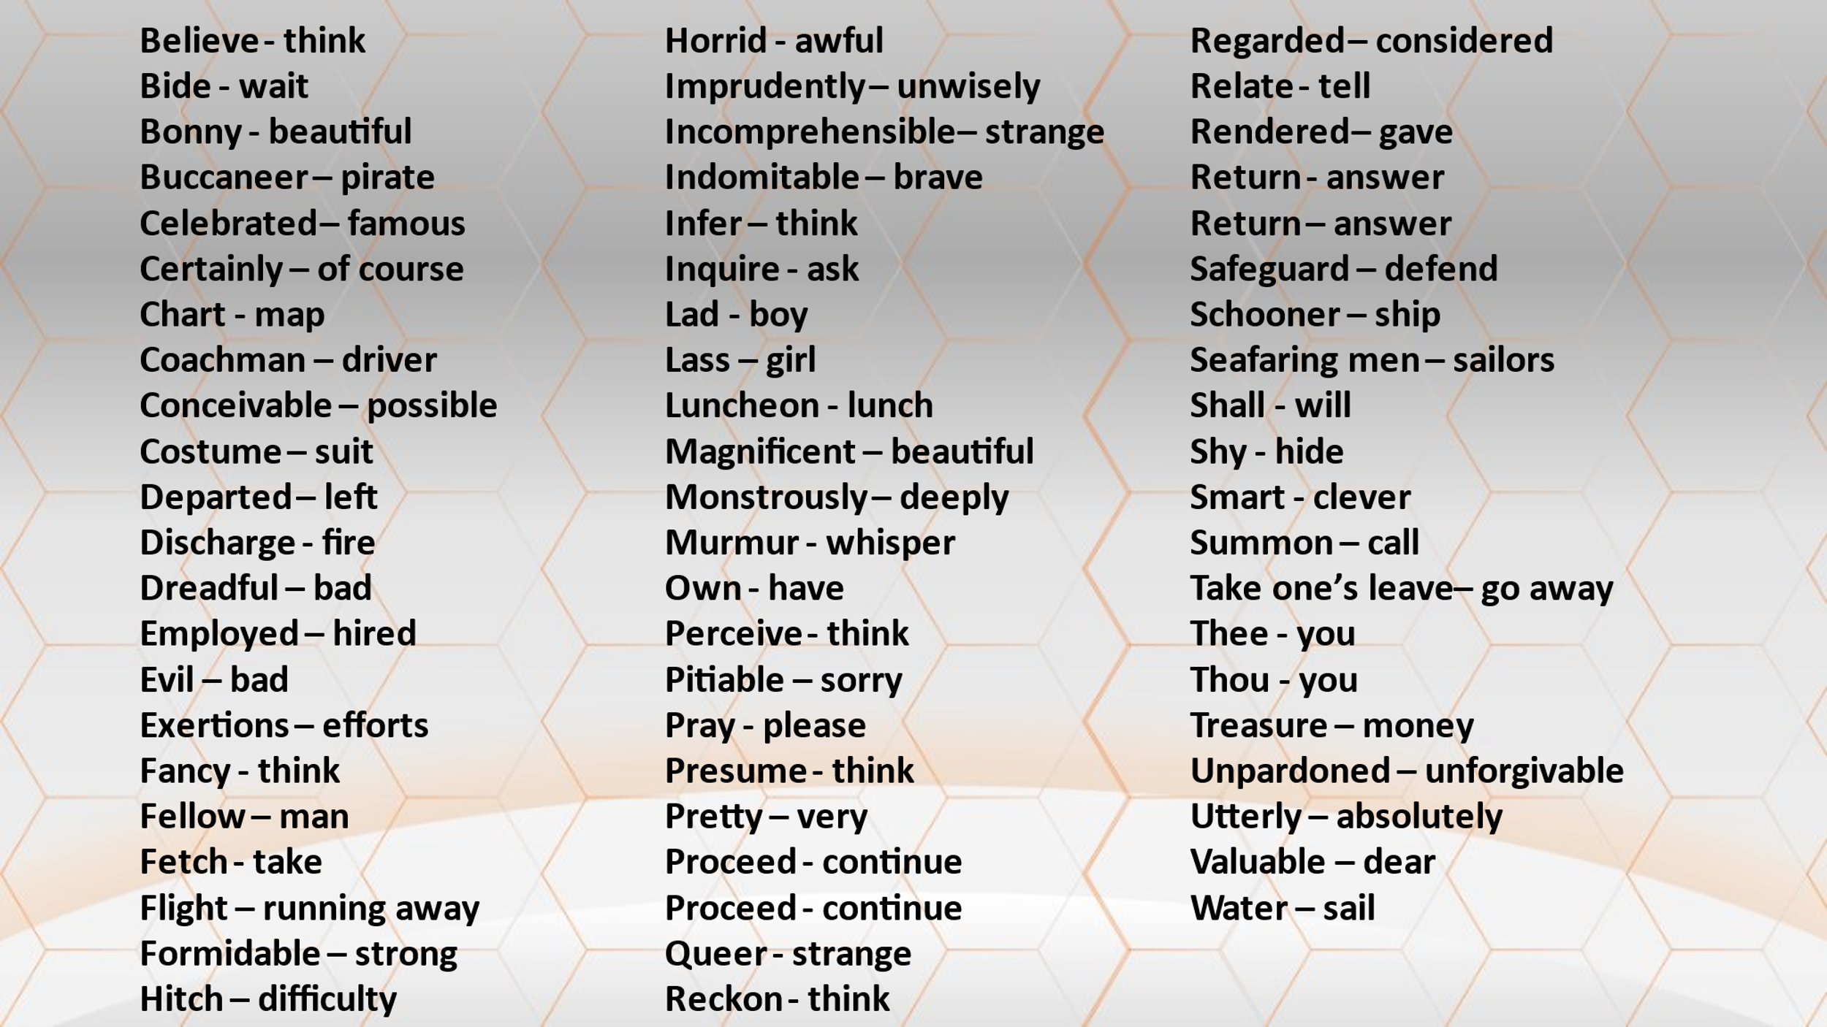 | Предлагает обучающимся в группах перевести учебный текст XXI века на язык XIX века, пользуясь словарями:  - составленными в группах;  и  - представленным на доске. | Выполняют задание в группах.
Четвёртый шаг по достижению поставленной цели. Представление продукта. 6 мин.  Рабочий лист. | Организует демонстрацию продукта совместной деятельности – переведённого группами учебного текста. | По одному представителю от каждой группы читают полученный текст. Две другие группы пополняют собственные словари, задают по одному уточняющему вопросу выступающему, например:  - Что означает слово …?
Рефлексивно-оценочный этап урока
Организация рефлексии деятельности. 2 мин.  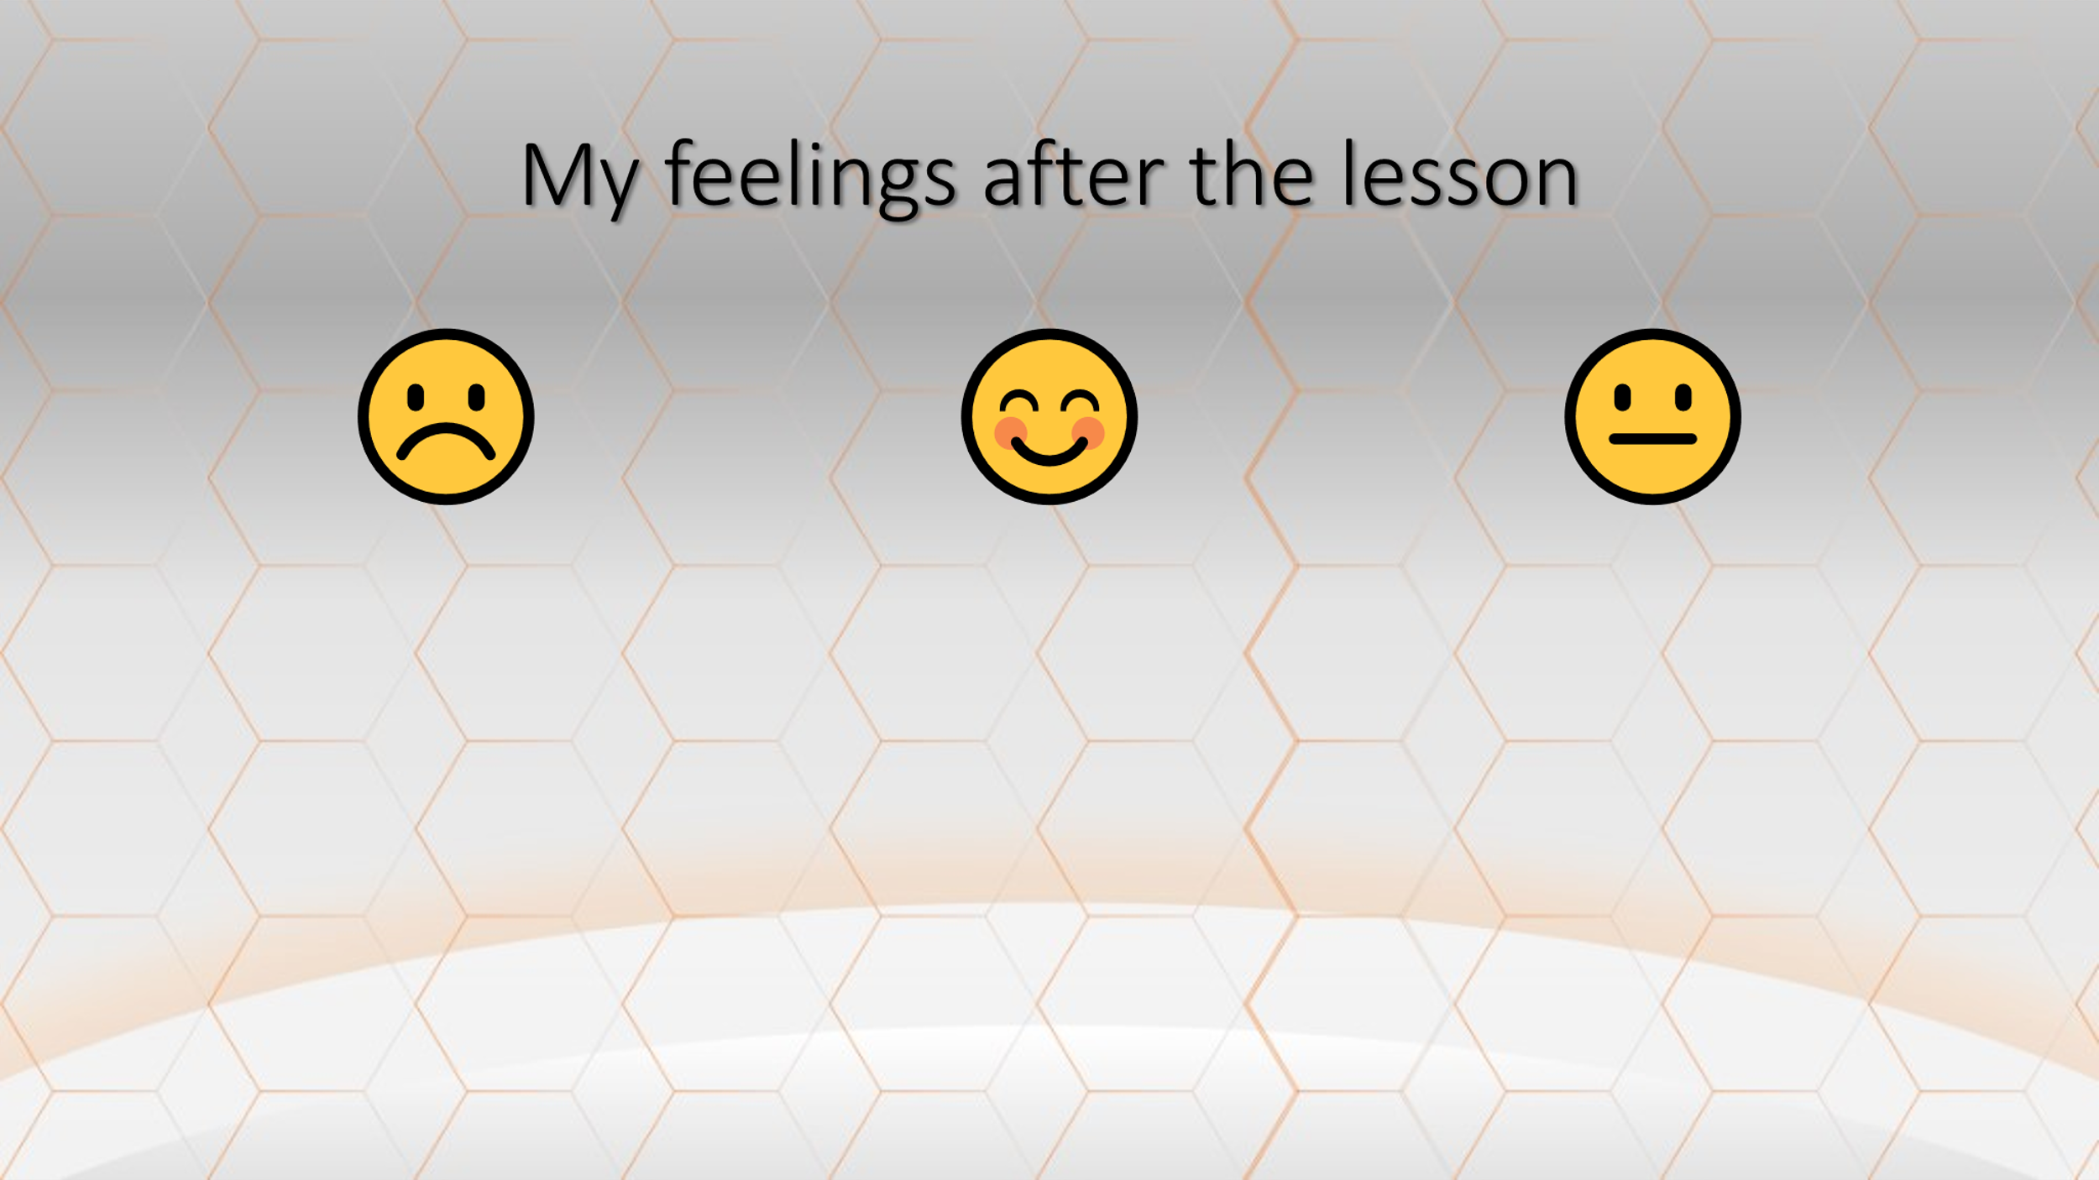 | Учитель организует подведение предметного итога и рефлексию деятельности по следующим вопросам:  - Что мы планировали сделать на уроке?  - Что мы добились?  - Что мы сделать не смогли?  - Как я чувствую себя к концу урока?  Учитель предлагает учащимся выразить их настроение, отметив одно из полей на интерактивной доске: отличное, среднее, неважное. | Участвуют в рефлексивной беседе, сопоставляют запланированные действия и результат, оценивают свои способности и настроение в конце урока.  Отмечают собственное настроение на интерактивной доске.
Выставление отметок за работу на уроке.  1 мин. | В ходе урока обучающимися осуществлялась самооценка, взаимооценка. В конце урока учитель аргументированно выставляет отметки отдельным ученикам за работу на уроке, расписывается в дневниках. | Выставляют отметки в дневник, подают дневники на подпись учителю.
Домашнее задание. 1 мин. | Объявляет классу домашнее задание:  - Составить письмо другу с приглашением на бал. Использовать язык XIX века. | Записывают домашнее задание в дневники.

- Приложения к уроку
- презентация .pdf;
- видеозапись английского стихотворения (https://www.youtube.com/watch?v=OCZ91mTxFi8&t=9s);
- раздаточные материалы (задания № 1 – 4, рабочий лист).

Задания № 1 - 4
Arthur Conan Doyle

1 Read the sentences and guess the meaning of the words in bold:

“Pray take a seat,“ said Homes. “This is my friend and colleague, Dr. Watson, who is occasionally good enough to help me in my cases. Whom have I the honour to address?”
“I was also aware of that,” murmured Holmes, settling himself down in his armchair and closing his eyes.
“This I presume is your celebrated friend, Mr. Sherlock Holmes?”
“Thank you. Pray proceed.”
“He is sure to be at the laboratory,” returned my companion. “He either avoids the place for weeks, or else he works there from morning to night. If you like, we shall drive round together after luncheon.”
“Certainly,” I answered, and the conversation drifted away into other channels.
“How are you?” he said cordially, gripping my hand with a strength for which I should hardly have given him credit. “You have been in Afghanistan, I perceive.”
“I think we have done all that can be done,” he answered; “it’s a queer case though, and I knew your taste for such things.”

2 Match the XIX century words (1-10) to their XXI century synonyms (A-J):

1 certainly | A answer
2 luncheon | B continue
3 murmur | C lunch
4 perceive | D of course
5 pray | E please
6 presume | F strange
7 proceed | G think
8 queer | H think
9 shall | I whisper
10 return | J will

3 Read the letter and fill in the XIX century words which are synonyms to the words in (brackets):

* celebrated * coachman * costume * departed * employed * evil * flight
* formidable * imprudently * safeguard

MY DEAR MR. SHERLOCK HOLMES,
You really did it very well. You took me in completely. Until after the alarm of fire, I had not a suspicion. But then, when I found how I had betrayed myself, I began to think. I had been warned against you months ago. I had been told that if the King __________ (hired) an agent it would certainly be you. And your address had been given me. Yet, with all this, you made me reveal what you wanted to know. Even after I became suspicious, I found it hard to think __________ (bad) of such a dear, kind old clergyman. But, you know, I have been trained as an actress myself. Male __________ (suit) is nothing new to me. I often take advantage of the freedom which it gives. I sent John, the _________ (driver), to watch you, ran up stairs, got into my walking-clothes, as I call them, and came down just as you __________ (left).

Well, I followed you to your door, and so made sure that I was really an object of interest to the __________ (famous) Mr. Sherlock Holmes. Then I, rather __________ (unwisely), wished you good-night, and started for the Temple to see my husband. We both thought the best resource was __________ (running away), when pursued by so __________ (strong) an antagonist; so you will find the nest empty when you call to-morrow. As to the photograph, your client may rest in peace. I love and am loved by a better man than he. The King may do what he will without hindrance from one whom he has cruelly wronged. I keep it only to __________ (defend) myself, and to preserve a weapon which will always secure me from any steps which he might take in the future. I leave a photograph which he might care to possess; and I remain, dear Mr. Sherlock Holmes,

Very truly yours,
IRENE NORTON, nee ADLER.

4 Read the completed sentences to the class.
Robert Lewis Stevenson

1 Read the sentences and guess the meaning of the words in bold:

‘That is all clear, and, I daresay, true enough,’ replied Livesey. ‘We take the risk; but we are not so ignorant as you believe us. Next, you say you don’t like the crew. Are they not good seamen?’
‘I don’t like them, sir,’ returned Captain Smollett. ‘And I think I should have had the choosing of my own hands, you go to that.’
‘Doctor,’ said the captain, ‘you are smart. When I came in here I meant to get discharged. I had no thought that Mr Trelawny would hear a word.’
‘That’s as you please, sir,’ said the captain. ‘You’ll find I do my duty.’
And with that he took his leave.
‘Well,’ says the doctor, ‘we shall see.
‘And now, men,’ said the captain, when all was sheeted home, ‘has any one of you ever seen that land ahead?’
‘I have, sir,’ said Silver. ‘I’ve watered there with a trader I was cook in.’
‘The anchorage is on the south, behind and islet, I fancy?’ asked the captain.
‘Well, here it is,’ said Silver. ‘We want that treasure, and we’ll have it – that’s our point! You would just as soon save your lives, I reckon; and that’s yours. You have a chart, haven’t you?’

2 Match the XIX century words (1-10) to their XXI century synonyms (A-J):

1 believe | A answer
2 discharge | B clever
3 chart | C fire
4 fancy | D go away
5 reckon | E map
6 return | F sail
7 shall | G think
8 smart | H think
9 take one’s leave | I think
10 water | J will

3 Read the letter and fill in the XIX century words which are synonyms to the words in (brackets):

* buccaneers * hitch * indomitable * magnificent * man * monstrously
* regarded * seafaring men * schooner * treasure
Dear Livesey,
The ship is bought and fitted. She lies at anchor, ready for sea. You never imagined a sweeter __________ (ship) —a child might sail her—two hundred tons; name, Hispaniola.
I got her through my old friend, Blandly, who has proved himself throughout the most surprising trump. The admirable _________ (man) literally slaved in my interest, and so, I may say, did everyone in Bristol, as soon as they got wind of the port we sailed for—treasure, I mean.
So far there was not a __________ (difficulty). The workpeople, to be sure—riggers and what not—were most annoyingly slow; but time cured that. It was the crew that troubled me.
I wished a round score of men—in case of natives, _________ (pirates), or the odious French—and I had the worry of the deuce itself to find so much as half a dozen, till the most remarkable stroke of fortune brought me the very man that I required.
I was standing on the dock, when, by the merest accident, I fell in talk with him. I found he was an old sailor, kept a public-house, knew all the ______________ (sailors) in Bristol, had lost his health ashore, and wanted a good berth as cook to get to sea again. He had hobbled down there that morning, he said, to get a smell of the salt.
I was _________ (deeply) touched—so would you have been—and, out of pure pity, I engaged him on the spot to be ship's cook. Long John Silver, he is called, and has lost a leg; but that I _____________ (considered) as a recommendation, since he lost it in his country's service, under the immortal Hawke. He has no pension, Livesey. Imagine the abominable age we live in!
Well, sir, I thought I had only found a cook, but it was a crew I had discovered. Between Silver and myself we got together in a few days a company of the toughest old salts imaginable—not pretty to look at, but fellows, by their faces, of the most __________ (brave) spirit. I declare we could fight a frigate.
I am in the most __________ (beautiful) health and spirits, eating like a bull, sleeping like a tree, yet I shall not enjoy a moment till I hear my old tarpaulins tramping round the capstan. Seaward ho! Hang the __________ (money)! It's the glory of the sea that has turned my head. So now, Livesey, come post; do not lose an hour, if you respect me.
John Trelawney

4 Read the completed sentences to the class.
Wilkie Collins

1 Read the sentences and guess the meaning of the words in bold:

‘Where is Rosanna?’ I inquired.
‘Rosanna’s late again for dinner,’ says Nancy. ‘And I’m sent to fetch her in. All the hard work falls on my shoulders in this house. Let me alone, Mr. Betteredge!’
‘You’re very kind, Mr. Betteredge,’ she said. ‘I don’t want any dinner to-day – let me bide a little longer here.’
‘There is one advantage about this horrid place,’ he said; ‘we have got it all to ourselves. Stay where you are, Betteredge; I have something to say to you.’
‘How do you come to know about the jugglers, sir?’ I asked, putting one question on the top of another, which was bad manners, I own. But you don’t expect much from poor human nature – so don’t expect much from me.
‘What are you thinking of?’ says Mr. Franklin, suddenly.
‘I was thinking, sir,’ I answered, ‘that I should like to shy the Diamond into the quicksand, and settle the question in that way.’
In one word, I told him: ‘Wait.’
‘With all my heart,’ says Mr. Franklin. ‘How long?’
I proceeded to explain myself.
I waited pretty confidently for that latter chance; but, strange to relate, it never came.
On the nineteenth another event happened. We had the doctor in the house professionally. He was summoned to prescribe for a person whom I have had occasion to present to you in these pages – our second housemaid, Rosanna Spearman.
2 Match the XIX century words (1-10) to their XXI century synonyms (A-J):

1 bide | A ask
2 fetch | B awful
3 horrid | C call
4 inquire | D continue
5 own | E have
6 pretty | F hide
7 proceed | G take
8 relate | H tell
9 shy | I very
10 summon | J wait

3 Read the letter and fill in the XIX century words which are synonyms to the words in (brackets):

* conceivable * dreadful * exertions * incomprehensible * infer * pitiable
* rendered * unpardoned * utterly * valuable
"You will wonder, I dare say" (her ladyship wrote), "at my allowing my own daughter to keep me perfectly in the dark. A Diamond worth twenty thousand pounds has been lost-- and I am left to __________ (think) that the mystery of its disappearance is no mystery to Rachel, and that some __________ (strange) obligation of silence has been laid on her, by some person or persons __________ (absolutely) unknown to me, with some object in view at which I cannot even guess. Is it __________ (possible) that I should allow myself to be trifled with in this way? It is quite conceivable, in Rachel's present state. She is in a condition of nervous agitation __________ (sorry) to see. I dare not approach the subject of the Moonstone again until time has done something to quiet her. To help this end, I have not hesitated to dismiss the police-officer. The mystery which baffles us, baffles him too. This is not a matter in which any stranger can help us. He adds to what I have to suffer; and he maddens Rachel if she only hears his name.
"My plans for the future are as well settled as they can be. My present idea is to take Rachel to London--partly to relieve her mind by a complete change, partly to try what may be done by consulting the best medical advice. Can I ask you to meet us in town? My dear Franklin, you, in your way, must imitate my patience, and wait, as I do, for a fitter time. The __________ (dear) assistance which you __________ (gave) to the inquiry after the lost jewel is still an __________ (unforgivable) offence, in the present __________ (bad) state of Rachel's mind. Moving blindfold in this matter, you have added to the burden of anxiety which she has had to bear, by innocently threatening her secret with discovery, through your __________ (efforts). It is impossible for me to excuse the perversity that holds you responsible for consequences which neither you nor I could imagine or foresee. She is not to be reasoned with--she can only be pitied. I am grieved to have to say it, but for the present, you and Rachel are better apart. The only advice I can offer you is, to give her time."

4 Read the completed sentences to the class.

Учебный словарь
XIX century – XXI century dictionary

Believe - think
Bide - wait
Bonny - beautiful
Buccaneer – pirate
Celebrated – famous
Certainly – of course
Chart - map
Coachman – driver
Conceivable – possible
Costume – suit
Departed – left
Discharge - fire
Dreadful – bad
Employed – hired
Evil – bad
Exertions – efforts
Fancy - think
Fellow – man
Fetch - take
Flight – running away
Formidable – strong
Hitch – difficulty
Horrid - awful
Imprudently – unwisely
Incomprehensible – strange
Indomitable – brave
Infer – think
Inquire - ask
Lad - boy
Lass - girl
Luncheon - lunch
Magnificent – beautiful

Monstrously – deeply
Murmur - whisper
Own - have
Perceive - think
Pitiable – sorry
Pray - please
Presume - think
Pretty - very
Proceed - continue
Proceed - continue
Queer - strange
Reckon - think
Regarded – considered
Relate - tell
Rendered – gave
Return - answer
Return – answer
Safeguard – defend
Schooner – ship
Seafaring men – sailors
Shall - will
Shy - hide
Smart - clever
Summon – call
Take one’s leave – go away
Thee - you
Thou - you
Treasure – money
Unpardoned – unforgivable
Utterly – absolutely
Valuable – dear
Water – sail

Рабочий лист
Group __________
Worksheet

1
Name, surname | Role in the group | Completed task number… | Completed (Y/N)
 | Chairman
 | Secretary
 | Brain
 | Speaker

2
Name, surname | At this lesson  I learnt… | The material was… to me | My discovery during the lesson | After the lesson  I want to… | After the lesson  I feel…

5. Список литературы
5.1. https://nsportal.ru/shkola/inostrannye-yazyki/angliiskiy-yazyk/library/2013/08/05/proektirovanie-sovremennogo-uroka
5.2. https://multiurok.ru/files/proektirovanie-sovremennogo-uroka-angliiskogo-iazy.html
5.3. https://uchitelya.com/angliyskiy-yazyk/22580-proektirovanie-sovremennogo-uroka-angliyskogo-yazyka.html

