Тамбовское Областное Государственное Автономное Профессиональное Образовательное Учреждение
«Тамбовский бизнес-колледж»

Методическая разработка
открытого урока по теме:
«What is a computer?»

Разработала: Преподаватель
иностранного языка
Алексеева Т.А.

2021 г.

План – конспект урока

Дисциплина: Иностранный язык
Группа:
Тип урока – комбинированный.
Форма урока – урок совершенствования умений и навыков.
Метод обучения - репродуктивный.
Цель: Активизация употребление компьютерной лексики в речи cстудентов по теме:
« What is a computer?”

Задачи
обучающие:
- развивать умение логически правильно строить устное и письменное высказывание;
- аргументировать свою точку зрения, делать выводы, выражать свое мнение;
- анализировать текст, выделять главное, сравнивать, сопоставлять прочитанное;
развивающие:
- развивать интеллектуальные способности учащихся, навыки творческого мышления, языковой догадки;
- развивать умения поиска, анализа и оценки информации, необходимой для профессионального и личностного развития;
воспитательные:
- мотивировать учащихся на дальнейшее изучение английского языка и его использование в своей будущей профессии;
- способствовать расширению общего кругозора студента;
- понимать сущность и социальную значимость своей будущей профессии, проявлять к ней устойчивый интерес;
- стимулировать учащихся к самостоятельной работе.
Освоение содержания урока обеспечивает достижение студентами следующих результатов:
личностных:
- сформированность ценностного отношения к языку как к культурному феномену и средству отображения развития общества;
- готовность и способность вести диалог на английском языке с представителями других культур, достигать взаимопонимания, находить общие цели и сотрудничать в различных областях для их достижения;
- готовность и способность к непрерывному образованию, включая самообразование, как в профессиональной области с использованием английского языка, так и в сфере английского языка;
метапредметных:
- умение самостоятельно выбирать успешные коммуникативные стратегии в различных ситуациях общения;
- владение навыками проектной деятельности, моделирующей реальные ситуации межкультурной коммуникации;
- умение организовать коммуникативную деятельность, продуктивно общаться и взаимодействовать с ее участниками, учитывать их позиции, эффективно разрешать конфликты;
- умение ясно, логично и точно излагать свою точку зрения, используя адекватные языковые средства;
предметных:
- сформированность коммуникативной иноязычной компетенции, необходимой для успешной социализации и самореализации;
- сформированность умения использовать английский язык как средство для получения информации из англоязычных источников в образовательных и самообразовательных целях.
Материально-техническое обеспечение занятия: компьютер, мультимедийный проектор, экран, раздаточный материал.
Предварительная работа: домашнее задание – подготовка презентации или монологического высказывания на тему «What is a computer ?».

Ход урока:

1. Организационный момент
а) Приветствие студентов

Hello /Good afternoon students. ( Hello /Good afternoon Татьяна Александровна)

I’ m glad to see you again. Sit down, please

Today there is a special guest in our classroom.
Let me introduce to you my colleague Демура Л.Н.( Hello /Good afternoon Лариса Николаевна)
She wants to see how you can work at the English lesson, how you understand me and each other. Don’t be nervous but be active and work carefully.

Беседа с дежурным:
What day is it today?
What is the date today?
Is anybody absent today?

б) Ознакомление с задачами урока
A few words about the plan of our lesson.
1. At first, we’ll start with the speech practice.
2. Then we’ll check up your homework.
3. And at last the work with a text: « What is a computer ?»

Let’s begin our work.

Look at the screen. You’ll watch some video and then tell me what device we are going to talk about today.
Просмотр видео и введение в тему урока.
Приложение 1. Видеофайл «What is a computer? »
What device is it? – It is a computer.
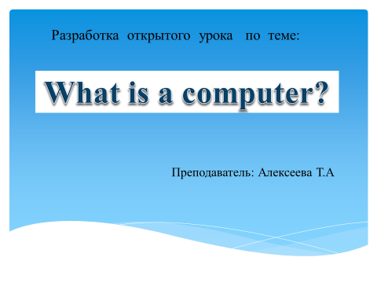

So the theme of our lesson is “What is a computer” (название темы появляется на экране).

Приложение 2. Слайд «Тема».
Write down the theme of our lesson in your notebook

Учащиеся записывают дату и название темы в тетрадях.

2. Постановка цели и определение задач по ее достижению
So, we are going to speak about the role of computers in our lives.
The task of our lesson is to systematize your knowledge about computers, to develop your skills and interest to your future profession.

Речевая зарядка
Who would like to speak about computers? Монологическая речь по теме
It”s time for speech practice
I want you to answer the questions.
.
Do you have a PC at home?
Can you use it?
What can you do?

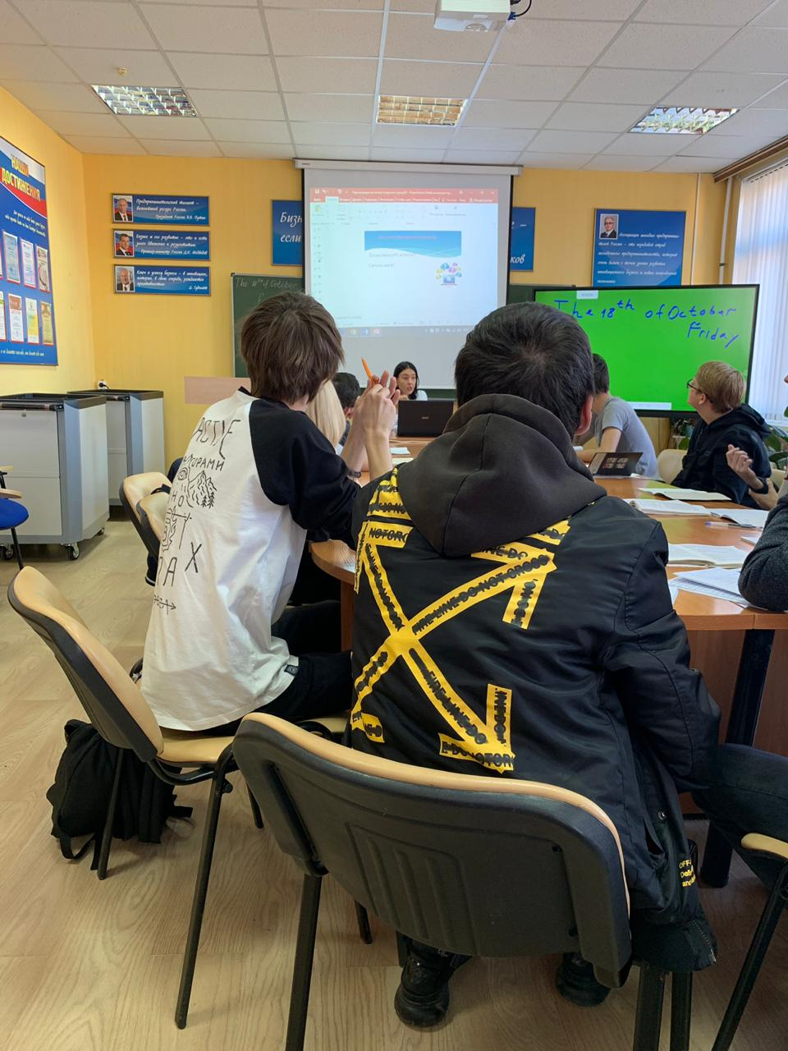

3. Проверка домашнего задания по теме «Компьютер в моей жизни»

Computers have become the most useful appliance in everyone’s homes nowadays and they have certainly changed our lives for the better.
What are the main parts of a computer? Let’s look at the screen and repeat the words altogether.
Просмотр видео и повторение лексики за диктором и индивидуально.
Приложение 3. Видеофайл «Компьютерный словарь».
https://urok.1sept.ru/%D1%81%D1%82%D0%B0%D1%82%D1%8C%D0%B8/674366/pril3.mp4

As we see computers play the important role in our life.
Our students have prepared the presentations. You can see it on the screen. Listen to the students’ reports very attentively and be ready to answer the questions.

Now let’s listen to the presentations of our students.
Трое студентов представляют свои презентации. После каждой презентации задается по 3-4 вопроса по их содержанию.

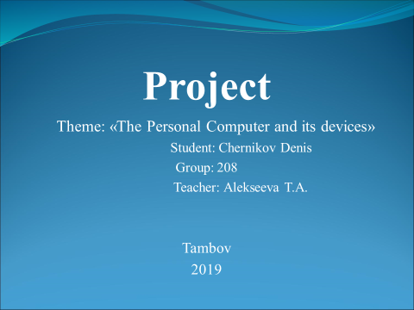

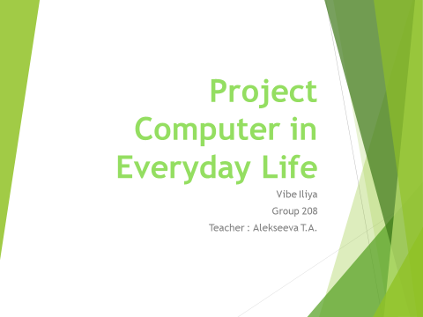

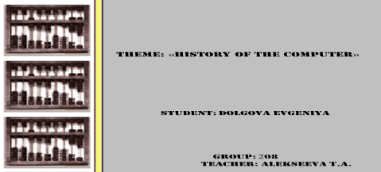

4. Расширение и систематизация знаний по теме «Компьютер в нашей жизни»
Интерактивная работа со слайдами «Для чего мы используем компьютер?», «изобретения 20-го века и их функции»;
Просмотр видео «Что такое компьютер?» и ответы на вопросы по нему.
Просмотр презентации «Персональный компьютер» с записью в тетрадях ключевых моментов, ответы на вопросы
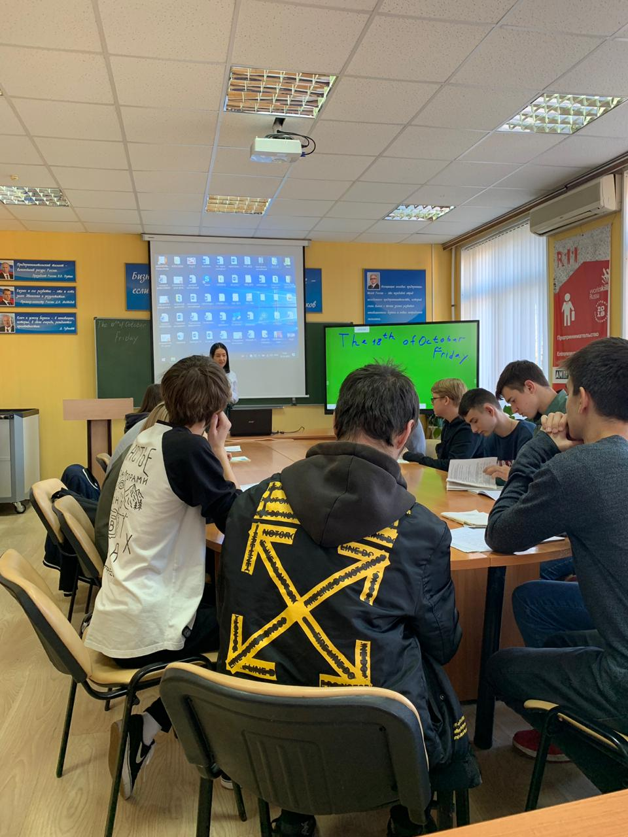

5 Приложение Видеофайл «Computers»
После просмотра видео студенты отвечают на вопросы:
1. Which combinations (compounds, components) do computers use? (Hardware and software).
2. How many styles of computers do you know? (PC and MAC).
3. What is the most common style? (PC).
We won’t talk about hardware and software in details because there will be a lesson devoted to these things at the end of the term. Now let’s speak about different types of computers.
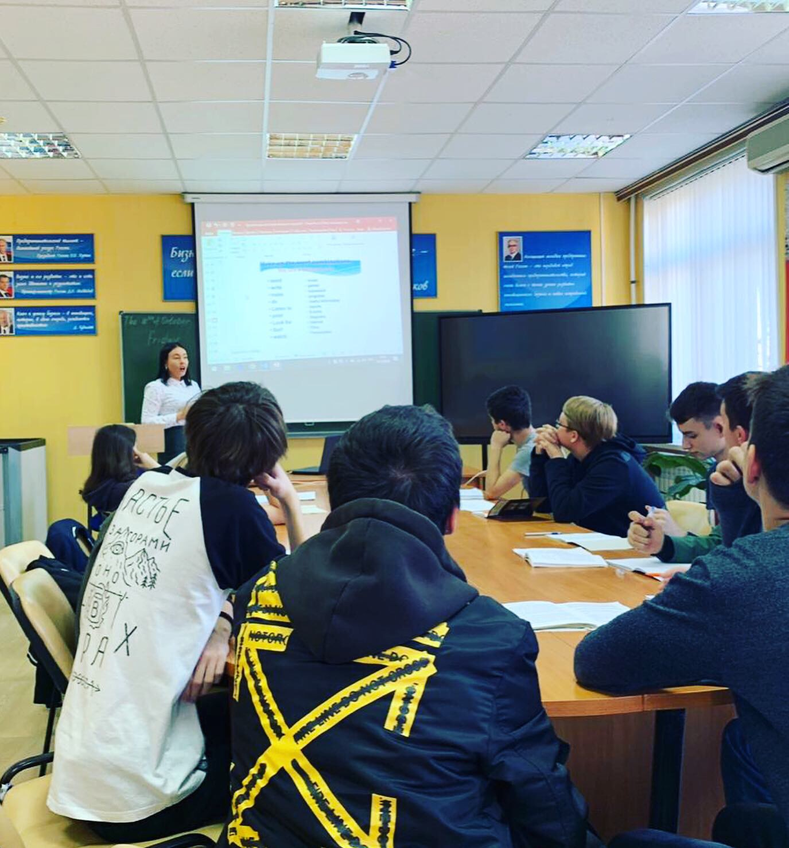
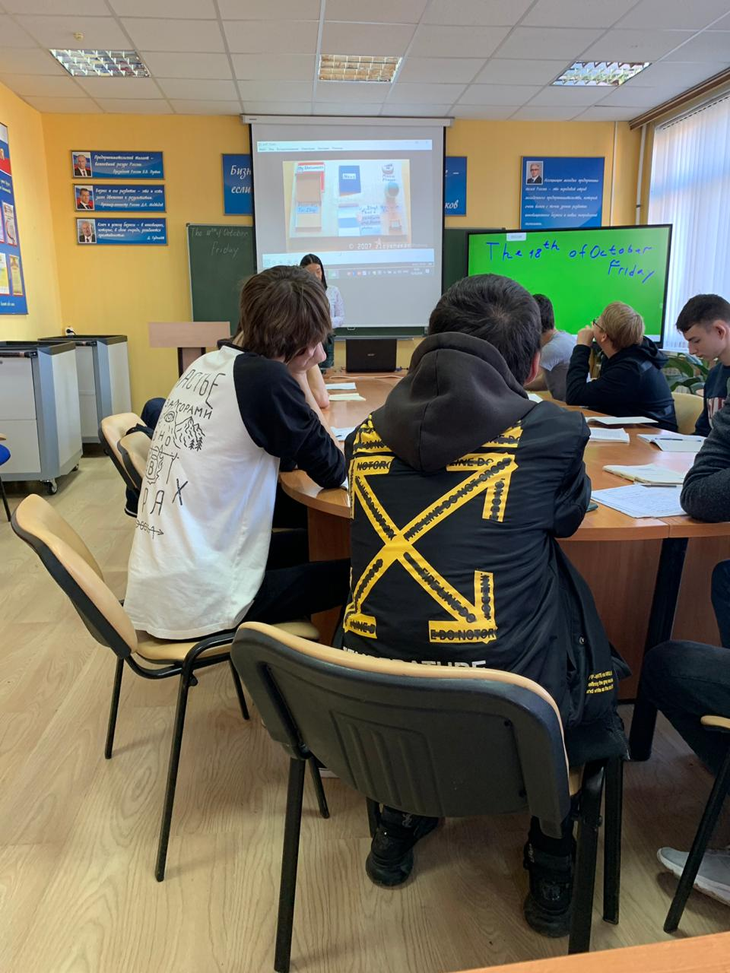

6
TEXT
What is a Computer?
A computer is a machine with an intricate network of electronic circuits that operate switches or magnetize tiny metal cores. The switches, like the cores, are capable of being in one of two possible states, that is, on or off; magnetized or demagnetized. The machine is capable of storing and manipulating numbers, letters and characters. The basic idea of a computer is that we can make the machine do what we want by inputting signals that turn certain switches on and turn the others off, or that magnetize or do not magnetize the cores.
The basic job of computers is the processing of information. For this reason, computers can be defined as devices which accept information in the form of instructions called a program and characters called data, perform mathematical and/or logical operations on the information, and then supply results of these operations. The program, or part of it, which tells the computers what to do and the data, which provide the information needed to solve the problem, are kept inside the computer in a place called memory.
Computers are thought to have many remarkable powers. However, most computers, whether large or small have three basic capabilities. First, computers have circuits for performing arithmetic operations, such as: addition, subtraction, division, multiplication and exponentiation. Second, computers have a means of communicating with the user. After all, if we couldn’t feed information in and get results back, these machines wouldn’t be of much use. However, certain computers (commonly minicomputers and microcomputers) are used to control directly things such as robots, aircraft navigation systems, medical instruments, etc.
Some of the most common methods of inputting information are to use punched cards, magnetic tape, disks, and terminals. The computer’s input device (which might be a card reader, a tape drive or disk drive, depending on the medium used in inputting information) reads the information into the computer. For outputting information, two common devices are a printer which prints the new information on paper, or a CRT display screen which shows the results on a TV like screen.
Third, computers have circuits which can make decisions. The kinds of decisions which computer circuits can make are not of the type: “Who would win a war between two countries?” or “Who is the richest person in the world?”. Unfortunately, the computer can only decide three things, namely: is one number less than another? Are two numbers equal? and, Is one number greater than another?
A computer can solve a series of problems and make hundreds, even thousands of logical decisions without becoming tired or bored. It can find the solution to a problem in a fraction of the time it takes a human being to do the job. A computer can replace people in dull, routine tasks, but it has no originality; it works according to the instructions given to it and can not exercise and value judgements. There are times when a computer seems to operate like a mechanical “brain”, but its achievements are limited by the minds of human beings. A computer cannot do anything unless a person tells it what to do and gives it the appropriate information; but because electric pulses can move at the speed of light, a computer can carry out vast numbers of arithmetic-logical operations almost instantaneously. A person can do everything a computer can do, but in many cases that person would be dead long before the job was finished.

Упражнение 15. Заполните пропуски при помощи данных слов в форме единственного или множественного числа (некоторые слова могут быть использованы более одного раза):
core device data circuit terminal switch

program
memory medium CRT display
- Every computer has … for performing arithmetic operations, operating … or magnetized ….
- A … with a screen is normally referred to as a … … unit.
- A computer is a … that processes information in the form of … and … and can store this information in a ….
- Card readers, tape drives, or disk drives are different … for inputting information.

7
Today we have tried to discuss a very interesting theme “What is a computer.” We have learned a lot of important and interesting information about computers in our lives. I think our work was useful and fruitful. I’m glad that each of you had an opportunity to tell us your opinion on the theme.
Thank you for your active and hard work. Your marks are good and excellent.
Your hometask for the next lesson is to read and translate the text about the Internet. Be ready to discuss it next time.

Учитель раздает студентам тексты для домашней работы.
What is a Computer?
A computer is a machine with an intricate network of electronic circuits that operate switches or magnetize tiny metal cores. The switches, like the cores, are capable of being in one of two possible states, that is, on or off; magnetized or demagnetized. The machine is capable of storing and manipulating numbers, letters and characters. The basic idea of a computer is that we can make the machine do what we want by inputting signals that turn certain switches on and turn the others off, or that magnetize or do not magnetize the cores.
The basic job of computers is the processing of information. For this reason, computers can be defined as devices which accept information in the form of instructions called a program and characters called data, perform mathematical and/or logical operations on the information, and then supply results of these operations. The program, or part of it, which tells the computers what to do and the data, which provide the information needed to solve the problem, are kept inside the computer in a place called memory.
Computers are thought to have many remarkable powers. However, most computers, whether large or small have three basic capabilities. First, computers have circuits for performing arithmetic operations, such as: addition, subtraction, division, multiplication and exponentiation. Second, computers have a means of communicating with the user. After all, if we couldn’t feed information in and get results back, these machines wouldn’t be of much use. However, certain computers (commonly minicomputers and microcomputers) are used to control directly things such as robots, aircraft navigation systems, medical instruments, etc.
Some of the most common methods of inputting information are to use punched cards, magnetic tape, disks, and terminals. The computer’s input device (which might be a card reader, a tape drive or disk drive, depending on the medium used in inputting information) reads the information into the computer. For outputting information, two common devices are a printer which prints the new information on paper, or a CRT display screen which shows the results on a TV like screen.
Third, computers have circuits which can make decisions. The kinds of decisions which computer circuits can make are not of the type: “Who would win a war between two countries?” or “Who is the richest person in the world?”. Unfortunately, the computer can only decide three things, namely: is one number less than another? Are two numbers equal? and, Is one number greater than another?
A computer can solve a series of problems and make hundreds, even thousands of logical decisions without becoming tired or bored. It can find the solution to a problem in a fraction of the time it takes a human being to do the job. A computer can replace people in dull, routine tasks, but it has no originality; it works according to the instructions given to it and can not exercise and value judgements. There are times when a computer seems to operate like a mechanical “brain”, but its achievements are limited by the minds of human beings. A computer cannot do anything unless a person tells it what to do and gives it the appropriate information; but because electric pulses can move at the speed of light, a computer can carry out vast numbers of arithmetic-logical operations almost instantaneously. A person can do everything a computer can do, but in many cases that person would be dead long before the job was finished.

c) Просмотрите вновь текст и скажите, верны ли данные утверждения. Измените предложения, содержащие неправильную информацию так, чтобы они тоже стали верными:
- A computer can store or handle any data even if it hasn’t received information to do so.
- All computers accept and process information in the form of instructions and characters.
- The information necessary for solving problems is found in the memory of the computer.
- Not all computers can perform arithmetic operations, make decisions, and communicate in some way with the user.
- Computers can still be useful machines even if they can’t communicate with the user.
- There are many different types of devices for feeding information into a computer.
13
- There aren’t as many different types of devices used for giving results as there are for accepting information.
- Computers can make any type of decision they are asked to.
- Computers can work endlessly without having to stop to rest unless there is a breakdown.



References
- What is a computer? Учебное пособие./Сост. Мороз И.Н.
- https://youtu.be/7cXEOWAStq4
- https://youtu.be/egRtFPavFBY

