Муниципальное бюджетное учреждение дополнительного образования города Мценска «Детско-юношеский центр»

Конспект занятия
по теме:
"Writers and poets of the Oryol region"
«Писатели и поэты Орловского края»
для обучающихся 5 класса

Автор:
педагог дополнительного образования
Медведева Ирина Сергеевна

г. Мценск
2020 г.

Тема: Литературный сквер Орла
Тип занятия: комбинированное
Режим работы: фронтальный, индивидуальный, в парах.
Цель – формировать представление об истории и культуре Орловского края; содействовать готовности ознакомлению с ней представителей других народов.
Задачи:
Обучающие: знакомить со знаменитыми писателями и поэтами Орловской области; формировать умения понимать содержание текста, реализовать имеющиеся знания путем активизации лексических единиц;
овладеть новыми способами познавательной деятельности.
Развивающие: совершенствование языковых и речевых навыков в ситуации речевого общения по теме «Культура родного края»;
стимулировать у каждого обучающегося желание проявлять инициативу;
развивать интерес к изучению родного края.
Воспитательные: воспитывать чувство гордости за своих земляков, за свой регион; воспитывать умение работать в паре.
Оборудование: презентация по теме «Writers of Oryol», карточки для работы у доски, фотографии памятников писателям для мини-проекта «Literary Square of the city of Oryol», тексты с заданиями для работы в мини- группах.
Ход занятия
I. Организационный момент
-Hello, boys and girls! Nice to see you!
-Hello, teacher! Nice to see you too!
II.Актуализация знаний
- Many people around the world love to read. Do you read books? What authors do you read? Do you know writers from our region? What are their names? (- Многие люди во всем мире любят читать. Вы читаете книги? Каких авторов вы читаете? Каких писателей нашего края вы знаете?)

III. Работа по теме
1.Работа с презентацией «Writers of Oryol»
-Let's see the presentation and find out what the city of Oryol is known for?
Обучающиеся смотрят презентацию, читают по очереди комментарии к слайдам. Педагог объясняет незнакомые слова.
1слайд - Oryol is a beautiful old Russian town. Do you know what is it famous for?
2 слайд - Many talented writers of Russia lived in Oryol. In the historical centre of the city there is a Museum of writers in Orel.
3 слайд- The Museum of Writers in Oryol tells about Russian writers and poets who lived and worked in Oryol. You can learn about the life and work of Turgenev and Bunin, Leskov, Fet and others (F. Tyutchev, P. Yakushkin, A. Apukhtin, M. Prishvin, L. Andreev).
4 слайд - Next to the city park you can see the Turgenev’s Monument. It is on the bank of the Oka River. People called this place Turgenev’s Coast. The monument is popular among citizens and tourists.
5 слайд - The famous writer N. Leskov was born in Oryol. In this city he spent his childhood and received an education. The monument to Leskov is on the banks of the Orlik River. This monument you can see next to the gymnasium (school) where Leskov studied.
6 слайд - Famous writer, poet and translator Ivan Bunin grew up and was educated in Oryol. In Oryol, he published his first book. Bunin wrote his first poems at 17 years old. In his works you will feel the love for the nature of the native land.
7 слайд -Afanasy Fet was born near the town of Mtsensk. Here he spent his childhood and youth. The nature of the native land played an important role in the work of Fet. The bust of the famous poet is set next to the "House of Writers ", in the center of Oryol. Works of the poet are known and popular in Russia.
8 слайд - Leonid Andreev one of the most popular writers of the early twentieth century. Andreev is a talented artist as well. He was fond of photography and drawing. His books wrote about people, their thoughts.
9 слайд - In Oryol there is a Square of writers from Orel. The figures of the five most popular writers are located in the park. Here you will see Turgenev, Leskov, Fet, Bunin and Andreev. Oryol played an important role in the work of each of them.
Изображение последнего слайда остаётся на экране.
2. Выполнение задания на доске
- What could you find out about our hometown? What famous writers did live and create in Oryol? (- Что вы узнали о нашем родном городе? Какие известные писатели жили и творили в Орле?)
-Match the information (соотнесите информацию).
На доске фамилии Орловских писателей и информация о них из презентации. Обучающиеся выходят к доске и прикрепляют информацию о писателе рядом с его фамилией.
Keys (ключи):
I.S. Turgenev – Turgenev’s coast
Ivan Bunin - writer, poet and translator
Afanasy Fet - was born near Mtsensk
Leonid Andreev - writer, photographer and artist
Nikolay Leskov - the monument is located next to his school
IV.Выполнениемини-проекта «Literary Square of the city of Oryol»
-Let’s collect the information about the writers from Literary Square of the city of Oryol and make the school exhibition. (Соберем информацию о писателях с Литературной площади города Орла и сделаем школьную выставку.)
Обучающиеся работают в парах с новой информацией. Пары формируются «в слепую». Обучающиеся выбирают фотографии скульптуры писателя или поэта из Литературного Сквера. Тексты напечатаны крупным шрифтом. Необходимо прочитать текст, вставить пропущенные слова, которые предложены в задании.
-Read your texts, fill in missing words and translate. You have a few minutes.
Во время выполнения задания педагог проверяет работу групп. Затем обучающиеся выходят к доске, прикрепляют на доску под вывеской «Literary Square of the city of Oryol» фотографию скульптуры писателя или поэта, сообщают информацию одноклассникам, прикрепляют её на доску.
Текст № 1: Ivan Bunin
Слова для работы с текстом: to. in, Oryol, was, didn’t.
Ivan Bunin was born in the Voronezh region 1) _____ 1870, but his childhood and youth were spent in 2) _____. As a child, he loved 3) ____ read Pushkin's poems and English poetry. At the age of eight, he composed his first poem. He 4) _____ (not) like Maths. Bunin knew English, Polish and was a good translator. He has translated many works of English poetry.
Bunin traveled a lot in Africa and Europe. He 5) _____ a very active person: he loved horse riding, danced well.
Текст № 2: Nicolay Leskov
Слова для работы с текстом: at, writers, didn’t, his, was.
Nicolay Leskov is one of the world famous 1) _______ of the Oryol region. Leskov 2) ______ born in 1831 on February 4 in the village of Gorokhovo. He studied at the Oryol gymnasium but he 3) _______(not) like to study there. Nikolai received a good education 4) _____ home. Leskov traveled a lot in Russia. He collected paintings, watches and books. Leskov began publishing 5) ______ stories at the age of 26. Leskov's most famous story is “Left-handed”. Students read this work at school.

Текст № 3: Afanasy Fet
Слова для работы с текстом: to, are, with, his, home.
Afanasy Fet is a famous Russian poet. He was born in 1820 in the village of Novosyolki, not far from Mtsensk. Here he spent 1) _____ childhood and youth. Fet received a good education at 2) ______. At the age of 18 he entered Moscow University. Fet was friends 3) ______Ivan Turgenev.
Fet loved 4) _______write about nature and love. He was fond of translating classical German literature. His poems 5) ______ famous in modern Russia.
Текст № 4: Leonid Andreev
Слова для работы с текстом: he, lots, is, at, too.
Leonid Andreev 1) _______ one of the most popular and talented writers. 2) _____ was born in Oryol on August 21, 1871. He learned to read at the age of 6. Leonid studied at the Oryol gymnasium. He read 3) _____ of different authors. 4)______ school he was also interested in drawing. Leonid Anlreev wrote novels, short stories and plays. He was known as a master of photography and artist 5) ______.
Текст № 5: Ivan Turgenev
Слова для работы с текстом: Russian, play, very, family, in.
Ivan Turgenev is a famous 1) ________ writer. He was born and spent his childhood in Spasskoye-Lutovinovo near Mtsensk. Ivan Turgenev had a big 2) ________: father, mother and two brothers – Nikolai and Sergey. There is a home library in the largest room 3) _______ the house. Little Ivan liked reading 4) ______much. He spoke and read in French, Russian, German and English. He also liked to 5) _______ chess and sing. Turgenev wrote a lot of stories: "Mumu", "Sparrow", "Fathers and children "," Bezhinfield".
Keys to stories:
- Ivan Bunin – in, to, Oryol, didn’t, was
- Nicolay Leskov – writers, was, didn’t, at
- Afanasy Fet- his, home, with, to, are
- Leonid Andreev – is, he, lots, at, too
- Ivan Turgenev – Russian, family, in, very, play

V. Инструктаж по выполнению домашнего задания
-Find some information and photos about Writers' houses-museums in Oryol.
Обучающиеся в парах готовят краткие сообщения о Домах-музеях писателей в городе Орёл.

VI. Подведение итогов
- Was it interesting to learn about your hometown? Can you tell about it to your friends? What do you know about Literary Square in Oryol?
Педагог оценивает деятельность обучающихся на занятии.
-Thanks for the lesson. Good buy dear friends!

Презентация к занятию
Слайд 1
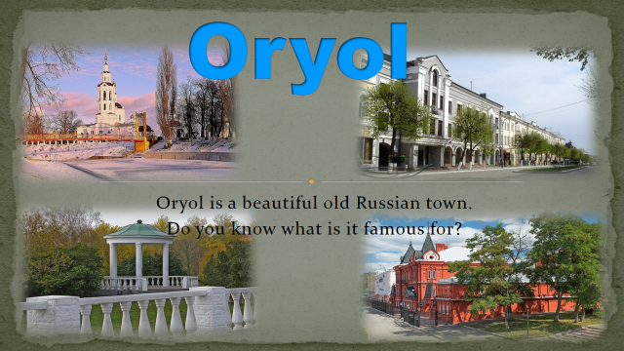

Слайд 2
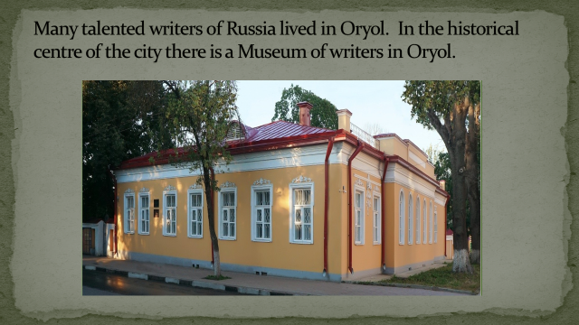
Слайд 3

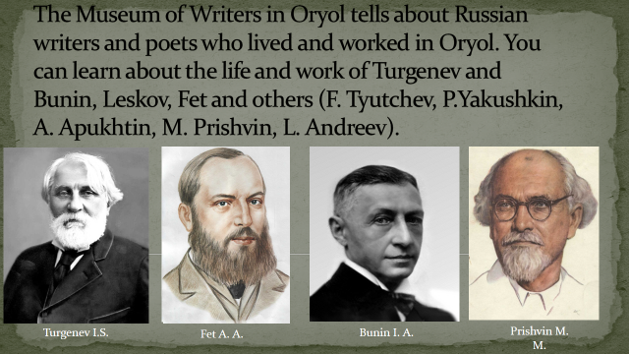

Слайд 4

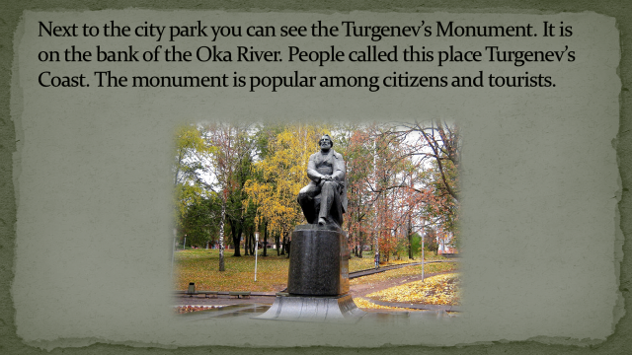

Слайд 5

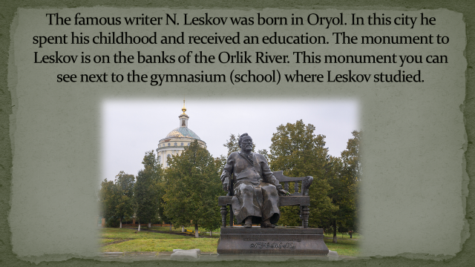

Слайд 6

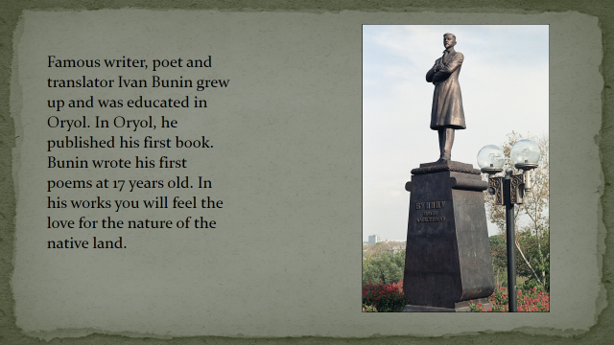

Слайд 7

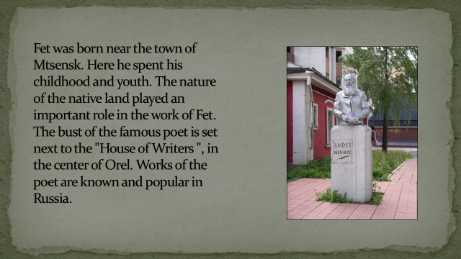

Слайд 8

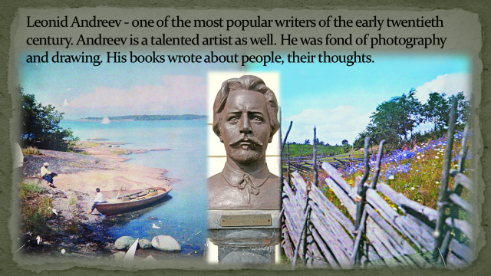

Слайд 9



